

Parish of St Mary the Virgin
Great Shelford

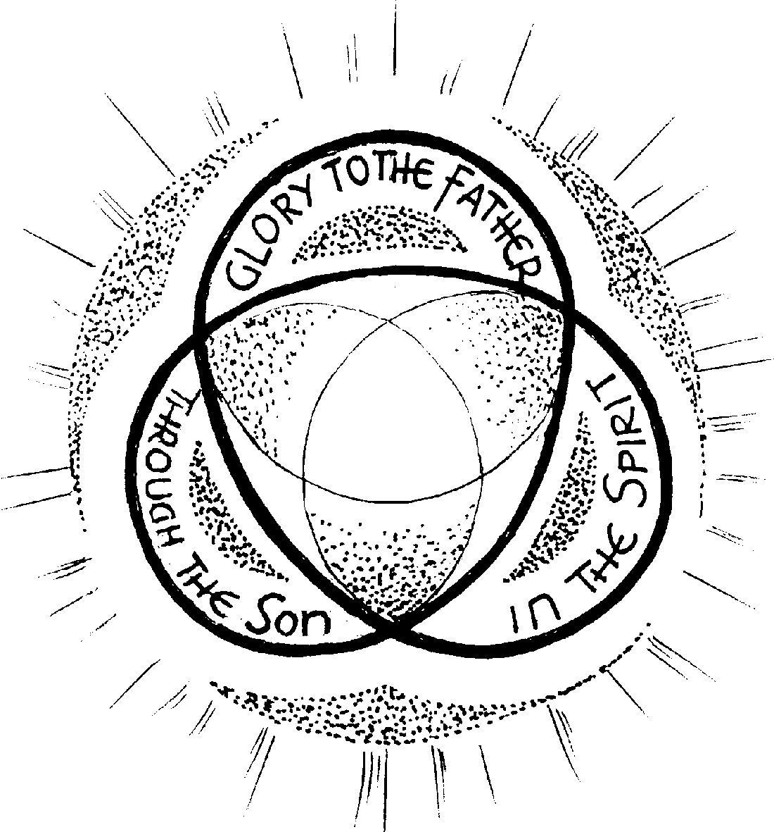

Last Sunday After Trinity
10am 26 October 2025
Bible Sunday

Welcome to St Mary’s, and to the service today.

If you would like a clergy visit, please let us know.
Please note that when asked to kneel or stand, you can do this in body or in heart. There are Gluten Free and wafers with wine added for those with medical need, please ask at the altar.
Please stand as the Choir process and for the first hymn.
Opening hymn 334 All people that on earth do dwell
- All people that on earth do dwell,
Sing to the Lord with cheerful voice;
Him serve with fear, his praise forth tell,
Come ye before him, and rejoice.
- The Lord, ye know, is God indeed,
Without our aid he did us make;
We are his folk, he doth us feed,
And for his sheep he doth us take.
- O enter then his gates with praise,
Approach with joy his courts unto;
Praise, laud, and bless his name always,
For it is seemly so to do.
- For why? the Lord our God is good:
His mercy is for ever sure;
His truth at all times firmly stood,
And shall from age to age endure.
- To Father, Son, and Holy Ghost,
The God whom heaven and earth adore,
From men and from the Angel-host
Be praise and glory evermore. Amen.
W Kethe. Tune OLD HUNDREDTH
THE GATHERING

The president says,
In the name of the Father, and of the Son,
and of the Holy Spirit.
All Amen.

Welcome

The Greeting
Grace, mercy and peace from God our Father
and the Lord Jesus Christ be with you
All and also with you.

Prayer of Preparation
All Almighty God, to whom all hearts are open,
all desires known, and from whom no secrets are hidden:
cleanse the thoughts of our hearts
by the inspiration of your Holy Spirit,
that we may perfectly love you,
and worthily magnify your holy name;
through Christ our Lord. Amen.
Prayers of Confession

The deacon says,
My brothers and sisters,
as we prepare to celebrate the presence of Christ
in word and sacrament,
let us call to mind and confess our sins
Please sit or kneel
All Father eternal, giver of light and grace,
we have sinned against you and against our neighbour;
through ignorance, through weakness,
through our own deliberate fault.
We have wounded your love,
and marred your image in us.
We are sorry and ashamed, and repent of all our sins.
For the sake of your Son Jesus Christ, who died for us,
forgive us all that is past; and lead us out from darkness
to walk as children of light. Amen.

Absolution

The president says,
May the God of love and power
forgive you and free you from your sins,
heal and strengthen you by his Spirit,
and raise you to new life in Christ our Lord.
All Amen.
We stand and pray together as the children prepare to leave for their activities
All Creator God, we thank you for giving us Jesus as our Saviour: he blessed the children who came to him,
and welcomes those who come to him now.
Look with love upon these children
and protect them with your care.
May they grow in wisdom, age and strength in your presence and in the sight of all.
We ask this through your beloved Son,
Jesus Christ our Lord. Amen.
We remain standing to sing the Gloria
GLORIA IN EXCELSIS

Glory to God, Glory to God, Glory to God in the Highest.

Glory to God in the Highest, and peace to his people on earth.

Lord God, Heav’nly King, Almighty God and Father,

We worship you, we give you thanks, we praise you for your glory.

Glory to God, Glory to God, Glory to God in the highest.

Lord, Jesus Christ, only son of the Father, Lord God, Lamb of God, you take away the sin of the world, have mercy on us:

You are seated at the right hand of the Father: receive our prayer.

Glory to God, Glory to God, Glory to God in the Highest.

For you alone are the Holy one, you alone are the Lord,

You alone are the most high, Jesus Christ, with the Holy Spirit,

In the glory of God the Father.

Glory to God, Glory to God, Glory to God in the Highest.

David Thorne
Please remain standing. The president introduces a period of silent prayer
The Collect
All Blessed Lord,
who caused all holy Scriptures to be written for our learning:
help us so to hear them, to read, mark, learn
and inwardly digest them that, through patience,
and the comfort of your holy word,
we may embrace and for ever hold fast
the hope of everlasting life, which you have given us
in our Saviour Jesus Christ,
who is alive and reigns with you,
in the unity of the Holy Spirit,
one God, now and for ever. Amen
Please sit for the readings
THE LITURGY OF THE WORD
First Reading: Isaiah 45.22-end
Turn to me and be saved, all the ends of the earth!
For I am God, and there is no other. By myself I have sworn, from my mouth has gone forth in righteousness a word that shall not return:
‘To me every knee shall bow, every tongue shall swear.’
Only in the Lord, it shall be said of me, are righteousness and strength;
all who were incensed against him shall come to him and be ashamed.
In the Lord all the offspring of Israel shall triumph and glory.
This is the word of the Lord.
All Thanks be to God.
Second Reading: Romans 15.1–6
We who are strong ought to put up with the failings of the weak, and not to please ourselves. Each of us must please our neighbour for the good purpose of building up the neighbour. For Christ did not please himself; but, as it is written, ‘The insults of those who insult you have fallen on me.’ For whatever was written in former days was written for our instruction, so that by steadfastness and by the encouragement of the scriptures we might have hope. May the God of steadfastness and encouragement grant you to live in harmony with one another, in accordance with Christ Jesus, so that together you may with one voice glorify the God and Father of our Lord Jesus Christ.
This is the word of the Lord
All Thanks be to God.
Gradual hymn 407: Lord, thy word abideth
- Lord, thy word abideth,
And our footsteps guideth;
Who its truth believeth,
Light and joy receiveth.

- When our foes are near us,
Then thy word doth cheer us,
Word of consolation,
Message of salvation.

- When the storms are o'er us,
And dark clouds before us,
Then its light directeth,
And our way protecteth.

- Word of mercy, giving
Succour to the living;
Word of life, supplying
Comfort to the dying.

- O that we discerning
Its most holy learning,
Lord, may love and fear thee,
Evermore be near thee! H. W. Baker 1821-77 Tune Ravenshaw
Please remain standing and face the Gospel
The Gospel

Alleluia, alleluia.

We do not live by bread alone,

But by every word that comes from the mouth of God.

All Alleluia.

Hear the Gospel of our Lord Jesus Christ according to Luke

All Glory to you, O Lord.
When he came to Nazareth, where he had been brought up, he went to the synagogue on the sabbath day, as was his custom. He stood up to read, and the scroll of the prophet Isaiah was given to him. He unrolled the scroll and found the place where it was written:
‘The Spirit of the Lord is upon me, because he has anointed me
to bring good news to the poor.
He has sent me to proclaim release to the captives and recovery of sight to the blind,
to let the oppressed go free, to proclaim the year of the Lord’s favour.’
And he rolled up the scroll, gave it back to the attendant, and sat down. The eyes of all in the synagogue were fixed on him. Then he began to say to them, ‘Today this scripture has been fulfilled in your hearing.’ All spoke well of him and were amazed at the gracious words that came from his mouth. They said, ‘Is not this Joseph’s son?’ He said to them, ‘Doubtless you will quote to me this proverb, “Doctor, cure yourself!” And you will say, “Do here also in your home town the things that we have heard you did at Capernaum.” ’ And he said, ‘Truly I tell you, no prophet is accepted in the prophet’s home town. Luke 4.16–24
This is the Gospel of the Lord.
All Praise to you, O Christ.
Please be seated
Sermon

THE CREED
Let us stand to affirm our faith in God, Father, Son and Holy Spirit.
All We believe in one God,
the Father, the Almighty,
maker of heaven and earth,
of all that is,
seen and unseen.
We believe in one Lord, Jesus Christ,
the only Son of God,
eternally begotten of the Father,
God from God, Light from Light,
true God from true God, begotten, not made,
of one Being with the Father;
through him all things were made.
For us and for our salvation he came down from heaven,
was incarnate from the Holy Spirit and the Virgin Mary
and was made man.
For our sake he was crucified under Pontius Pilate;
he suffered death and was buried.
On the third day he rose again
in accordance with the Scriptures;
he ascended into heaven
and is seated at the right hand of the Father.
He will come again in glory to judge the living and the dead, and his kingdom will have no end.
We believe in the Holy Spirit, the Lord, the giver of life,
who proceeds from the Father and the Son,
who with the Father and the Son
is worshipped and glorified,
who has spoken through the prophets.
We believe in one holy catholic and apostolic Church.
We acknowledge one baptism for the forgiveness of sins.
We look for the resurrection of the dead,
and the life of the world to come. Amen.
Prayers Of Intercession
Please sit or kneel to pray
In the power of the Spirit and in union with Christ let us pray to the Father.
At the end
Merciful Father,
All accept these prayers
for the sake of your Son,
our Saviour Jesus Christ. Amen

Please stand for the Peace
THE LITURGY OF THE SACRAMENT
The Peace
God is love
and those who live in love live in God
and God lives in them.
All and also with you.
Let us offer one another a sign of peace.
Offertory Hymn: 302: O Thou, who at thy Eucharist didst pray
- O thou, who at thy Eucharist didst pray
That all thy Church might be for ever one,
Grant us at every Eucharist to say
With longing heart and soul, 'Thy will be done.'
Oh, may we all one Bread, one Body be,
One through this Sacrament of unity.

- For all thy Church, O Lord, we intercede;
Make thou our sad divisions soon to cease;
Draw us the nearer each to each, we plead,
By drawing all to thee, O Prince of Peace:
Thus may we all one Bread, one Body be,
One through this Sacrament of unity.

- We pray thee too for wanderers from thy fold;
O bring them back, good Shepherd of the sheep,
Back to the faith which saints believed of old,
Back to the Church which still that faith doth keep:
Soon may we all one Bread, one Body be,
One through this Sacrament of unity.

- So, Lord, at length when sacraments shall cease,
May we be one with all thy Church above,
One with thy saints in one unbroken peace,
One with thy saints in one unbounded love:
More blessèd still, in peace and love to be
One with the Trinity in Unity.
William Turton. Tune SONG 1 Orlando Gibbons
Preparation of the Table
Please remain standing
God of life, Saviour of the poor, receive with these gifts
gratitude for your goodness, penitence for our pride and dedication to your service in Jesus Christ our Lord.
All Amen.
The Eucharistic Prayer
The president says
The Lord is here
All His Spirit is with us
Lift up your hearts.
All We lift them to the Lord.
Let us give thanks to the Lord our God.
All It is right to give thanks and praise.

Father, you made the world and love your creation.
You gave your Son Jesus Christ to be our Saviour.
His dying and rising have set us free from sin and death.
And so we gladly thank you,
with saints and angels praising you, and singing:
Sanctus / Benedictus
All Holy, holy, holy Lord, God of power and might,
Heaven and earth are full of your glory.
Hosanna, hosanna, hosanna in the highest.
Blessed is he who comes in the name of the Lord.
Hosanna, hosanna, hosanna in the highest. David Thorne
Please sit or kneel
We praise and bless you, loving Father,
through Jesus Christ, our Lord;
and as we obey his command,
send your Holy Spirit,
that broken bread and wine outpoured
may be for us the body and blood of your dear Son.
On the night before he died he had supper with his friends
and, taking bread, he praised you.
He broke the bread, gave it to them and said:
Take, eat; this is my body which is given for you;
do this in remembrance of me.
When supper was ended he took the cup of wine.
Again he praised you, gave it to them and said:
Drink this, all of you;
this is my blood of the new covenant,
which is shed for you and for many for the forgiveness of sins.
Do this, as often as you drink it, in remembrance of me.
So, Father, we remember all that Jesus did,
in him we plead with confidence his sacrifice
made once for all upon the cross.
Bringing before you the bread of life and cup of salvation,
we proclaim his death and resurrection
until he comes in glory.

Great is the mystery of faith;
Christ has died.
Christ is risen.
Christ will come again.
Lord of all life,
help us to work together for that day
when your kingdom comes
and justice and mercy will be seen in all the earth.
Look with favour on your people,
gather us in your loving arms
and bring us with Blessed Mary, and all the saints
to feast at your table in heaven.
Through Christ, and with Christ, and in Christ,
in the unity of the Holy Spirit, all honour and glory are yours,
O loving Father, for ever and ever.
All Amen.

THE LORD’S PRAYER

Let us pray with confidence as our Saviour has taught us
All Our Father, who art in heaven, hallowed be thy name;
thy kingdom come; thy will be done;
on earth as it is in heaven.
Give us this day our daily bread.
And forgive us our trespasses,
as we forgive those who trespass against us.
And lead us not into temptation; but deliver us from evil. For thine is the kingdom, the power and the glory,
for ever and ever. Amen.

Breaking of the Bread
The president breaks the consecrated bread.
We break this bread to share in the body of Christ.
All Though we are many, we are one body,
because we all share in one bread.
Giving of Communion
The president says
Draw near with faith.
Receive the body of our Lord Jesus Christ
which he gave for you,
and his blood which he shed for you.
Eat and drink
in remembrance that he died for you,
and feed on him in your hearts by faith with thanksgiving.
Agnus Dei
Lamb of God, you take away the sins of the world: have mercy on us.
Lamb of God, you take away the sins of the world: have mercy on us.
Lamb of God, you take away the sins of the world: grant us peace. David Thorne

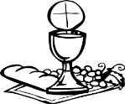
If you need a wafer with the wine already present please ask, but do not dip. If you need a gluten free wafer, please ask. All are welcome to come to the altar for a blessing please carry this Booklet to indicate this.
Hymn During Communion Spirit of God, unseen as the wind
Refrain:
Spirit of God, unseen as the wind,
gentle as is the dove:
teach us the truth and help us believe,
show us the Saviour's love!
You spoke to us - long, long ago - gave us the written word;
we read it still, needing its truth, through it God's voice is heard. Refrain:
Without your help we fail our Lord,
we cannot live his way;
we need your power, we need your strength,
following Christ each day. Refrain
Author: Margaret V. Old Tune: SKYE BOAT SONG

Prayer After Communion
God of all grace, your Son Jesus Christ fed the hungry
with the bread of his life and the word of his kingdom:
renew your people with your heavenly grace,
and in all our weakness sustain us
by your true and living bread;
who is alive and reigns, now and for ever.
All Amen
Thanksgiving, said by everyone.
All Almighty God,
we thank you for feeding us
with the body and blood of your Son Jesus Christ.
Through him we offer you our souls and bodies
to be a living sacrifice.
Send us out in the power of your Spirit
to live and work to your praise and glory. Amen.
SUNDAY CLUB FEEDBACK Mary Mouse & NOTICES
Closing Hymn: 415: O for a thousand tongues to sing
- O for a thousand tongues to sing
2x My dear Redeemer's praise,
The glories of my God and King,
3x The triumphs of his grace!
- Jesus--the name that charms our fears,
2x That bids our sorrows cease;
'Tis music in the sinner's ears,
3x 'Tis life, and health, and peace,
- He speaks; and, listening to his voice,
2x New life the dead receive,
The mournful broken hearts rejoice,
3x The humble poor believe.
- My gracious Master and my God,
2x Assist me to proclaim
And spread through all the earth abroad
3x The honours of thy name. C Wesley Tune LYNGHAM

THE DISMISSAL
May the Father from whom every family
in earth and heaven receives its name
strengthen you with his Spirit in your inner being,
so that Christ may dwell in your hearts by faith;
and the blessing of God almighty,
the Father, the Son and the Holy Spirit,
be among you, and remain with you always.
All Amen.

Go in peace to love and serve the Lord.
All In the name of Christ. Amen.

You are warmly invited to join us for refreshments in the Community Room after this service.

Common Worship, Services and Prayers for the Church of England, material in this service, is copyright © The Archbishops' Council 2000 and 2008.

