
The Parish Church of St Mary the Virgin,
Great Shelford

Parish Communion

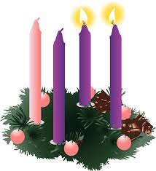

2nd Sunday in Advent

7th December 2025 10am

WELCOME TO ST MARY’S, AND TO THE SERVICE TODAY.
If you would like a clergy visit, please let us know.
Please note that when asked to kneel or stand, you can do this in body or in heart. There are Gluten Free and wafers with wine added for those who need them, please ask at the altar.
Please remain seated as the Choir sing the anthem

THE CHOIR SING THE ADVENT ANTHEM ‘People Look East’ Words Eleanor Farjeon Tune BESANCON

THE GATHERING
Please stand to sing
THE OPENING HYMN: 5: Hark! a herald voice is calling
- Hark! a herald voice is calling:
'Christ is nigh,' it seems to say;
'Cast away the dreams of darkness,
Oh ye children of the day!'
- Startled at the solemn warning,
Let the earth-bound soul arise;
Christ, her Sun, all sloth dispelling,
Shines upon the morning skies.
- Lo! the Lamb, so long expected,
Comes with pardon down from heaven;
Let us haste, with tears of sorrow,
One and all to be forgiven;
- So when next he comes in glory,
And earth's final hour draws near,
May he then as our defender
On the clouds of heaven appear.
- Honour, glory, virtue, merit,
To the Father and the Son,
With the co-eternal Spirit,
While unending ages run. Amen.
From the Latin hymn by an unknown author Tr. E. Caswall 1814-78 Tune MERTON

THE GREETING

The president says
In the name of the Father,
and of the Son, and of the Holy Spirit.
All Amen.
Please be seated. The president greets the people.

Grace, mercy and peace

from God our Father
and the Lord Jesus Christ be with you.
All and also with you.
THE ADVENT WREATH
The second purple candle is lit
Blessed are you, sovereign Lord, just and true:
to you be praise and glory for ever.
Of old you spoke by the mouth of your prophets,
but in our days you speak through your Son,
whom you have appointed the heir of all things.
Grant us, your people, to walk in his light,
that we may be found ready and watching
when he comes again in glory and judgement;
for you are our light and our salvation.
All Blessed be God for ever.

God comes in justice and peace,
to all who follow his ways.
All Lord, make us one in the peace of Christ
today and for ever. Amen.

INVITATION TO CONFESSION

Please sit or kneel to pray
A voice cries out in the wilderness,
‘Make straight the way of the Lord.’
So let us listen, and turn to the Lord
  - in penitence and faith. cf John 1.23
All Most merciful God,
Father of our Lord Jesus Christ,
we confess that we have sinned
in thought, word and deed.
We have not loved you with our whole heart.
We have not loved our neighbours as ourselves.
In your mercy forgive what we have been,
help us to amend what we are,
and direct what we shall be;
that we may do justly, love mercy,
and walk humbly with you, our God. Amen.

May the God of love bring you back to himself,
forgive you your sins,
and assure you of his eternal love in Jesus Christ our Lord.
All Amen.

Please stand as we pray together for the children before younger ones go their activities:
All Creator God, we thank you for giving us Jesus as our Saviour:
he blessed the children who came to him,
and welcomes those who come to him now.
Look with love upon these children
and protect them with your care.
May they grow in wisdom, age and strength in your presence
and in the sight of all.
We ask this through your beloved Son, Jesus Christ our Lord. Amen.

THE COLLECT

The president introduces a period of silent prayer
As we wait with hope and anticipation for the coming of our Lord, we ask for peace and mercy for ourselves and the world.

O Lord, raise up, we pray, your power
and come among us, and with great might succour us;
that whereas, through our sins and wickedness
we are grievously hindered
in running the race that is set before us,
your bountiful grace and mercy
may speedily help and deliver us;
through Jesus Christ your Son our Lord,
to whom with you and the Holy Spirit,
be honour and glory, now and for ever. Amen
THE LITURGY OF THE WORD

Please sit for the first and second readings
FIRST READING: Isaiah 11.1–10
A shoot shall come out from the stock of Jesse,
and a branch shall grow out of his roots.
The spirit of the Lord shall rest on him,
the spirit of wisdom and understanding,
the spirit of counsel and might,
the spirit of knowledge and the fear of the Lord.
His delight shall be in the fear of the Lord.
He shall not judge by what his eyes see, or decide by what his ears hear;
but with righteousness he shall judge the poor,
and decide with equity for the meek of the earth;
he shall strike the earth with the rod of his mouth,
and with the breath of his lips he shall kill the wicked.
Righteousness shall be the belt around his waist,
and faithfulness the belt around his loins.
The wolf shall live with the lamb, the leopard shall lie down with the kid,
the calf and the lion and the fatling together,
and a little child shall lead them.
The cow and the bear shall graze, their young shall lie down together;
and the lion shall eat straw like the ox.
The nursing child shall play over the hole of the asp,
and the weaned child shall put its hand on the adder’s den.
They will not hurt or destroy on all my holy mountain;
for the earth will be full of the knowledge of the Lord
as the waters cover the sea.
On that day the root of Jesse shall stand as a signal to the peoples; the nations shall inquire of him, and his dwelling shall be glorious.
This is the word of the Lord
All Thanks be to God

Short silence

SECOND READING: Romans 15.4-13

For whatever was written in former days was written for our instruction, so that by steadfastness and by the encouragement of the scriptures we might have hope. May the God of steadfastness and encouragement grant you to live in harmony with one another, in accordance with Christ Jesus, so that together you may with one voice glorify the God and Father of our Lord Jesus Christ. Welcome one another, therefore, just as Christ has welcomed you, for the glory of God. For I tell you that Christ has become a servant of the circumcised on behalf of the truth of God in order that he might confirm the promises given to the patriarchs, and in order that the Gentiles might glorify God for his mercy. As it is written,
‘Therefore I will confess you among the Gentiles,
and sing praises to your name’
and again he says,
‘Rejoice, O Gentiles, with his people’;
and again,
‘Praise the Lord, all you Gentiles, and let all the peoples praise him’;
and again Isaiah says,
‘The root of Jesse shall come, the one who rises to rule the Gentiles;
in him the Gentiles shall hope.’
May the God of hope fill you with all joy and peace in believing, so that you may abound in hope by the power of the Holy Spirit.
This is the word of the Lord

All Thanks be to God

Short silence

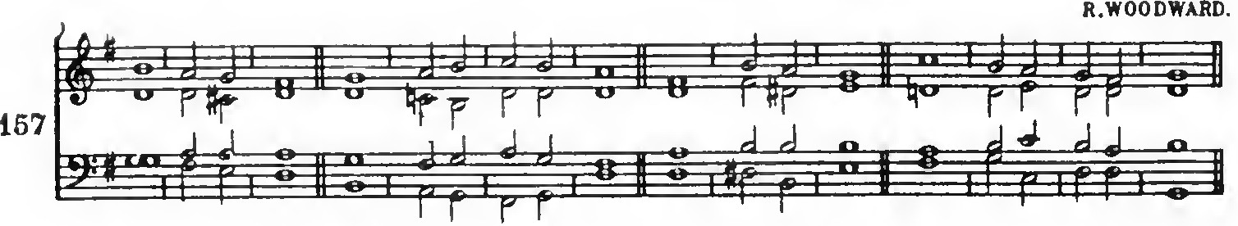
THE CANTICLE – ‘A song of the wilderness’ set to

1 The wilderness and the dry land ‘ shall re ‘ joice, : the desert shall ‘ blossom and ‘ burst into ‘ song.
2 They shall see the ‘ glory . of the ‘ Lord, : the ‘ majesty of ‘our
‘ God.
3 Strengthen the ‘ weary ‘ hands, : and make ‘ firm the ‘ feeble
‘ knees.
4 Say to the anxious, ‘Be strong, fear not, your God is ‘coming with ‘ judgement, : coming with ‘ judgement to ‘ save ‘ you.’
5 Then shall the eyes of the ‘ blind be ‘ opened,: and the ‘ ears of the ‘ deaf un’stopped;
6 Then shall the lame leap ‘ like a ‘ hart, : and the tongue of the ‘ dumb ‘ sing for ‘ joy.
7 For waters shall break ‘ forth in the ‘ wilderness,: and ‘ streams ‘ in the ‘ desert;
8 The ransomed of the Lord shall re’turn with ‘ singing, : with everlasting ‘ joy up’on their ‘ heads.
9 Joy and gladness ‘ shall be ‘ theirs, : and sorrow and ‘ sighing shall ‘ flee a’way.
Glory be to the Father, and ‘ to the ‘ Son : and ‘ to the ‘ Holy ‘ Ghost
As it was in the beginning, is now and ‘ever ‘shall be : world
without ‘ end ‘ A’men.
GOSPEL READING:
Please stand to face the Gospel as it is being proclaimed

Alleluia, alleluia.
Prepare the way of the Lord, make his paths straight, and all flesh shall see the salvation of God. (Isaiah 40:3-5)
All Alleluia.

Hear the Gospel of our Lord Jesus Christ
according to Matthew.
All Glory to you, O Lord.

Matthew 3.1–12

In those days John the Baptist appeared in the wilderness of Judea, proclaiming, ‘Repent, for the kingdom of heaven has come near.’ This is the one of whom the prophet Isaiah spoke when he said,
‘The voice of one crying out in the wilderness:
“Prepare the way of the Lord,
make his paths straight.” ’
Now John wore clothing of camel’s hair with a leather belt around his waist, and his food was locusts and wild honey. Then the people of Jerusalem and all Judea were going out to him, and all the region along the Jordan, and they were baptized by him in the river Jordan, confessing their sins. But when he saw many Pharisees and Sadducees coming for baptism, he said to them, ‘You brood of vipers! Who warned you to flee from the wrath to come? Bear fruit worthy of repentance. Do not presume to say to yourselves, “We have Abraham as our ancestor”; for I tell you, God is able from these stones to raise up children to Abraham. Even now the axe is lying at the root of the trees; every tree therefore that does not bear good fruit is cut down and thrown into the fire. ‘I baptize you with water for repentance, but one who is more powerful than I is coming after me; I am not worthy to carry his sandals. He will baptize you with the Holy Spirit and fire. His winnowing-fork is in his hand, and he will clear his threshing-floor and will gather his wheat into the granary; but the chaff he will burn with unquenchable fire.’
This is the Gospel of the Lord.
All Praise to you, O Christ.

Please be seated
SERMON
Short silence

THE APOSTLES CREED
Let us stand to affirm our faith in God, Father, Son and Holy Spirit.

All I believe in God, the Father almighty,
creator of heaven and earth.
I believe in Jesus Christ, his only Son, our Lord,
who was conceived by the Holy Spirit, born of the Virgin Mary,
suffered under Pontius Pilate,
was crucified, died, and was buried;
he descended to the dead.
On the third day he rose again; he ascended into heaven,
he is seated at the right hand of the Father,
and he will come to judge the living and the dead.
I believe in the Holy Spirit, the holy catholic Church,
the communion of saints, the forgiveness of sins,
the resurrection of the body, and the life everlasting.
Amen.

PRAYERS OF INTERCESSION

Please sit or kneel to pray. The president says

In the power of the Spirit and in union with Christ
let us pray to the Father.

At the end of each prayer
Lord in your mercy
All hear our prayer.

At the end
Merciful Father,
All accept these prayers
for the sake of your Son,
our Saviour Jesus Christ.
Amen.

THE LITURGY OF THE SACRAMENT
The children return and join their families

THE PEACE

Please stand
God will speak peace to his people,
to those who turn to him in their hearts.
The peace of the Lord be always with you.
All and also with you.

Let us offer one another a sign of peace.

THE OFFERTORY HYMN 295: Let all Mortal flesh keep silence
During the hymn, the gifts of bread and wine and our offerings will be brought to the altar.

- Let all mortal flesh keep silence
And with fear and trembling stand;
Ponder nothing earthly-minded,
For with blessing in his hand
Christ our God to earth descendeth,
Our full homage to demand.
- King of kings, yet born of Mary,
As of old on earth he stood,
Lord of lords, in human vesture,
In the body and the blood:
He will give to all the faithful
His own self for heavenly food.
- Rank on rank the host of heaven
Spreads its vanguard on the way,
As the Light of light descendeth
From the realms of endless day,
That the powers of hell may vanish
As the darkness clears away.

- At his feet the six-winged seraph;
Cherubim with sleepless eye,
Veil their faces to the Presence,
As with ceaseless voice they cry,
Alleluya, Alleluya,
Alleluya, Lord most high!
Liturgy of St James Tr Gerard Moultrie. Tune. PICARDY

PRAYERS AT THE PREPARATION OF THE TABLE

Please remain standing
Look upon us in mercy not in judgement;
draw us from hatred to love;
make the frailty of our praise a dwelling place for your glory.
All Amen.
THE EUCHARISTIC PRAYER

The Lord is here.
All His spirit is with us.

Lift up your hearts.
All We lift them to the Lord.

Let us give thanks to the Lord our God.
All It is right to give thanks and praise.

It is indeed right and good to give you thanks and praise,
almighty God and everlasting Father,
through Jesus Christ your Son.
For when he humbled himself to come among us in human flesh,
he fulfilled the plan you formed before the foundation of the world
to open for us the way of salvation.
Confident that your promise will be fulfilled,
we now watch for the day
when Christ our Lord will come again in glory.
And so we join our voices with angels and archangels
and with all the company of heaven
to proclaim your glory for ever praising you and singing:
THE SANCTUS/BENEDICTUS 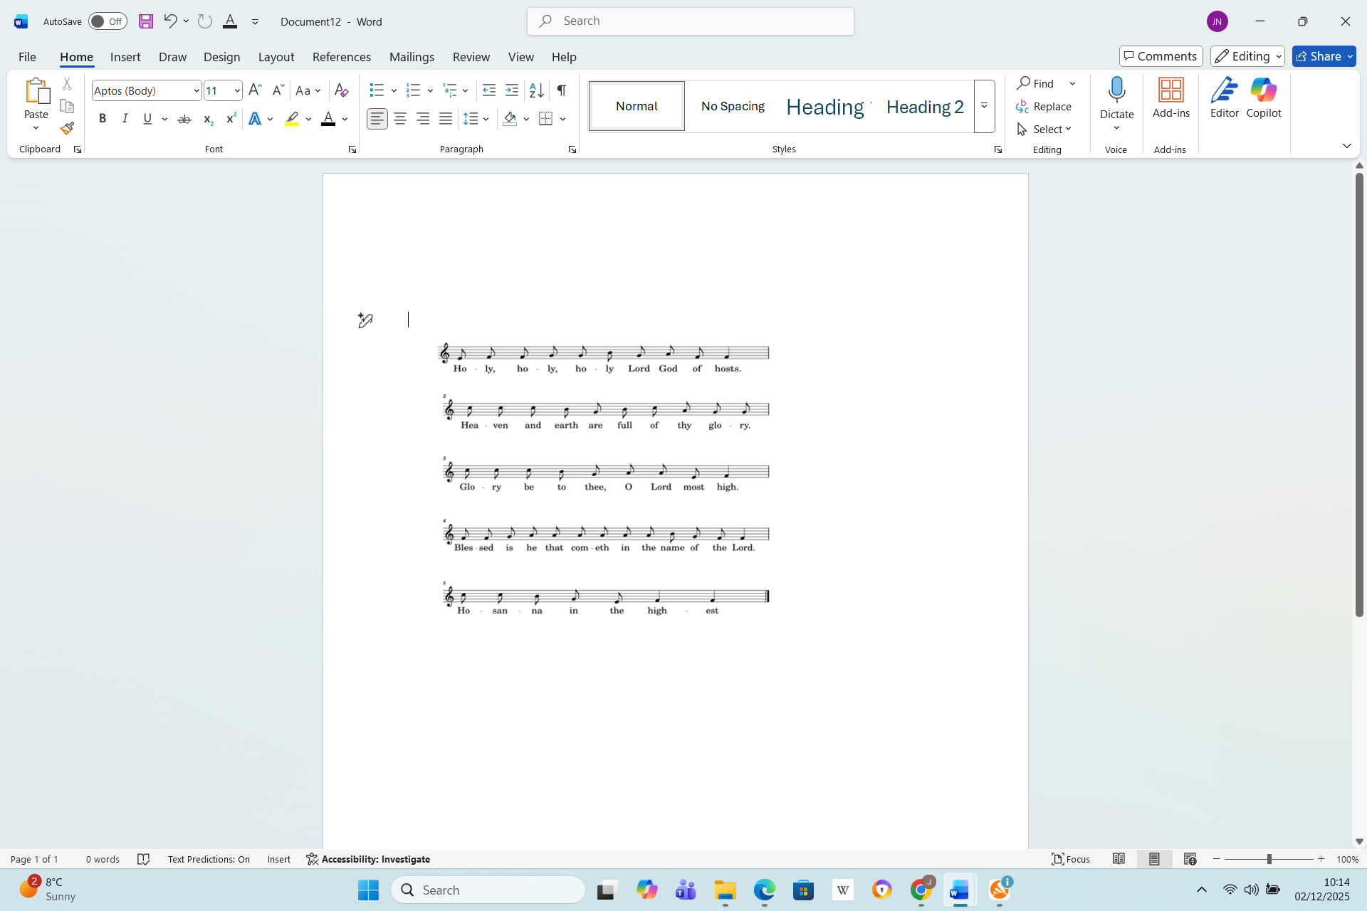
J Merbecke
THE SANCTUS/BENEDICTUS
Holy, holy, holy, Lord God of hosts.
Heaven and earth are full of thy glory.
Glory be to thee, O Lord most high.
Blessed is he that cometh in the name of the Lord.
Hosanna in the highest.

Please sit or kneel

We praise and bless you, loving Father,
through Jesus Christ our Lord;
and as we obey his command,
send your Holy Spirit,
that broken bread and wine outpoured
may be for us the body and blood of your dear Son.
On the night before he died he had supper with his friends and, taking bread, he praised you.
He broke the bread, gave it to them and said:
Take, eat; this is my body which is given for you;
do this in remembrance of me.
When supper was ended he took the cup of wine.
Again he praised you, gave it to them and said:
Drink this, all of you: this is my blood of the new covenant,
which is shed for you and for many for the forgiveness of sins.
Do this as often as you drink it,
in remembrance of me.
So, Father, we remember all that Jesus did,
in him we plead with confidence
his sacrifice made once for all upon the cross.
Bringing before you the bread of life
and cup of salvation,
we proclaim his death and resurrection
until he comes in glory.
Praise to you, Lord Jesus:
All Dying you destroyed our death,
rising you restored our life:
Lord Jesus, come in glory.
Lord of all life, help us to work together
for that day when your kingdom comes
and justice and mercy will be seen in all the earth.
Look with favour on your people,
gather us in your loving arms
and bring us with Mary and all the saints
to feast at your table in heaven.
Through Christ, and with Christ, and in Christ,
in the unity of the Holy Spirit, all honour and glory are yours,
O loving Father, for ever and ever.
All Amen.
We keep a brief silence

THE LORD’S PRAYER

May the Lord when he comes find us watching and waiting,

now and at all times.

As our Saviour taught us, so we pray
All Our Father, who art in heaven,
hallowed be thy name;
thy kingdom come; thy will be done,
on earth as it is in heaven.
Give us this day our daily bread.
And forgive us our trespasses
as we forgive those who trespass against us.
And lead us not into temptation but deliver us from evil.
For thine is the kingdom, the power and the glory,
for ever and ever. Amen.

THE BREAKING OF THE BREAD

The president breaks the consecrated bread

Every time we eat this bread and drink this cup,
All we proclaim the Lord’s death
until he comes.
  - GIVING OF COMMUNION
  - Draw near with faith.
  - Receive the body of our Lord Jesus Christ

which he gave for you, and his blood which he shed for you.

Eat and drink in remembrance that he died for you,

and feed on him in your hearts by faith with thanksgiving.

If you are used to receiving communion in your own church, you are welcome to do so here. Gluten-free wafer is available. If, for any reason, you cannot take from the common cup, wafers with wine are available, but please do not dip(Keep the wine Gluten free). If you would like to receive a blessing, please hold this booklet.

THE AGNUS DEI
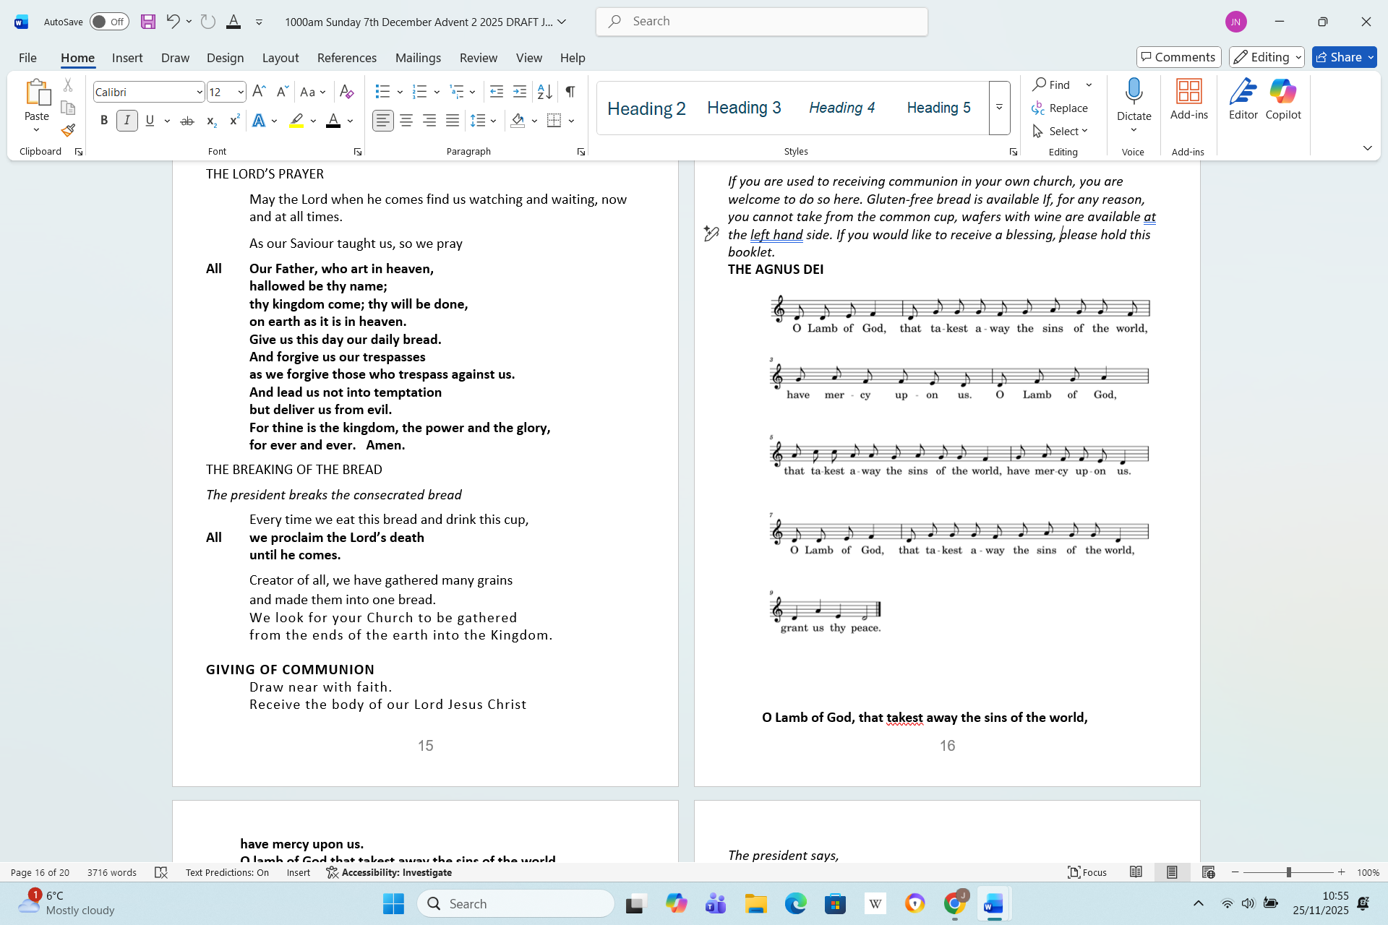

O Lamb of God, that takest away the sins of the world,
have mercy upon us.
O lamb of God that takest away the sins of the world
have mercy upon us’
O Lamb of God, you takest away the sins of the world,
grant us thy peace.
THE COMMUNION HYMN 12: On Jordan's bank the Baptist's cry

Please remain seated to sing
- On Jordan's bank the Baptist's cry
Announces that the Lord is nigh;
Come then and hearken, for he brings
Glad tidings from the King of kings.
- Then cleansed be every Christian breast,
And furnished for so great a guest!
Yea, let us each our hearts prepare
For Christ to come and enter there.
- For thou art our salvation, Lord,
Our refuge and our great reward;
Without thy grace our souls must fade,
And wither like a flower decayed.
- Stretch forth thine hand to heal our sore,
And make us rise, to fall no more;
Once more upon thy people shine,
And fill the world with love divine.
- All praise, eternal Son, to thee
Whose advent sets thy people free,
Whom, with the Father, we adore,
And Spirit blest, for evermore. Amen
Charles Coffin 1676=1749 Tr. John Chandler 1808-76 Tune Winchester New
PRAYER AFTER COMMUNION
The president says,
Father in heaven,
who sent your Son to redeem the world
and will send him again to be our judge:
give us grace so to imitate him in the humility
and purity of his first coming that, when he comes again,
we may be ready to greet him with joyful love and firm faith;
through Jesus Christ our Lord.
All Amen
Together we say,,
All Almighty God,
we thank you for feeding us
with the body and blood of your Son Jesus Christ.
Through him we offer you our souls and bodies
to be a living sacrifice.
Send us out in the power of your Spirit
to live and work to your praise and glory. Amen.
MARY MOUSE AND SUNDAY CLUB FEEDBACK AND YOUNG PILGRIMS
NOTICES
After the notices, please stand to sing
THE RECESSIONAL HYMN : 10: Long ago, prophets knew
- Long ago, prophets knew
Christ would come, born a Jew,
Come to make all things new;
Bear his People's burden,
Freely love and pardon.
Refrain: Ring, bells, ring, ring, ring!
Sing, choirs, sing, sing, sing!
When he comes, When he comes,
Who will make him welcome?
- God in time, God in man,
This is God's timeless plan:
He will come, as a man.
Born himself of woman,
God divinely human. Refrain
- Mary, hail! Though afraid,
She believed, she obeyed.
In her womb God is laid;
Till the time expected
Nurtured and protected. Refrain
- Journey ends! Where afar
Bethlem shines, like a star,
Stable door stands ajar.
Unborn Son of Mary,
Saviour, do not tarry!
Ring, bells, ring, ring, ring!
Sing, choirs, sing, sing, sing!
Jesus comes! Jesus comes!
We will make him welcome! F. Pratt Green b 1903 Tune Personet Hodie

THE DISMISSAL
THE BLESSING

May God the Father, judge all-merciful,
make us worthy of a place in his kingdom.
All Amen.
May God the Son, coming among us in power,
reveal in our midst the promise of his glory.
All Amen.
May God the Holy Spirit make us steadfast in faith,
joyful in hope and constant in love.
All Amen.
And the blessing …
As we await our coming Saviour,
go in peace to love and serve the Lord.
All In the name of Christ. Amen.

You are warmly invited to join us for refreshments after the service

Common Worship, Services and Prayers for the Church of England, and Times and Seasons. Material from which is included in this service, is copyright © The Archbishops’ Council 2000 and 2006

