
The Parish Church of St Mary the Virgin,
Great Shelford

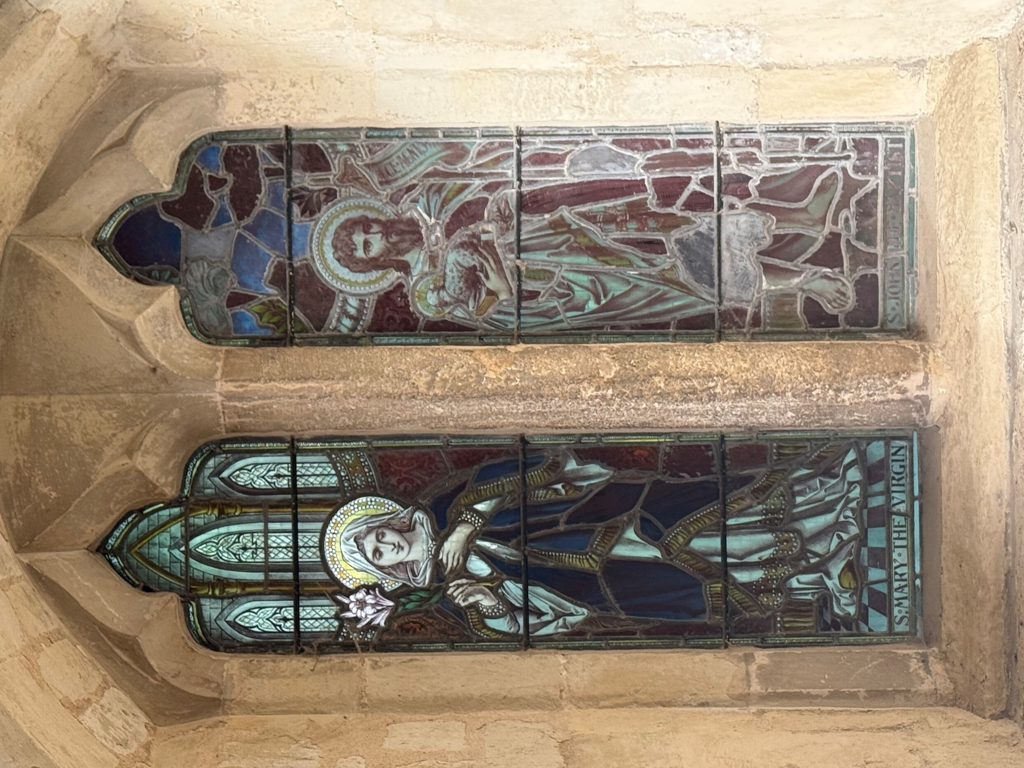

MIDNIGHT MASS

CHRISTMAS EVE
11.30pm

MERRY CHRISTMAS.

WELCOME TO ST MARY’S, AND TO THE SERVICE TODAY.

Please note that when asked to kneel or stand, you can do this in body or in heart. There are Gluten Free and wafers with wine added for those who need them, please ask at the altar.
If you would like to get to know us better, please talk to one of the clergy or Sidespersons. If you would like a clergy visit, please let us know.
There is a retiring collection today which will go to Christian Aid

Please stand as the choir and ministers process to the back.
THE GATHERING

Please stand to sing

THE OPENING HYMN 30: O come, all ye faithful (v 3&4 left out)
- O come, all ye faithful,
Joyful and triumphant,
O come ye, O come ye to Bethlehem;
Come and behold him
Born the King of Angels:
Refrain: O come, let us adore him, O come, let us adore him,
O come, let us adore him, Christ the Lord!
- God of God,
Light of Light,
Lo! he abhors not the Virgin's womb;
Very God,
Begotten, not created: Refrain

- Child, for us sinners
Poor and in the manger,
Fain we embrace thee, with awe and love;
Who would not love thee,
Loving us so dearly? Refrain
- Sing, choirs of Angels,
Sing in exultation,
Sing, all ye citizens of heaven above;
Glory to God
In the Highest: Refrain
Attributed to J F Wade; Translator: F Oakeley Tune: ADESTE FIDELES

THE GREETING

The president says
In the name of the Father,
and of the Son,
and of the Holy Spirit.
All Amen.
The president greets the people

Grace, mercy and peace
from God our Father and the Lord Jesus Christ
be with you
All and also with you.

THE CONFESSION
Please sit or kneel to pray
Christ the light of the world has come to dispel the darkness of our hearts. Let us turn to the light and confess our sins.
Silence is kept.
All Almighty God, our heavenly Father,
we have sinned against you and against our neighbour
in thought and word and deed, through negligence,
through weakness, through our own deliberate fault.
We are truly sorry and repent of all our sins.
For the sake of your Son Jesus Christ, who died for us,
forgive us all that is past and grant that we may serve you
in newness of life to the glory of your name. Amen.
May the God of all healing and forgiveness
draw you to himself, and cleanse you from all your sins,
that you may behold the glory of his Son,
the Word made flesh, Jesus Christ our Lord.
All Amen.
GLORIA IN EXCELSIS
Please stand
Glory to God, Glory to God, Glory to God in the Highest.
Glory to God in the Highest, and peace to his people on earth.
Lord God, Heav’nly King, Almighty God and Father,
We worship you, we give you thanks, we praise you for your glory.
Glory to God, Glory to God, Glory to God in the highest.
Lord, Jesus Christ, only son of the Father, Lord God, Lamb of God,
you take away the sin of the world, have mercy on us:
You are seated at the right hand of the Father: receive our prayer.
Glory to God, Glory to God, Glory to God in the Highest.
For you alone are the Holy one, you alone are the Lord,
You alone are the most high, Jesus Christ, with the Holy Spirit,
In the glory of God the Father.
Glory to God, Glory to God, Glory to God in the Highest. David Thorne

THE COLLECT

The president introduces a period of silent prayer:
All Eternal God,
in the stillness of this night
you sent your almighty Word
to pierce the world’s darkness with the light of salvation:
give to the earth the peace that we long for
and fill our hearts with the joy of heaven
through our Saviour, Jesus Christ. Amen
THE LITURGY OF THE WORD

Please sit
THE FIRST READING: Isaiah 52. 7 - 10
How beautiful upon the mountains are the feet of the messenger who announces peace, who brings good news, who announces salvation, who says to Zion, ‘Your God reigns.’ Listen! Your sentinels lift up their voices, together they sing for joy; for in plain sight they see the return of the Lord to Zion. Break forth together into singing, you ruins of Jerusalem; for the Lord has comforted his people, he has redeemed Jerusalem. The Lord has bared his holy arm before the eyes of all the nations; and all the ends of the earth shall see the salvation of our God.
This is the word of the Lord All Thanks be to God
THE SECOND READING: Hebrews 1. 1 - 4
Long ago God spoke to our ancestors in many and various ways by the prophets, but in these last days he has spoken to us by a Son, whom he appointed heir of all things, through whom he also created the worlds. He is the reflection of God’s glory and the exact imprint of God’s very being, and he sustains all things by his powerful word. When he had made purification for sins, he sat down at the right hand of the Majesty on high, having become as much superior to angels as the name he has inherited is more excellent than theirs.
This is the word of the Lord
All Thanks be to God
Please stand to sing the Gradual Hymn
THE GRADUAL HYMN 32: O little town of Bethlehem (V 3 left out)
- O little town of Bethlehem,
How still we see thee lie!
Above thy deep and dreamless sleep
The silent stars go by.
Yet in thy dark streets shineth
The everlasting light;
The hopes and fears of all the years
Are met in thee to-night.
- O morning stars, together
Proclaim the holy birth,
And praises sing to God the King,
And peace to men on earth;
For Christ is born of Mary;
And, gathered all above,
While mortals sleep, the angels keep
Their watch of wondering love.
- O holy Child of Bethlehem,
Descend to us, we pray;
Cast out our sin, and enter in,
Be born in us today.
We hear the Christmas angels
The great glad tidings tell:
O come to us, abide with us,
Our Lord Emmanuel. Words Phillips Brooks Tune: FOREST GREEN
GOSPEL READING: John 1. 1 - 14
Alleluia, alleluia.
The Word became flesh and dwelt among us,
and we have seen his glory. John 1:14
All Alleluia.
Hear the Gospel of our Lord Jesus Christ
according to John
All Glory to you, O Lord.
In the beginning was the Word, and the Word was with God, and the Word was God. He was in the beginning with God. All things came into being through him, and without him not one thing came into being. What has come into being in him was life, and the life was the light of all people. The light shines in the darkness, and the darkness did not overcome it.
There was a man sent from God, whose name was John. He came as a witness to testify to the light, so that all might believe through him. He himself was not the light, but he came to testify to the light. The true light, which enlightens everyone, was coming into the world. He was in the world, and the world came into being through him; yet the world did not know him. He came to what was his own, and his own people did not accept him. But to all who received him, who believed in his name, he gave power to become children of God, who were born, not of blood or of the will of the flesh or of the will of man, but of God. And the Word became flesh and lived among us, and we have seen his glory, the glory as of a father’s only son, full of grace and truth.
This is the Gospel of the Lord.
All Praise to you, O Christ.
Please be seated
SERMON
LAST VERSE OF HYMN 30: O come, all ye faithful Please stand
Yea, Lord, we greet thee,
Born this happy morning,
Jesu, to thee be glory given;
Word of the Father,
Now in flesh appearing:
Refrain: O come, let us adore him,
O come, let us adore him,
O come, let us adore him,
Christ the Lord!

THE CREED
Let us affirm our faith In God, Father, Son and Holy Spirit.
All We believe in one God, the Father, the Almighty,
maker of heaven and earth,
of all that is, seen and unseen.
We believe in one Lord, Jesus Christ,
the only Son of God, eternally begotten of the Father,
God from God, Light from Light,
true God from true God, begotten, not made,
of one Being with the Father;
through him all things were made.
For us and for our salvation he came down from heaven,
was incarnate from the Holy Spirit
and the Virgin Mary, and was made man.
For our sake he was crucified under Pontius Pilate;
He suffered death and was buried.

On the third day he rose again in accordance with the Scriptures;
he ascended into heaven and is seated at the right hand of the Father.
He will come again in glory to judge the living and the dead,
and his kingdom will have no end.
We believe in the Holy Spirit, the Lord, the giver of life,
who proceeds from the Father and the Son,
who with the Father and the Son is worshipped and glorified,
who has spoken through the prophets.
We believe in one holy catholic and apostolic Church.
We acknowledge one baptism for the forgiveness of sins.
We look for the resurrection of the dead,
and the life of the world to come. Amen.
PRAYERS OF INTERCESSION
At the end
Merciful Father,
All accept these prayers
for the sake of your Son,
our Saviour Jesus Christ. Amen.

THE LITURGY OF THE SACRAMENT

THE PEACE

Please stand
This holy night the angels sang, ‘Glory to God in the highest heaven,
and on earth peace to all in whom he delights.’ Luke 2.14
The peace of the Lord be always with you
All and also with you.
Let us offer one another a sign of peace.
THE OFFERTORY HYMN 29: It came upon the midnight clear ( v3 LEFT OUT)
During the hymn, the gifts of the people are gathered and presented. The offertory is for St Mary’s Church. There is also a retiring collection for Christian Aid.
- It came upon the midnight clear,
That glorious song of old,
From angels bending near the earth
To touch their harps of gold:
'Peace on the earth, good-will to men,
From heaven's all gracious King!'
The world in solemn stillness lay
To hear the angels sing.
- Still through the cloven skies they come,
With peaceful wings unfurled;
And still their heavenly music floats
O'er all the weary world;
Above its sad and lowly plains
They bend on hovering wing;
And ever o'er its Babel sounds
The blessèd angels sing.
- For lo! the days are hastening on,
By prophet bards foretold,
When, with the ever-circling years,
Comes round the age of gold;
When peace shall over all the earth
Its ancient splendours fling,
And the whole world give back the song
Which now the angels sing. Words Edmund H. Sears Tune: NOEL
Please remain standing

PRAYERS AT THE PREPARATION OF THE TABLE
Word made flesh, life of the world,
in your incarnation you embraced our poverty:
by your Spirit may we share in your riches.

THE EUCHARISTIC PRAYER
The Lord is here
All His Spirit is with us.
Lift up your hearts.
All We lift them to the Lord.
Let us give thanks to the Lord our God.
All It is right to give thanks and praise.
All glory and honour be yours always and everywhere,
mighty creator, ever-living God.
We give you thanks and praise for your Son,
our Saviour Jesus Christ,
who for love of our fallen race humbled himself,
and on this night was born of the Virgin Mary
by the power of your Spirit, and lived as one of us.
In this mystery of the Word made flesh
you have caused his light to shine in our hearts,
to give knowledge of your glory in the face of Jesus Christ.
In him we see our God made visible
and so are caught up in the love of the God we cannot see.
Therefore with all the angels of heaven we lift our voices
to proclaim the glory of your name and sing our joyful hymn of praise:
Sanctus / Benedictus
Holy, holy, holy Lord, God of power and might,
Heaven and earth are full of your glory.
Hosanna, hosanna, hosanna in the highest.
Blessed is he who comes in the name of the Lord.
Hosanna, hosanna, hosanna in the highest. David Thorne
Please sit or kneel
Lord, you are holy indeed, the source of all holiness;
grant that by the power of your Holy Spirit,
and according to your holy will,
these gifts of bread and wine
may be to us the body and blood of our Lord Jesus Christ;
who, in the same night that he was betrayed,
took bread and gave you thanks;
he broke it and gave it to his disciples, saying:
Take, eat; this is my body which is given for you;
do this in remembrance of me.
In the same way, after supper
he took the cup and gave you thanks;
he gave it to them, saying: Drink this, all of you;
this is my blood of the new covenant,
which is shed for you and for many for the forgiveness of sins.
Do this, as often as you drink it, in remembrance of me.
Great is the mystery of faith:
All Christ has died:
Christ is risen:
Christ will come again.
And so, Father, calling to mind his death on the cross,
his perfect sacrifice made once for the sins of the whole world; rejoicing in his mighty resurrection and glorious ascension,
and looking for his coming in glory,
we celebrate this memorial of our redemption.
As we offer you this our sacrifice of praise and thanksgiving,
we bring before you this bread and this cup
and we thank you for counting us worthy
to stand in your presence and serve you.
Send the Holy Spirit on your people
and gather into one in your kingdom
all who share this one bread and one cup,
so that we, in the company of St Mary and all the saints,
may praise and glorify you for ever,
through Jesus Christ our Lord;
by whom, and with whom, and in whom,
in the unity of the Holy Spirit, all honour and glory be yours,
almighty Father, for ever and ever.
All Amen.
THE LORD’S PRAYER

As our Saviour taught us, so we pray
All Our Father, who art in heaven,
hallowed be thy name;
thy kingdom come; thy will be done,
on earth as it is in heaven.
Give us this day our daily bread.
And forgive us our trespasses,
as we forgive those who trespass against us.
And lead us not into temptation;
but deliver us from evil.
For thine is the kingdom, the power and the glory,
for ever and ever. Amen.

THE BREAKING OF THE BREAD
The president breaks the consecrated bread
We break the bread of life,
and that life is the light of the world.
All God here among us,
light in the midst of us,
bring us to light and life.

GIVING OF COMMUNION

All Draw near with faith.
Receive the body of our Lord Jesus Christ
which he gave for you,
and his blood which he shed for you.
Eat and drink in remembrance that he died for you,
and feed on him in your hearts by faith with thanksgiving.

Agnus Dei
Lamb of God, you take away the sins of the world: have mercy on us.
Lamb of God, you take away the sins of the world: have mercy on us.
Lamb of God, you take away the sins of the world: grant us peace. David Thorne
You are welcome to receive if this is your practice. If you prefer to receive a blessing please carry this booklet. If you wish to receive Gluten Free, or wafers with wine already included please ask, but do not dip.
THE COMMUNION CAROL ‘ Silent night, Holy night’
- Silent night, Holy night,
All is calm, all is bright,
Round yon Virgin Mother and Child
Holy Infant so tender and mild;
Sleep in heavenly peace, Sleep in heavenly peace.
- Silent night, Holy night,
Shepherds quake at the sight,
Glories stream from heaven afar,
Heavenly hosts sing Alleluia
Christ the Saviour is born, Christ the Saviour is born.
- Silent night, Holy night,
Son of God, Love’s pure light,
Radiant beams from Thy holy face,
With the dawn of redeeming grace;
Jesus, Lord at Thy birth, Jesus, Lord at Thy birth.
Joseph Mohr Tune STILLE NACHT Franz Gruber
PRAYER AFTER COMMUNION
God our Father,
in this night you have made known to us again
the coming of our Lord Jesus Christ:
confirm our faith and fix our eyes on him
until the day dawns
and Christ the Morning Star rises in our hearts.
To him be glory both now and for ever. Amen
All Almighty God,
we thank you for feeding us
with the body and blood of your Son Jesus Christ.
Through him we offer you our souls and bodies
to be a living sacrifice.
Send us out in the power of your Spirit
to live and work to your praise and glory. Amen.

THE FINAL HYMN 26: Hark! the herald angels sing
Please stand to sing our final Carol.
The Offertory will be collected for St Mary’s Church. Please note that there is also a retiring collection for Christian Aid.
- Hark! The herald angels sing
Glory to the new-born King;
Peace on earth and mercy mild,
God and sinners reconciled:
Joyful all ye nations rise,
Join the triumph of the skies,
With the angelic host proclaim,
Christ is born in Bethlehem:
Refrain: Hark! The herald angels sing
Glory to the new-born King.
- Christ, by highest heaven adored,
Christ, the everlasting Lord,
Late in time behold him come
Offspring of a Virgin's womb!
Veiled in flesh the Godhead see,
Hail the incarnate Deity!
Pleased as man with man to dwell,
Jesus, our Emmanuel: Refrain
- Hail the heaven-born Prince of peace!
Hail the Sun of Righteousness!
Light and life to all he brings,
Risen with healing in his wings;
Mild he lays his glory by,
Born that man no more may die,
Born to raise the sons of earth,
Born to give them second birth: Refrain
Charles Wesley 1707-88 Alterer: George Whitefield; Tune: MENDELSSOHN (51171)

THE BLESSING
Christ, who by his incarnation gathered into one
things earthly and heavenly,
fill you with peace and goodwill,
and make you partakers of the divine nature;
And the blessing of God Almighty,
the Father, the Son and the Holy Spirit,
be among you, and remain with you always.
All Amen.

Go in peace to love and serve the Lord.

All In the name of Christ. Amen.

Merry Christmas

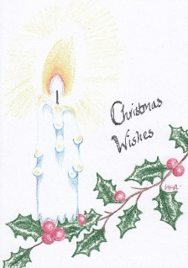

Common Worship: Services and Prayers for the Church of England, material from which is included in this service, is copyright © The Archbishops’ Council 2006 CCLi 1031266 All carols words and music: Public Domain

