
The Parish Church of St Mary the Virgin,

Great Shelford

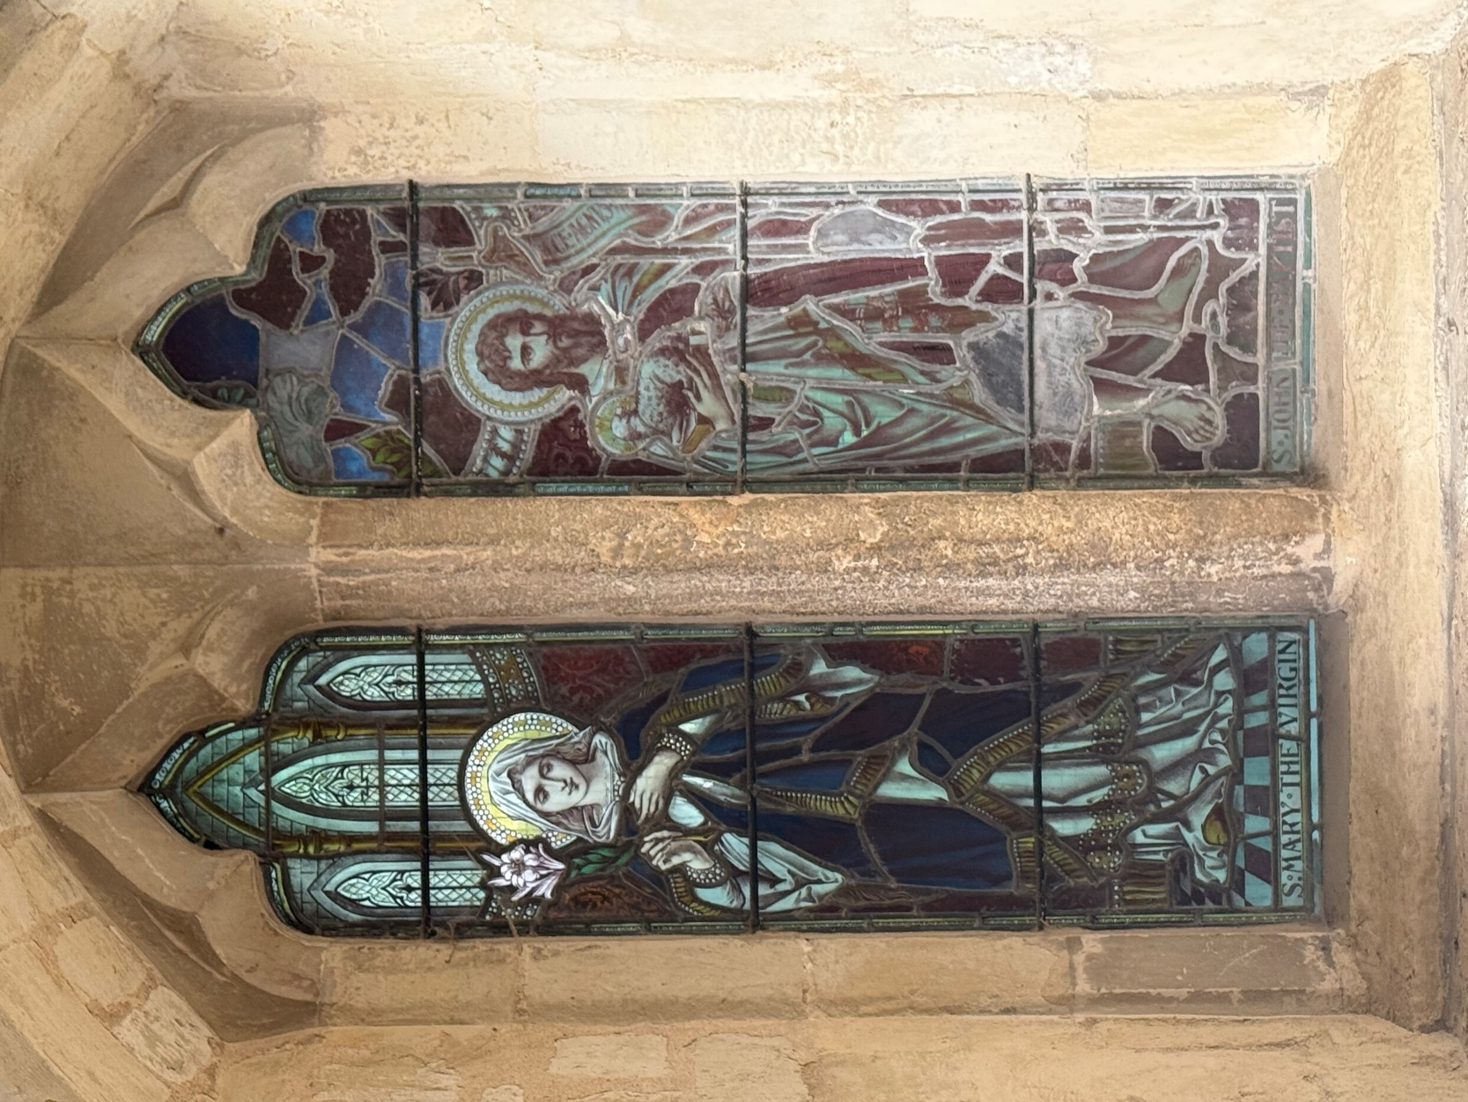

CHRISTMAS DAY FAMILY

PARISH COMMUNION

10AM

MERRY CHRISTMAS.

WELCOME TO ST MARY’S, AND TO THE SERVICE TODAY.

Please note that when asked to kneel or stand, you can do this in body or in heart. There are Gluten Free and wafers with wine added for those who need them, please ask at the altar.
If you would like to get to know us better, please talk to one of the clergy or Sidespersons. If you would like a clergy visit, please let us know.
There is a retiring collection today which will go to Christian Aid

Please stand as the choir and ministers process to the back.
THE GATHERING
CAROL
34 'Once in royal David's city '
Solo 1. Once in royal David's city
Stood a lowly cattle shed,
Where a mother laid her baby
In a manger for his bed:
Mary was that Mother mild,
Jesus Christ her little Child.
Choir 2. He came down to earth from heaven
Who is God and Lord of all,
And his shelter was a stable,
And his cradle was a stall:
With the poor and mean and lowly,
Lived on earth our Saviour holy.
All 3. And through all his wondrous childhood
Day by day like us he grew,
He was little, weak, and helpless,
Tears and smiles like us he knew:
And he feeleth for our sadness,
And he shareth in our gladness.

4. Not in that poor lowly stable,
With the oxen standing by,
We shall we see him: but in heaven,
Set at God's right hand on high,
Where like stars his children crowned,
All in white shall wait around.
Words C F Alexande.r Music IRBY
We remain standing as the President introduces the service.

THE GREETING

The president says
In the name of the Father, and of the Son,
and of the Holy Spirit.
All Amen.

The president greets the people

Grace, mercy and peace from God our Father
and the Lord Jesus Christ be with you
All and also with you.
LIGHTING OF THE CHRISTMAS CANDLE
All Lord Jesus, Light of light,
you have come among us.
Help us who live by your light
to shine as lights in your world.
Glory to God in the highest.

INVITATION TO CONFESSION
Please sit or kneel to pray
Hear the words of the angel to Joseph:
‘You shall call his name Jesus,
for he will save his people from their sins.’
Therefore let us seek the forgiveness of God
through Jesus the Saviour of the world. cf Matthew 1.21

All Most merciful God,
Father of our Lord Jesus Christ,
we confess that we have sinned in thought, word and deed.
We have not loved you with our whole heart.
We have not loved our neighbours as ourselves.
In your mercy forgive what we have been,
help us to amend what we are,
and direct what we shall be;
that we may do justly, love mercy,
and walk humbly with you, our God. Amen.
May the God of all healing and forgiveness
draw you to himself, and cleanse you from all your sins,
that you may behold the glory of his Son,
the Word made flesh, Jesus Christ our Lord.
All Amen.
WHAT IS SPECIAL ABOUT TODAY?

We remain standing to sing
GLORIA IN EXCELSIS
Glory to God, Glory to God, Glory to God in the Highest.
Glory to God in the Highest, and peace to his people on earth.
Lord God, Heav’nly King, Almighty God and Father,
We worship you, we give you thanks, we praise you for your glory.
Glory to God, Glory to God, Glory to God in the highest.
Lord, Jesus Christ, only son of the Father,
Lord God, Lamb of God, you take away the sin of the world,
have mercy on us:
You are seated at the right hand of the Father: receive our prayer.
Glory to God, Glory to God, Glory to God in the Highest.
For you alone are the Holy one, you alone are the Lord,
You alone are the most high, Jesus Christ, with the Holy Spirit,
In the glory of God the Father.
Glory to God, Glory to God, Glory to God in the Highest. David Thorne

THE COLLECT

The president introduces a period of silent prayer:
Let us pray in the peace of this Christmas celebration
that our joy in the birth of Christ will last for ever.

Lord Jesus Christ,
your birth at Bethlehem
draws us to kneel in wonder at heaven touching earth:
accept our heartfelt praise
as we worship you,
our Saviour and our eternal God.

THE LITURGY OF THE WORD

Please sit for the First Reading.
FIRST READING: Isaiah 9.2 and 6- 7
The people who walked in darkness have seen a great light;
those who lived in a land of deep darkness - on them light has shined.
For a child has been born for us, a son given to us; authority rests upon his shoulders; and he is named Wonderful Counsellor, Mighty God, Everlasting Father, Prince of Peace. His authority shall grow continually, and there shall be endless peace for the throne of David and his kingdom. He will establish and uphold it with justice and with righteousness from this time onwards and for evermore. The zeal of the Lord of hosts will do this.
This is the word of the Lord

All Thanks be to God
GRADUAL HYMN 42: ‘While shepherds watched their flocks by night’ (V2 left out)
Please Stand
- While shepherds watched their flocks by night,
All seated on the ground,
The angel of the Lord came down,
And glory shone around.
- 'To you in David's town this day
Is born of David's line
A Saviour, who is Christ the Lord;
And this shall be the sign:'
- 'The heavenly Babe you there shall find
To human view displayed,
All meanly wrapped in swathing bands,
And in a manger laid.'
- Thus spake the seraph; and forthwith
Appeared a shining throng
Of angels praising God, who thus
Addressed their joyful song:
- 'All glory be to God on high,
And on the earth be peace;
Good-will henceforth from heaven to men
Begin and never cease.' N Tate Tune: WINCHESTER OLD

GOSPEL READING: Luke 2. 8-10 and 15-20
Please remain standing and face the Gospel
Alleluia, alleluia.
The Word became flesh and dwelt among us,
and we have seen his glory. John 1:14
All Alleluia.
Hear the Gospel of our Lord Jesus Christ according to Luke
All Glory to you, O Lord.
In that region there were shepherds living in the fields, keeping watch over their flock by night. Then an angel of the Lord stood before them, and the glory of the Lord shone around them, and they were terrified. But the angel said to them, ‘Do not be afraid; for see—I am bringing you good news of great joy for all the people: to you is born this day in the city of David a Saviour, who is the Messiah, the Lord.
When the angels had left them and gone into heaven, the shepherds said to one another, ‘Let us go now to Bethlehem and see this thing that has taken place, which the Lord has made known to us.’ So they went with haste and found Mary and Joseph, and the child lying in the manger. When they saw this, they made known what had been told them about this child; and all who heard it were amazed at what the shepherds told them. But Mary treasured all these words and pondered them in her heart. The shepherds returned, glorifying and praising God for all they had heard and seen, as it
had been told them.
This is the Gospel of the Lord.
All Praise to you, O Christ.
Please be seated
SERMON
AFFIRMATION OF FAITH
Please stand
Let us declare our faith in God:
We believe in God the Father,
from whom every family in heaven and on earth is named.
We believe in God the Son,
who lives in our hearts through faith, and fills us with his love.
We believe in God the Holy Spirit,
who strengthens us with power from on high.
We believe in one God; Father, Son and Holy Spirit.
Amen.
PRAYERS OF INTERCESSION
Please sit or kneel to pray. The president says:
In the power of the Spirit and in union with Christ
let us pray to the Father.

At the end
Merciful Father,
All accept these prayers for the sake of your Son,
our Saviour Jesus Christ. Amen.

THE LITURGY OF THE SACRAMENT

THE PEACE

Please stand
Unto us a child is born, unto us a son is given,
and his name shall be called the Prince of Peace. Isaiah 9:6
The peace of the Lord be always with you
All and also with you.
Let us offer one another a sign of peace.

THE OFFERTORY HYMN
- In the bleak midwinter, Frosty wind made moan,
Earth stood hard as iron, Water like a stone:
Snow had fallen, snow on snow, Snow on snow,
In the bleak midwinter, Long ago.
- Our God, heaven cannot hold him, Nor earth sustain;
Heaven and earth shall flee away, When he comes to reign:
In the bleak midwinter A stable place sufficed
The Lord God Almighty, Jesus Christ.
- Angels and archangels, May have gathered there,
Cherubim and Seraphim Thronged the air
But only his mother In her maiden bliss
Worshipped the Beloved, With a kiss.
- What can I give him, Poor as I am?
If I were a shepherd I would bring a lamb;
If I were a wise man, I would do my part;
Yet what I can I give him, Give my heart.
Christina Rossetti. Tune Cranham (Holst)
Please remain standing

PRAYERS AT THE PREPARATION OF THE TABLE
Word made flesh, life of the world,
in your incarnation you embraced our poverty:
by your Spirit may we share in your riches.

THE EUCHARISTIC PRAYER

The Lord is here
All His Spirit is with us.

Lift up your hearts.
All We lift them to the Lord.

Let us give thanks to the Lord our God.
All It is right to give thanks and praise.

It is always right to give you thanks,
God our Creator, loving and faithful, holy and strong.
And now we give you thanks
because in coming to dwell among us,
he revealed the radiance of your glory
and brought us out of darkness into your own marvellous light.
And so we join the angels to celebrate and sing:
All Holy, holy, holy Lord, God of power and might,
Heaven and earth are full of your glory.
Hosanna, hosanna, hosanna in the highest.
Blessed is he who comes in the name of the Lord.
Hosanna, hosanna, hosanna in the highest. David Thorne
Please sit or kneel
Father, on the night before he died,
Jesus shared a meal with his friends.
He took the bread, and thanked you.
He broke it, and gave it to them, saying:
Take and eat; this is my body, given for you.
Do this to remember me.
After the meal, Jesus took the cup of wine.
He thanked you, and gave it to them, saying:
Drink this, all of you. This is my blood,
the new promise of God’s unfailing love. Do this to remember me.
Great is the mystery of faith:
All Christ has died:
Christ is risen:
Christ will come again.
Father, as we bring this bread and wine,
and remember his death and resurrection,
pour your Spirit on us that we may love one another,
work for the healing of the earth,
and share the good news of Jesus,
as we wait for his coming in glory.
For honour and praise belong to you, Father,
with Jesus your Son, and the Holy Spirit:
one God, for ever and ever.
All Amen.
THE LORD’S PRAYER
As our Saviour taught us, so we pray
All Our Father, who art in heaven, hallowed be thy name;
thy kingdom come; thy will be done,
on earth as it is in heaven.
Give us this day our daily bread.
And forgive us our trespasses,
as we forgive those who trespass against us.
And lead us not into temptation; but deliver us from evil.
For thine is the kingdom, the power and the glory,
for ever and ever. Amen.

THE BREAKING OF THE BREAD
The president breaks the consecrated bread
We break the bread of life, and that life is the light of the world.
All God here among us,
light in the midst of us,
bring us to light and life.

GIVING OF COMMUNION

All Draw near with faith.
Receive the body of our Lord Jesus Christ
which he gave for you, and his blood which he shed for you.
Eat and drink in remembrance that he died for you,
and feed on him in your hearts by faith with thanksgiving.

Agnus Dei
Lamb of God, you take away the sins of the world: have mercy on us.
Lamb of God, you take away the sins of the world: have mercy on us.
Lamb of God, you take away the sins of the world: grant us peace. David Thorne
If it is you practice to receive you are welcome to do so here. Gluten-free wafer is available. If, for any reason, you cannot take from the common cup, wafers with wine are available, but please do not dip. If you would like to receive a blessing, hold this booklet.

THE COMMUNION HYMN 22: Away in a manger
- Away in a manger, no crib for a bed,
The little Lord Jesus laid down his sweet head.
The stars in the bright sky looked down where he lay,
The little Lord Jesus asleep on the hay.
- The cattle are lowing, the baby awakes,
But little Lord Jesus no crying he makes.
I love thee, Lord Jesus! Look down from the sky,
And stay by my side until morning is nigh.
- Be near me, Lord Jesus; I ask thee to stay
Close by me for ever, and love me, I pray.
Bless all the dear children in they tender care,
And fit us for heaven, to live with thee there.
Attributed to Martin Luther. Tune: CRADLE SONG
PRAYER AFTER COMMUNION
God our Father,
whose Word has come among us in the Holy Child of Bethlehem: may the light of faith illumine our hearts
and shine in our words and deeds;
through him who is Christ the Lord. Amen
All Almighty God,
we thank you for feeding us
with the body and blood of your Son Jesus Christ.
Through him we offer you our souls and bodies
to be a living sacrifice.
Send us out in the power of your Spirit
to live and work to your praise and glory.
Amen.

THE RECESSIONAL HYMN – 26: Hark! the herald angels sing

- Hark! the herald angels sing
Glory to the new-born King;
Peace on earth and mercy mild,
God and sinners reconciled:
Joyful all ye nations rise,
Join the triumph of the skies,
With the angelic host proclaim,
Christ is born in Bethlehem:
Refrain: Hark! the herald angels sing
Glory to the new-born King.
- Christ, by highest heaven adored,
Christ, the everlasting Lord,
Late in time behold him come
Offspring of a Virgin's womb!
Veiled in flesh the Godhead see,
Hail the incarnate Deity!
Pleased as man with man to dwell,
Jesus, our Emmanuel: Refrain

- Hail the heaven-born Prince of peace!
Hail the Sun of Righteousness!
Light and life to all he brings,
Risen with healing in his wings;
Mild he lays his glory by,
Born that man no more may die,
Born to raise the sons of earth,
Born to give them second birth: Refrain
Charles Wesley 1707-88 and others, Alterer: George Whitefield
Tune: MENDELSSOHN (51171)

THE DISMISSAL
THE BLESSING
May the joy of the angels,
the eagerness of the shepherds,
the perseverance of the wise men,
the obedience of Joseph and Mary,
and the peace of the Christ-child
be yours this Christmas;
And the blessing of God Almighty,
the Father, the Son and the Holy Spirit,
be among you, and remain with you always.
All Amen.

Go in peace to love and serve the Lord.

All In the name of Christ. Amen.

Merry Christmas
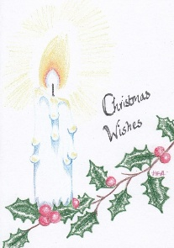

Common Worship ‘Times and Season’s and ‘Services and Prayers for the Church of England’, ©
The Archbishops’ Council 2000, 2012 Church Publishing House CCLi 1031266 All carols words
and music Public Domain

