
Parish of St Mary the Virgin,
Great Shelford

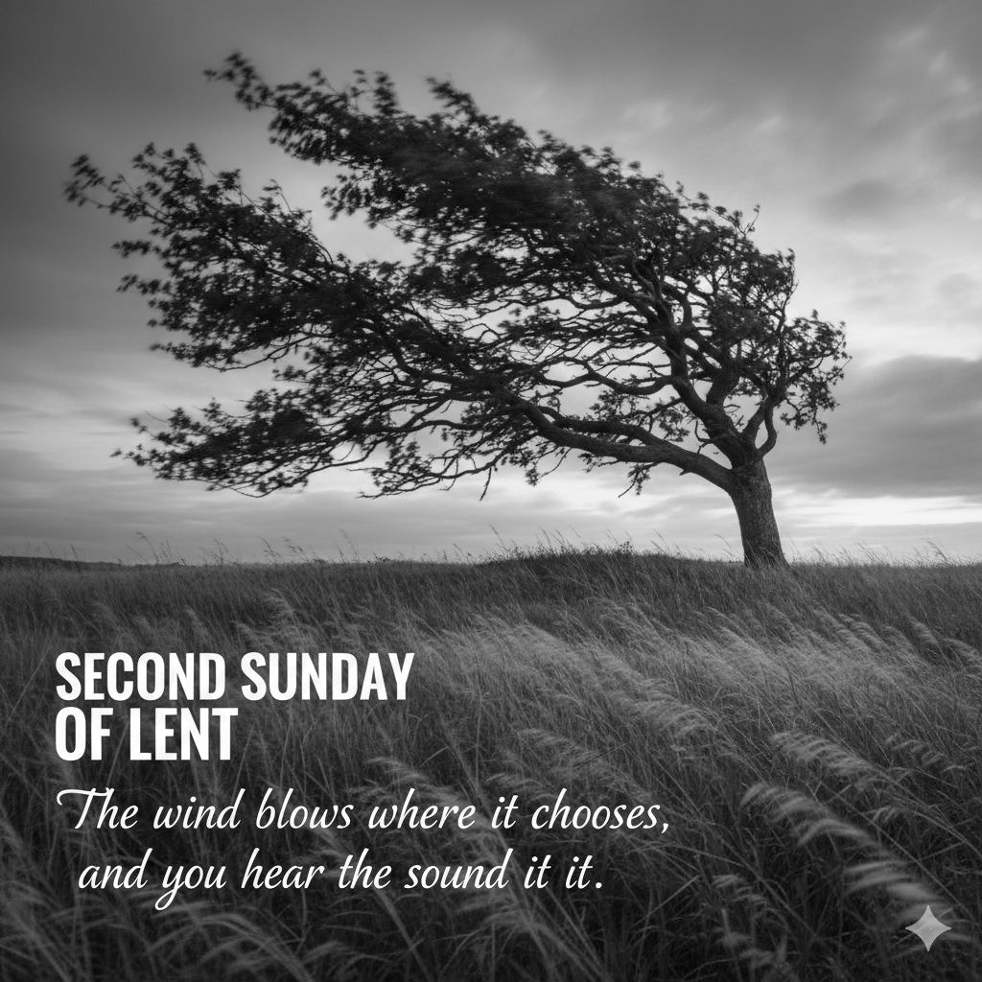

Parish Communion
1 March 2026
10am

WELCOME TO ST MARY’S

We are very pleased you are joining us today.

Instructions to stand, sit or kneel during the service can be followed in body or heart.

If you have any special requirements please talk to one of the clergy or Sidespersons.
THE GATHERING
Welcome to St Mary’s, and to the service today.
Please note, if asked to kneel or stand, you can do this in body or in heart.

Please stand to sing
THE OPENING HYMN 238 ‘New every morning is the love’
- New every morning is the love
Our wakening and uprising prove;
Through sleep and darkness safely brought,
Restored to life, and power, and thought.
- New mercies, each returning day,
Hover around us while we pray;
New perils past, new sins forgiven,
New thoughts of God, new hopes of heaven.
- If on our daily course our mind
Be set to hallow all we find,
New treasures still, of countless price,
God will provide for sacrifice.
- The trivial round, the common task,
Would furnish all we ought to ask,
Room to deny ourselves, a road
To bring us daily nearer God.
- Only, O Lord, in thy dear love
Fit us for perfect rest above;
And help us this and every day
To live more nearly as we pray. Words John Keble.Tune MELCOMBE

The president says
In the name of the Father, and of the Son,
and of the Holy Spirit.
All Amen.
The president greets the people

Grace, mercy and peace from God our Father
and the Lord Jesus Christ be with you
All and also with you.

PRAYER OF PREPARATION
All Almighty God,
to whom all hearts are open,
all desires known,
and from whom no secrets are hidden:
cleanse the thoughts of our hearts
by the inspiration of your Holy Spirit,
that we may perfectly love you,
and worthily magnify your holy name;
through Christ our Lord. Amen.

INVITATION TO CONFESSION
Please sit or kneel to pray
  - The sacrifice of God is a broken spirit;
  - a broken and contrite heart God will not despise.
  - Let us come to the Lord, who is full of compassion,
  - and acknowledge our transgressions in penitence and faith. cf Psalm 51.17
All Lord God,
we have sinned against you; we have done evil in your sight.
We are sorry and repent.
Have mercy on us according to your love.
Wash away our wrongdoing and cleanse us from our sin.
Renew a right spirit within us
and restore us to the joy of your salvation,
through Jesus Christ our Lord. Amen.
May the Father of all mercies cleanse you from your sins
and restore you in his image to the praise and glory of his name,
through Jesus Christ our Lord. Amen.
All Amen.
We stand and pray together as the children prepare to leave for their activities
All Creator God, we thank you for giving us Jesus as our Saviour:
he blessed the children who came to him
and welcomes those who come to him now.
Look with love upon these children and protect them with your care. May they grow in wisdom, age and strength
in your presence and in the sight of all.
We ask this through your beloved Son, Jesus Christ our Lord. Amen.

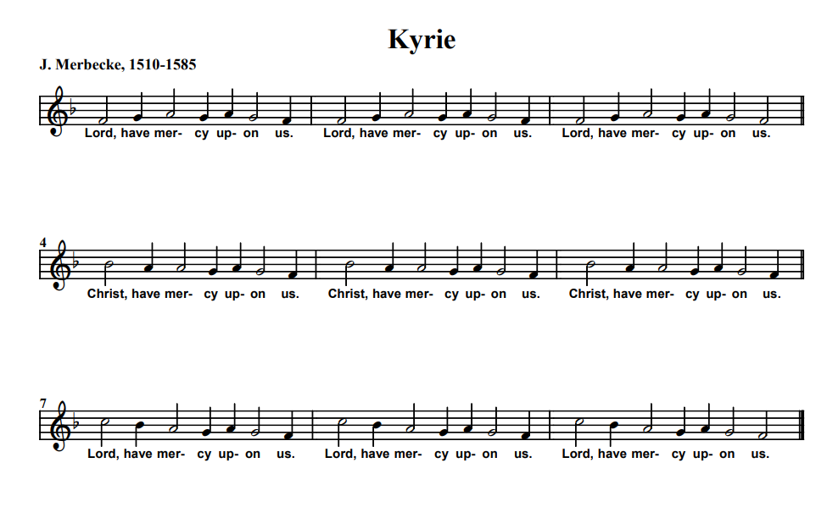

We stand to sing the Kyrie,

KYRIE

Lord have mercy upon us,

Lord have mercy upon us,

Lord have mercy upon us.

Christ have mercy upon us,

Christ have mercy upon us,

Christ have mercy upon us.

Lord have mercy upon us,

Lord have mercy upon us,

Lord have mercy upon us.

THE COLLECT
The president introduces a period of silent prayer
All Almighty God,
you show to those who are in error the light of your truth,
that they may return to the way of righteousness:
grant to all those who are admitted
into the fellowship of Christ’s religion,
that they may reject those things
that are contrary to their profession,
and follow all such things as are agreeable to the same;
through our Lord Jesus Christ,
who is alive and reigns with you,
in the unity of the Holy Spirit,
one God, now and for ever. Amen

Please sit for the first two readings

THE LITURGY OF THE WORD

FIRST READING Genesis 12 1-4a
12 Now the Lord said to Abram, ‘Go from your country and your kindred and your father’s house to the land that I will show you. I will make of you a great nation, and I will bless you, and make your name great, so that you will be a blessing. I will bless those who bless you, and the one who curses you I will curse; and in you all the families of the earth shall be blessed.’
So Abram went, as the Lord had told him; and Lot went with him. Abram was seventy-five years old when he departed from Haran.
This is the word of the Lord
All Thanks be to God

SECOND READING Romans 4.1–5, 13–17
What then are we to say was gained by Abraham, our ancestor according to the flesh? For if Abraham was justified by works, he has something to boast about, but not before God. For what does the scripture say? ‘Abraham believed God, and it was reckoned to him as righteousness.’ Now to one who works, wages are not reckoned as a gift but as something due. But to one who without works trusts him who justifies the ungodly, such faith is reckoned as righteousness.
For the promise that he would inherit the world did not come to Abraham or to his descendants through the law but through the righteousness of faith. If it is the adherents of the law who are to be the heirs, faith is null and the promise is void. For the law brings wrath; but where there is no law, neither is there violation.

For this reason it depends on faith, in order that the promise may rest on grace and be guaranteed to all his descendants, not only to the adherents of the law but also to those who share the faith of Abraham (for he is the father of all of us, as it is written, ‘I have made you the father of many nations’)—in the presence of the God in whom he believed, who gives life to the dead and calls into existence the things that do not exist.

This is the word of the Lord

All Thanks be to God

Short silence. Please stand to sing
THE GRADUAL HYMN Psalm 121
- I to the hills will lift mine eyes,
from whence doth come mine aid.
My safety cometh from the Lord,
who heav'n and earth hath made.
Thy foot he'll not let slide, nor will
he slumber that thee keeps.
Behold, he that keeps Israel,
he slumbers not, nor sleeps.
- The Lord thee keeps, the Lord thy shade
on thy right hand doth stay:
The moon by night thee shall not smite,
nor yet the sun by day.
The Lord shall keep thy soul; he shall
preserve thee from all ill.
Henceforth thy going out and in
God keep for ever will.
Tune DUNDEE

Please stand for the Gospel
GOSPEL READING John 3. 1-17
The Holy Gospel is written in the third chapter of Gospel according to St John beginning reading at the first verse.
All Glory to you O Lord.

Now there was a Pharisee named Nicodemus, a leader of the Jews. He came to Jesus by night and said to him, ‘Rabbi, we know that you are a teacher who has come from God; for no one can do these signs that you do apart from the presence of God.’ Jesus answered him, ‘Very truly, I tell you, no one can see the kingdom of God without being born from above.’ Nicodemus said to him, ‘How can anyone be born after having grown old? Can one enter a second time into the mother’s womb and be born?’ Jesus answered, ‘Very truly, I tell you, no one can enter the kingdom of God without being born of water and Spirit. What is born of the flesh is flesh, and what is born of the Spirit is spirit. Do not be astonished that I said to you, “You must be born from above.” The wind blows where it chooses, and you hear the sound of it, but you do not know where it comes from or where it goes. So it is with everyone who is born of the Spirit.’ Nicodemus said to him, ‘How can these things be?’ Jesus answered him, ‘Are you a teacher of Israel, and yet you do not understand these things?
Very truly, I tell you, we speak of what we know and testify to what we have seen; yet you do not receive our testimony. If I have told you about earthly things and you do not believe, how can you believe if I tell you about heavenly things? No one has ascended into heaven except the one who descended from heaven, the Son of Man. And just as Moses lifted up the serpent in the wilderness, so must the Son of Man be lifted up, that whoever believes in him may have eternal life.
For God so loved the world that he gave his only Son, so that everyone who believes in him may not perish but may have eternal life.
Indeed, God did not send the Son into the world to condemn the world, but in order that the world might be saved through him.
This is the Gospel of the Lord.
All Praise to you, O Christ.
Please be seated
SERMON
Short silence

PRAYERS OF INTERCESSION
Please sit or kneel to pray. The president says:
In the power of the Spirit and in union with Christ
let us pray to the Father.

At the end
Merciful Father,
All accept these prayers for the sake of your Son,
our Saviour Jesus Christ. Amen.

THE LITURGY OF THE SACRAMENT

THE PEACE

Please stand
Since we are justified by faith,
we have peace with God through our Lord Jesus Christ,
who has given us access to his grace. Romans 5.1,2
The peace of the Lord be always with you
All and also with you.
Let us offer one another a sign of peace.
OFFERTORY CREEDAL HYMN
During the hymn, the gifts of the people are gathered and presented.

The gifts of bread and wine and our offerings will be brought to the altar
- We believe in God the Father,
God Almighty, by whose plan
Earth and Heaven sprang into being,
All created things began.
We believe in Christ the Saviour,
Son of God in human frame,
Virgin born, the Child of Mary,
Upon whom the Spirit came.
- Christ, who on the cross forsaken,
Like a lamb to slaughter led,
Suffered under Pontius Pilate,
He descended to the dead.
We believe in Jesus risen,
Heaven’s King to rule and reign,
To the Father’s side ascended
Till as Judge He comes again.
- We believe in God the Spirit:
In one Church, below, above;
Saints of God in one communion,
One in holiness and love.
So by faith, our sins forgiven,
Christ our Saviour, Lord and friend,
We shall rise with Him in glory
To the life that knows no end. T Dudley-Smith. Tune.BLAENWERN
Please remain standing
PRAYERS AT THE PREPARATION OF THE TABLE
God of wisdom,
may the light of your eternal Word, our Lord and Saviour Jesus Christ,
lead us in holiness and guide us to glory; we ask this in his name.
All Amen.

THE EUCHARISTIC PRAYER
The Lord is here
All His Spirit is with us.
Lift up your hearts.
All We lift them to the Lord.
Let us give thanks to the Lord our God.
All It is right to give thanks and praise.
It is indeed right,
it is our duty and our joy,
at all times and in all places
to give you thanks and praise,
holy Father, heavenly King,
almighty and eternal God,
through Jesus Christ your Son our Lord.
And now we give you thanks
because you give us the spirit of discipline,
that we may triumph over evil and grow in grace,
as we prepare to celebrate the paschal mystery
with mind and heart renewed.
Therefore with all the angels of heaven
we lift our voices to proclaim the glory of your name
and sing our joyful hymn of praise:

THE SANCTUS/BENEDICTUS J Merbecke
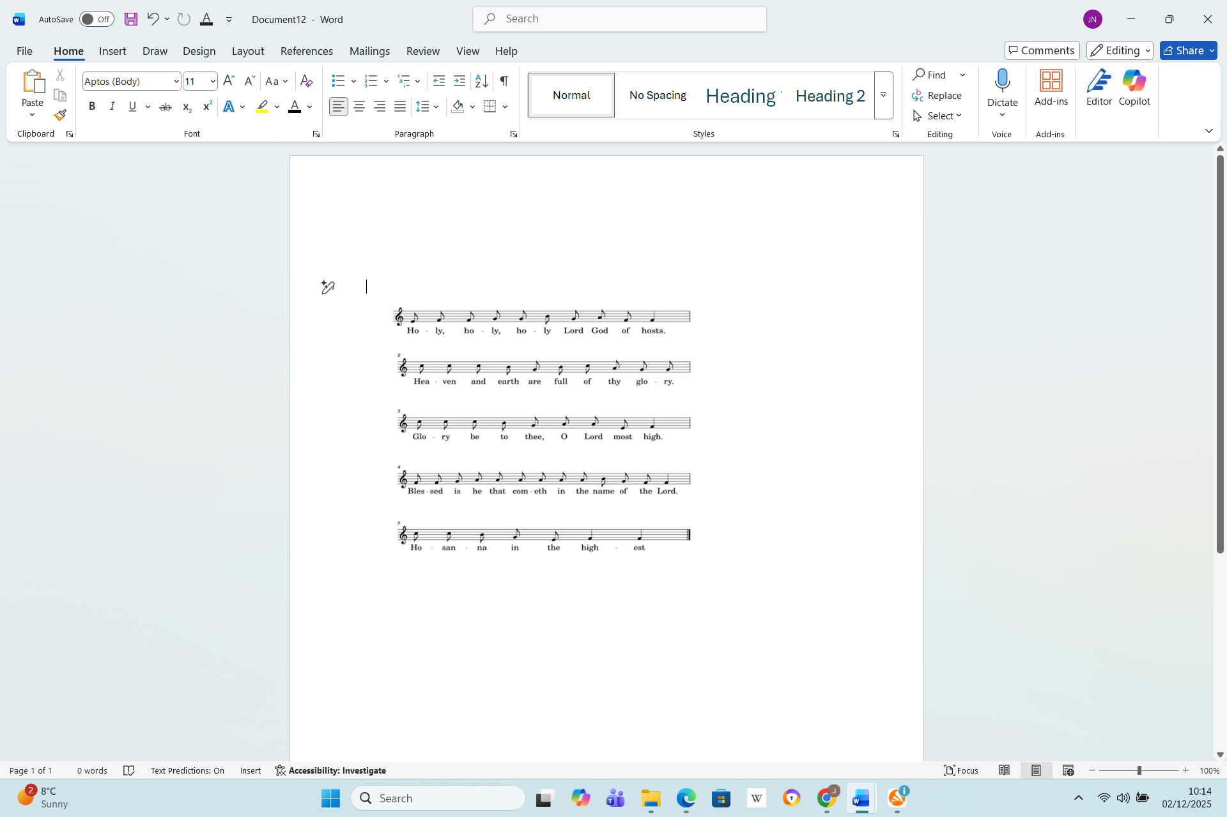
Holy, holy, holy, Lord God of hosts.
Heaven and earth are full of thy glory.
Glory be to thee, O Lord most high.
Blessed is he that cometh
in the name of the Lord.
Hosanna in the highest.

Please sit or kneel
Accept our praises, heavenly Father,
through your Son our Saviour Jesus Christ,
and as we follow his example and obey his command,
grant that by the power of your Holy Spirit
these gifts of bread and wine
may be to us his body and his blood;
who, in the same night that he was betrayed,
took bread and gave you thanks;
he broke it and gave it to his disciples, saying:
Take, eat; this is my body which is given for you;
do this in remembrance of me.
In the same way, after supper he took the cup and gave you thanks;
he gave it to them, saying: Drink this, all of you;
this is my blood of the new covenant,
which is shed for you and for many for the forgiveness of sins.
Do this, as often as you drink it, in remembrance of me.
Therefore, heavenly Father,
we remember his offering of himself
made once for all upon the cross;
we proclaim his mighty resurrection and glorious ascension;
we look for the coming of your kingdom,
and with this bread and this cup
we make the memorial of Christ your Son our Lord.
Praise to you, Lord Jesus:
All Dying you destroyed our death,
rising you restored our life:
Lord Jesus, come in glory.
Accept through him, our great high priest,
this our sacrifice of thanks and praise,
and as we eat and drink these holy gifts
in the presence of your divine majesty,
renew us by your Spirit, inspire us with your love
and unite us in the body of your Son,
Jesus Christ our Lord.
Through him, and with him, and in him,
in the unity of the Holy Spirit,
with all who stand before you in earth and heaven,
we worship you, Father almighty,
in songs of everlasting praise:
All Blessing and honour and glory and power
be yours for ever and ever.
Amen.
THE LORD’S PRAYER
As our Saviour taught us, so we pray
All Our Father, who art in heaven, hallowed be thy name;
thy kingdom come; thy will be done, on earth as it is in heaven.
Give us this day our daily bread.
And forgive us our trespasses,
as we forgive those who trespass against us.
And lead us not into temptation; but deliver us from evil.
For thine is the kingdom, the power and the glory,
for ever and ever. Amen.

THE BREAKING OF THE BREAD
The president breaks the consecrated bread
We break the bread of life,
and that life is the light of the world.
All God here among us,
light in the midst of us,
bring us to light and life.

GIVING OF COMMUNION

Draw near with faith.
Receive the body of our Lord Jesus Christ
which he gave for you,
and his blood which he shed for you.
Eat and drink in remembrance that he died for you,
and feed on him in your hearts
by faith with thanksgiving.

AGNUS DEI
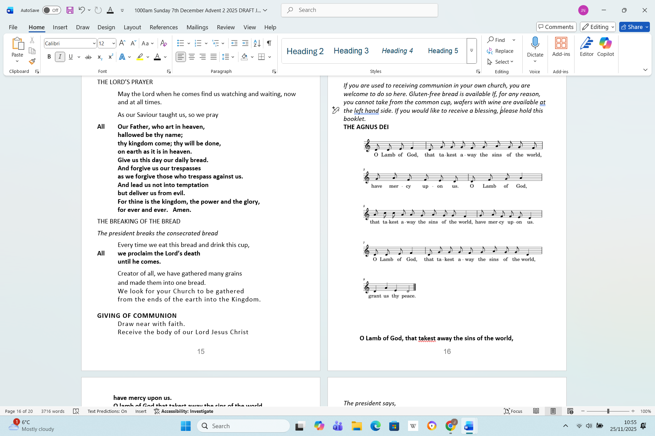
O Lamb of God, that takest away the sins of the world, have mercy upon us.
O lamb of God that takest away the sins of the world have mercy upon us’
O Lamb of God, that takest away the sins of the world, grant us thy peace.
THE COMMUNION

You are welcome to receive if this is your practice. If you prefer to receive a blessing please carry this booklet to the Altar Rail. If you wish to receive Gluten Free, or wafers with wine already added please ask at the altar. Please do not dip.

COMMUNION HYMN ‘339 Be thou my vision’
- Be thou my vision, O Lord of my heart,
Be all else but naught to me, save that thou art,
Be thou my best thought in the day and the night,
Both waking and sleeping, thy presence my light.
- Be thou my wisdom, be thou my true word
Be thou ever with me, and I with thee, Lord,
Be thou my great Father, and I thy true son,
Be thou in me dwelling, and I with thee one.
- Be thou my breastplate, my sword for the fight,
Be thou my whole armour, be thou my true might,
Be thou my soul’s shelter, be thou my strong tower,
O raise thou me heavenward, great Power of my power.
- Riches I heed not, nor man’s empty praise,
Be thou my inheritance now and always,
Be thou and thou only the first in my heart,
O Sovereign of heaven, my treasure thou art.
- High King of heaven, thou heaven's bright Sun,
O grant me its joys after vict'ry is won,
Great Heart of my own heart, whatever befall,
Still be thou my vision, O Ruler of all. Mary Byrrne. Tune SLANE (Hull)
PRAYER AFTER COMMUNION
Almighty God,
you see that we have no power of ourselves to help ourselves:
keep us both outwardly in our bodies,
and inwardly in our souls;
that we may be defended from all adversities
which may happen to the body,
and from all evil thoughts which may assault and hurt the soul;
through Jesus Christ our Lord.
Amen
All Almighty God,
we thank you for feeding us
with the body and blood of your Son Jesus Christ.
Through him we offer you our souls and bodies
to be a living sacrifice.
Send us out in the power of your Spirit
to live and work to your praise and glory. Amen.
NOTICES AND SUNDAY CLUB FEEDBACK
Please stand to sing the hymn.
THE RECESSIONAL HYMN 420 ‘O Jesus I have promised’
- O Jesus, I have promised
To serve thee to the end;
Be thou for ever near me,
My Master and my Friend;
I shall not fear the battle
If thou art by my side,
Nor wander from the pathway
If thou wilt be my guide.
- O let me hear thee speaking
In accents clear and still,
Above the storms of passion,
The murmurs of self-will;
O speak to reassure me,
To hasten or control;
O speak, and make me listen,
Thou guardian of my soul.
- O Jesus, thou hast promised
To all who follow thee,
That where thou art in glory
There shall thy servant be;
And Jesus, I have promised
To serve Thee to the end;
O give me grace to follow,
My Master and my Friend.
- O let me see thy footmarks,
And in them plant mine own;
My hope to follow duly
Is in thy strength alone;
O guide me, call me, draw me,
Uphold me to the end;
And then in heaven receive me,
My Saviour and my Friend. Words John Bode - Tune WOLVERCOTE

THE BLESSING
Christ give you grace to grow in holiness,
to deny yourselves, take up your cross, and follow him;
And the blessing of God Almighty,
the Father, the Son and the Holy Spirit,
be among you and remain with you always.
All Amen.
Go in peace to love and serve the Lord.

All In the name of Christ. Amen.

You are warmly invited to join us for refreshments after the service

Common Worship: Times and Seasons, material from which is included here,
is copyright © The Archbishops' Council 2006 and published by Church House Publishing:’

