ST. MARY'S GREAT SHELFORD NEWSLETTER
FOR W/C 15 MARCH MOTHERING SUNDAY – FOURTH OF LENT
Website link: http://www.stmarysgreatshelford.org



Welcome to St Mary’s Church
We are pleased that you are able to join us for our services
THOUGHT FOR THE WEEK
We thank you dear Lord especially today………………………………………………… for mothers and for the joy
which with their children they bring to family life. Thank you for their care and concern and the pains
they have borne for us. Be near to families who are sad because they have no children or are far
apart from those they love. May your love be present in every home. Amen David Peacock
Christian Aid giving for Lent
The Lent lunch on 6 March raised £151, plus £10 gift Aid £161. Thank you. David Peacock

STILL COMING UP FOR TODAY- 15 MARCH
11.15am YOUNG PILGRIM GROUP at the back of Church.
6.30pm EWORSHIP Rev Julie is leading this service https://us02web.zoom.us/j/84419975705?pwd=MkU5MEFXTGxWM1U3aUZBWXdGNFJWQT09
Meeting ID: 844 1997 5705 Passcode: STMARY
22 MARCH – FIFTH OF LENT PASSIONTIDE BEGINS
8am HOLY COMMUNION (BCP)
10am PARISH COMMUNION
11.15am FINAL CONFIRMATION SESSION FOR YOUNG PEOPLE at the back of Church. Looking at CONFIRMATION.
5pm EVENSONG Rev Prof A Coles is guest preacher
6.30pm EWORSHIP by The Eteam Time: Meeting ID: 590 692 0741 Passcode: 676561
https://us02web.zoom.us/j/5906920741?pwd=dTJIdDBHV2REZFNlc0hLeEhLRGdlQT09

EVENTS CALENDAR - COMING UP SOON

21 MARCH EASTER CRAFT MORNING FOR CHILDREN AND FAMILIES
10-12.30PM.
Come along for lots of Lent and Easter activities.

MONDAY 16 MARCH
8.30am MORNING PRAYER meeting in the Chancel
2pm PILGRIM GROUP MONDAY 16 MARCH - "I thirst.": (John 19:28). See below. We meet at the home of Norma Coggins.
WEDNESDAY 18 MARCH
7pm PCC Meeting in the Vicarage
THURSDAY 19 MARCH
8.30am MORNING PRAYER meeting in the Chancel
9.30am MORNING COLLECTIVE WORSHIP A St Mary’s Team are in School
11.00am HOLY COMMUNION IN THE CAMBRIDGSHIRE CARE HOME. A team from St Mary’s will take a service in the home. Family and friends are welcome to join us.
12.30pm FINAL ADULT CONFIRMATION PREPARATION in the Vicarage.
7pm “Where is God on the streets?” Chris Jenkin See Below
FRIDAY 20 MARCH
12 – 1.30PM LENT LUNCH at Johnson Hall, STAPLEFORD
SATURDAY 21 MARCH
10 – 12.30 EASTER CRAFT MORNING in St Mary’s Community Room as above.
LENT LUNCHES
FRIDAY 20 MARCH in the Johnson Hall, Stapleford. 12 to 1.30pm
MONDAY 23 MARCH at the Free Church – Charity Centre of Hope https://centreofhope.org.uk/wp/
LENT TALKS
‘Where is God’
7pm St Mary Church
THURSDAY 19 MARCH “Where is God on the streets?” Chris Jenkin Founder of It Takes A City, CCHP and
Cambridge Street Pastors
THURSDAY 26 MARCH “Where is God in conflict?” Ruth Adams Bishop’s Adviser for Resilience in Conflict
Come to enjoy an interesting talk and discussion
LENT STUDY
During Lent there is an opportunity to study together. This will take place at THE PILGRIM GROUP at 2pm on Monday afternoons at the home of Norma Coggins. We are drawing on the book By Paul Dominiak which focuses on the seven last words of Jesus. It is called ‘The Falling Dusk’. We welcome those who want to just come for Lent.
MONDAY 16 MARCH - "I thirst.": (John 19:28). Christ’s experience of physical need resonates with suffering of others across the world, and may also point to our own need for God.
MONDAY 23 MARCH – “It is finished” and “Father, into your hands I commend my spirit.": (Luke 23:46). This is Jesus’ final prayer of dedication and trust before he dies. What does it mean for us?

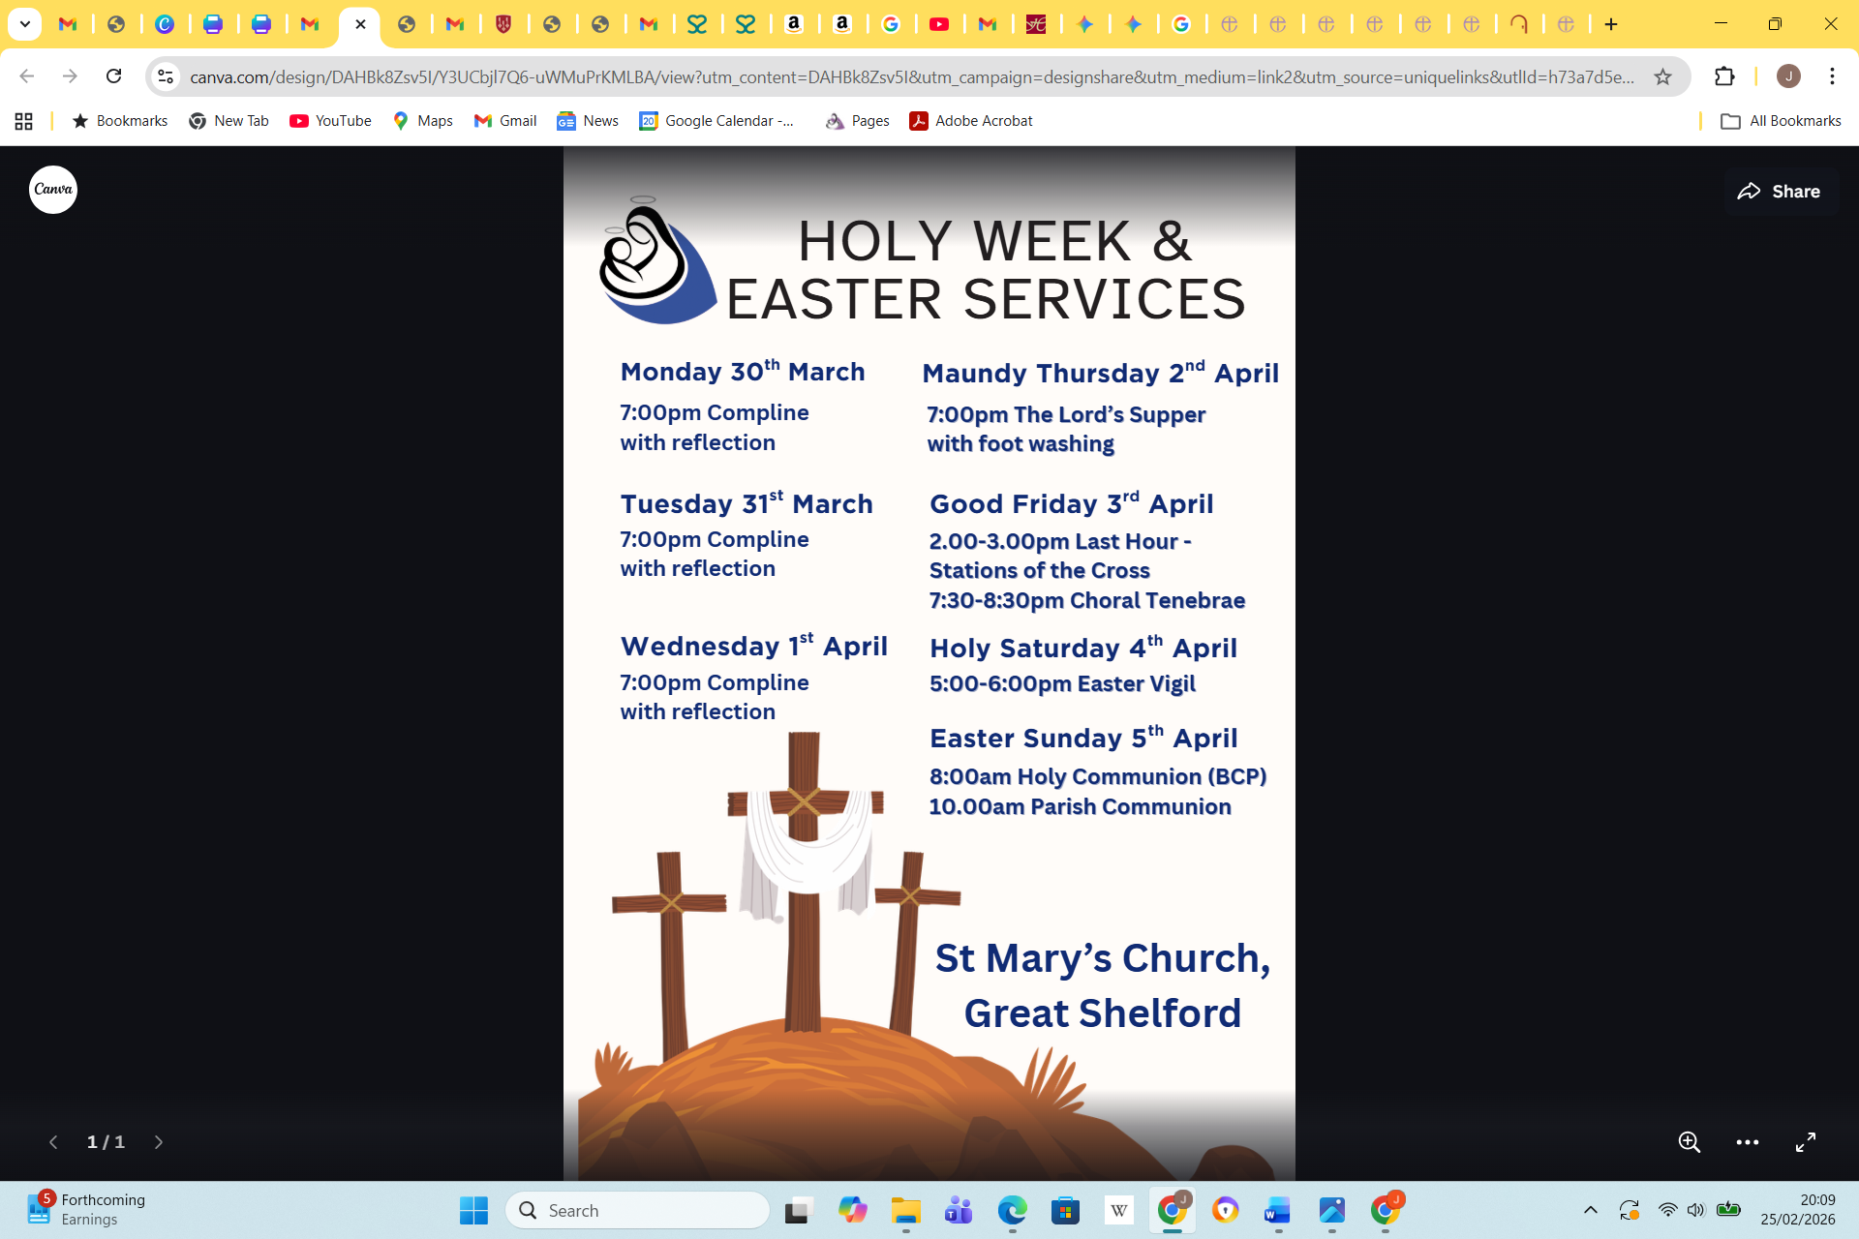

CONTACTS
Vicar The Rev Canon Dr Julie Norris Revjulienorris@gmail.com Tel: 07771 984699
Associate Priest Fr Edward Westrip TSSF edward.westrip@btinternet.com Tel: 07858 461872
Assistant Curates The Rev Chris Shore revchrisshore@outlook.com Tel: 07491 601655
The Rev Dr Sarah West revsarah@stmarysgreatshelford.org Tel: 07365 298174
Churchwardens Mrs Helen Clarke-Hill churchwarden@stmarysgreatshelford.org Tel: 07761 483203
Mr Kim Lane kimberley.lane@ntlworld.com Tel: 07825 769779
ALM Children’s and families Mrs Gillian Pett gillian.pett29@gmail.com
ALM Pastoral Assistant Mrs Davina Shore (contact Ministry Team)
Pastoral Co-Ordinator Mrs. Frances Simms francesjsimms47@gmail.com Tel: 01223 845895
Parish Website Administrator Mr David Wilding wildingdavid1@gmail.com
Website manager Mr David Peacock dkp5506@yahoo.com

