
Parish of St Mary the Virgin,
Great Shelford

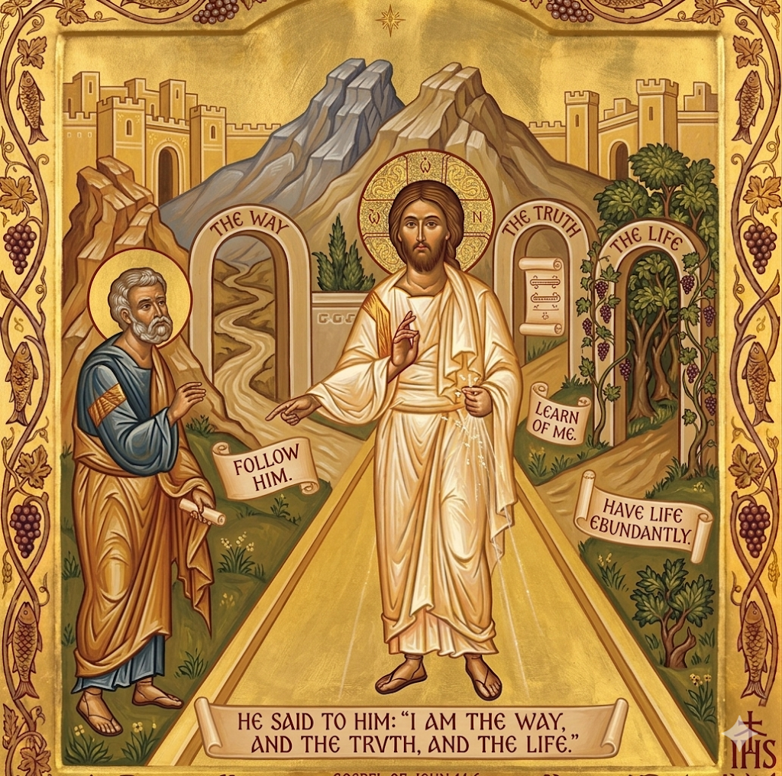

Parish Communion
FIFTH SUNDAY OF EASTER
3 May 2026
10am

WELCOME TO ST MARY’S

We are very pleased you are joining us today. Instructions to stand, sit or kneel during the service can be followed in body or heart. Please stand to sing the first hymn.
THE OPENING HYMN 205 ‘Christ is made the sure foundation’
- Christ is made the sure foundation,
And the precious corner-stone,
Who, the two walls underlying,
Bound in each, binds both in one,
Holy Sion's help for ever,
and our confidence alone.
- All that dedicated city,
Dearly loved by God on high,
In exultant jubilation
Pours perpetual melody,
God the One, in Threefold glory,
Singing everlastingly.
- To this temple, where we call thee,
Come, O Lord of hosts, today;
With thy wonted loving-kindness,
Hear thy people as they pray;
And thy fullest benediction
Shed within its walls for ay.
- Here vouchsafe to all thy servants
Gifts of grace by prayer to gain;
Here to have and hold for ever,
Those good things their prayers obtain,
And hereafter, in thy glory,
With thy blessèd ones to reign.
- Laud and honour to the Father,
Laud and honour to the Son,
Laud and honour to the Spirit,
Ever Three and ever One,
One in love, and One in splendour,
While unending ages run. Amen. J M Neale. Tune WESTMINSTER ABBEY
The president says
In the name of the Father, and of the Son,
and of the Holy Spirit.
All Amen.
The president greets the people

Grace, mercy and peace from God our Father
and the Lord Jesus Christ be with you
All and also with you.

PRAYER OF PREPARATION
All Almighty God,
to whom all hearts are open,
all desires known,
and from whom no secrets are hidden:
cleanse the thoughts of our hearts
by the inspiration of your Holy Spirit,
that we may perfectly love you,
and worthily magnify your holy name;
through Christ our Lord. Amen.

INVITATION TO CONFESSION
Please sit or kneel to pray

Christ died to sin once for all, and now he lives to God.

Let us confess our sins in penitence and faith. (cf Romans 6:10)
All Lord God,
we have sinned against you;
we have done evil in your sight.
We are sorry and repent.
Have mercy on us according to your love.
Wash away our wrongdoing and cleanse us from our sin.
Renew a right spirit within us and restore us to the joy of your salvation, through Jesus Christ our Lord. Amen.
May the Father of all mercies cleanse you from your sins
and restore you in his image to the praise and glory of his name,
through Jesus Christ our Lord. Amen.
All Amen.
We stand and pray together as the children prepare to leave for their activities
All Creator God, we thank you for giving us Jesus as our Saviour:
he blessed the children who came to him and welcomes those who come to him now. Look with love upon these children and protect them with your care. May they grow in wisdom, age and strength
in your presence and in the sight of all. We ask this through your beloved Son, Jesus Christ our Lord. Amen.
GLORIA IN EXCELSIS J Merbecke
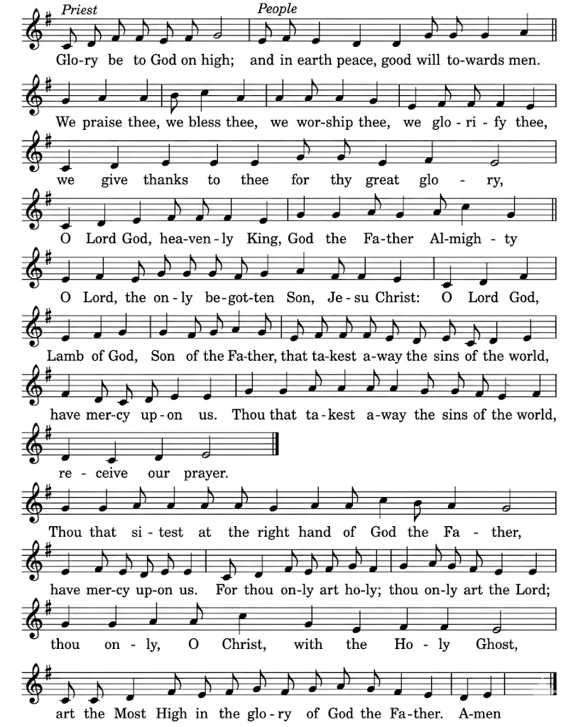

Glory be to God on high,
and in earth peace, goodwill towards men.
We praise thee, we bless thee, we worship thee, we glorify thee.
We give thanks to thee for they great glory,
O Lord God, heavenly King, God the Father almighty.
O Lord the only begotten Son, Jesu Christ;
O Lord God Lamb of God, Son of the Father,
that takest away the sins of the world, have mercy upon us.
Thou that takest away the sins of the world, receive our prayer.
Thou that sittest at the right hand of God the Father, have mercy upon us.
For thou only art holy, thou only art the Lord;
Thou only, O Christ, with the Holy Ghost, art the Most High
in the glory of God the Father. Amen.
THE COLLECT
All Almighty God,
who through your only-begotten Son Jesus Christ
have overcome death and opened to us the gate of everlasting life:
grant that, as by your grace going before us
you put into our minds good desires,
so by your continual help, we may bring them to good effect;
through Jesus Christ our risen Lord, who is alive and reigns with you,
in the unity of the Holy Spirit, one God, now and for ever. Amen

Please sit for the first two readings

THE LITURGY OF THE WORD

FIRST READING Genesis 8. 1-19
God remembered Noah and all the wild animals and all the domestic animals that were with him in the ark. And God made a wind blow over the earth, and the waters subsided; the fountains of the deep and the windows of the heavens were closed, the rain from the heavens was restrained, and the waters gradually receded from the earth. At the end of one hundred and fifty days the waters had abated; and in the seventh month, on the seventeenth day of the month, the ark came to rest on the mountains of Ararat. The waters continued to abate until the tenth month; in the tenth month, on the first day of the month, the tops of the mountains appeared.
At the end of forty days Noah opened the window of the ark that he had made and
sent out the raven; and it went to and fro until the waters were dried up from the
earth. Then he sent out the dove from him, to see if the waters had subsided from the face of the ground; but the dove found no place to set its foot, and it returned to him to the ark, for the waters were still on the face of the whole earth. So he put out his hand and took it and brought it into the ark with him. He waited another seven days, and again he sent out the dove from the ark; and the dove came back to him in the evening, and there in its beak was a freshly plucked olive leaf; so Noah knew that the waters had subsided from the earth. Then he waited another seven days, and sent out the dove; and it did not return to him any more.
In the six hundred and first year, in the first month, on the first day of the month, the waters were dried up from the earth; and Noah removed the covering of the ark, and looked, and saw that the face of the ground was drying. In the second month, on the twenty-seventh day of the month, the earth was dry. Then God said to Noah, Go out of the ark, you and your wife, and your sons and your sons' wives with you. Bring out with you every living thing that is with you of all flesh—birds and animals and every creeping thing that creeps on the earth—so that they may abound on the earth, and be fruitful and multiply on the earth.’
So Noah went out with his sons and his wife and his sons' wives. And every animal, every creeping thing, and every bird, everything that moves on the earth, went out of the ark by families.
This is the word of the Lord
All Thanks be to God
SECOND READING Acts 7.55-60
Stephen, filled with the Holy Spirit, gazed into heaven and saw the glory of God and Jesus standing at the right hand of God. ‘Look,’ he said, ‘I see the heavens opened and the Son of Man standing at the right hand of God!’ But they covered their ears, and with a loud shout all rushed together against him. Then they dragged him out of the city and began to stone him; and the witnesses laid their coats at the feet of a young man named Saul.While they were stoning Stephen, he prayed, ‘Lord Jesus, receive my spirit.’ Then he knelt down and cried out in a loud voice, ‘Lord, do not hold this sin against them.’ When he had said this, he died.
This is the word of the Lord

All Thanks be to God
Short silence. Please stand to sing
THE GRADUAL HYMN ‘339 Be thou my vision’
- Be thou my vision, O Lord of my heart,
Be all else but naught to me, save that thou art,
Be thou my best thought in the day and the night,
Both waking and sleeping, thy presence my light.
- Be thou my wisdom, be thou my true word
Be thou ever with me, and I with thee, Lord,
Be thou my great Father, and I thy true son,
Be thou in me dwelling, and I with thee one.
- Be thou my breastplate, my sword for the fight,
Be thou my whole armour, be thou my true might,
Be thou my soul’s shelter, be thou my strong tower,
O raise thou me heavenward, great Power of my power.
- Riches I heed not, nor man’s empty praise,
Be thou my inheritance now and always,
Be thou and thou only the first in my heart,
O Sovereign of heaven, my treasure thou art.
- High King of heaven, thou heaven's bright Sun,
O grant me its joys after vict'ry is won,
Great Heart of my own heart, whatever befall,
Still be thou my vision, O Ruler of all. Mary Byrrne. Tune SLANE (Hull)
Please stand for the Gospel
GOSPEL READING John 14 1-10
The Holy Gospel is written in the fourth chapter of the Gospel according to St John Chapter three beginning reading at the first verse.
All Glory to you O Lord.
‘Do not let your hearts be troubled. Believe in God, believe also in me. In my Father's house there are many dwelling-places. If it were not so, would I have told you that I go to prepare a place for you? And if I go and prepare a place for you, I will come again and will take you to myself, so that where I am, there you may be also. And you know the way to the place where I am going.’ Thomas said to him, ‘Lord, we do not know where you are going. How can we know the way?’ Jesus said to him, ‘I am the way, and the truth, and the life. No one comes to the Father except through me. If you know me, you will know my Father also. From now on you do know him and have seen him.’
Philip said to him, ‘Lord, show us the Father, and we will be satisfied.’ Jesus said to him, ‘Have I been with you all this time, Philip, and you still do not know me? Whoever has seen me has seen the Father. How can you say, “Show us the Father”? Do you not believe that I am in the Father and the Father is in me? The words that I say to you I do not speak on my own; but the Father who dwells in me does his works. Believe me that I am in the Father and the Father is in me; but if you do not, then believe me because of the works themselves. Very truly, I tell you, the one who believes in me will also do the works that I do and, in fact, will do greater works than these, because I am going to the Father. I will do whatever you ask in my name, so that the Father may be glorified in the Son. If in my name you ask me for anything, I will do it.
This is the Gospel of the Lord.
All Praise to you, O Christ.
Please be seated

SERMON

ANTHEM ‘The Call ‘ - ‘Come, my Way, my Truth, my Life’ George Herbert

PRAYERS OF INTERCESSION
Please sit or kneel to pray. The president says:
In the power of the Spirit and in union with Christ let us pray to the Father.

At the end
Merciful Father,
All accept these prayers for the sake of your Son,
our Saviour Jesus Christ. Amen.

THE LITURGY OF THE SACRAMENT

THE PEACE
Please stand. The president says,
The risen Christ came and stood among his disciples and said,
‘Peace be with you.’
Then were they glad when they saw the Lord. Alleluia. Alleluia.

The peace of the risen Christ be always with you
All and also with you. Alleluia, Alleluia.
Let us offer one another a sign of peace.
OFFERTORY CREEDAL HYMN
During the hymn, the gifts of the people are gathered and presented.
- We believe in God the Father,
God Almighty, by whose plan
Earth and Heaven sprang into being,
All created things began.
We believe in Christ the Saviour,
Son of God in human frame,
Virgin born, the Child of Mary,
Upon whom the Spirit came.
- Christ, who on the cross forsaken,
Like a lamb to slaughter led,
Suffered under Pontius Pilate,
He descended to the dead.
We believe in Jesus risen,
Heaven’s King to rule and reign,
To the Father’s side ascended
Till as Judge He comes again.
- We believe in God the Spirit:
In one Church, below, above;
Saints of God in one communion,
One in holiness and love.
So by faith, our sins forgiven,
Christ our Saviour, Lord and friend,
We shall rise with Him in glory
To the life that knows no end. T Dudley-Smith. Tune.BLAENWERN
Please remain standing

PRAYERS AT THE PREPARATION OF THE TABLE
Be present, be present, Lord Jesus Christ,
our risen high priest;
make yourself known in the breaking of bread.
All Amen.

THE EUCHARISTIC PRAYER
The Lord is here
All His Spirit is with us.
Lift up your hearts.
All We lift them to the Lord.
Let us give thanks to the Lord our God.
All It is right to give thanks and praise.
It is indeed right, it is our duty and our joy,
at all times and in all places to give you thanks and praise,
holy Father, heavenly King, almighty and eternal God,
through Jesus Christ your Son our Lord.
And now we give you thanks
because in his victory over the grave a new age has dawned,
the long reign of sin is ended, a broken world is being renewed
and humanity is once again made whole.
Therefore with all the angels of heaven
we lift our voices to proclaim the glory of your name
and sing our joyful hymn of praise:

THE SANCTUS/BENEDICTUS J Merbecke
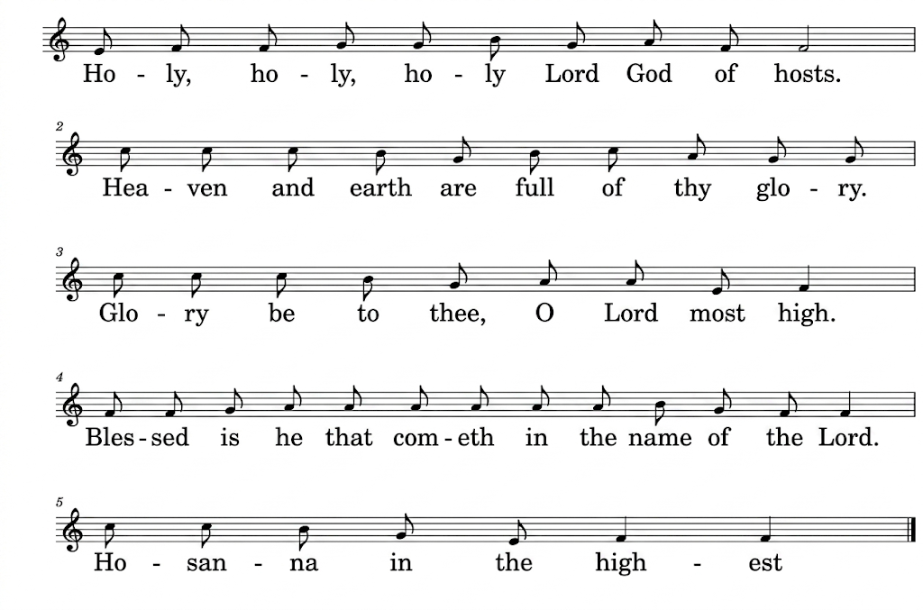
All sing Holy, holy, holy, Lord God of hosts.
Heaven and earth are full of thy glory.
Glory be to thee, O Lord most high.
Blessed is he that cometh
in the name of the Lord.
Hosanna in the highest.
Please sit or kneel
Accept our praises, heavenly Father,
through your Son our Saviour Jesus Christ,
and as we follow his example and obey his command,
grant that by the power of your Holy Spirit
these gifts of bread and wine
may be to us his body and his blood;
who, in the same night that he was betrayed,
took bread and gave you thanks;
he broke it and gave it to his disciples, saying:
Take, eat; this is my body which is given for you;
do this in remembrance of me.
In the same way, after supper
he took the cup and gave you thanks;
he gave it to them, saying: Drink this, all of you;
this is my blood of the new covenant,
which is shed for you and for many for the forgiveness of sins.
Do this, as often as you drink it, in remembrance of me.
Therefore, heavenly Father,
we remember his offering of himself
made once for all upon the cross;
we proclaim his mighty resurrection and glorious ascension;
we look for the coming of your kingdom,
and with this bread and this cup
we make the memorial of Christ your Son our Lord.
Praise to you, Lord Jesus:
All Dying you destroyed our death,
rising you restored our life:
Lord Jesus, come in glory.
Accept through him, our great high priest,
this our sacrifice of thanks and praise,
and as we eat and drink these holy gifts
in the presence of your divine majesty,
renew us by your Spirit, inspire us with your love
and unite us in the body of your Son,
Jesus Christ our Lord.
Through him, and with him, and in him,
in the unity of the Holy Spirit,
with all who stand before you in earth and heaven,
we worship you, Father almighty, in songs of everlasting praise:
All Blessing and honour and glory and power
be yours for ever and ever. Amen.
Please sit
THE LORD’S PRAYER
As our Saviour taught us, so we pray
All Our Father, who art in heaven, hallowed be thy name;
thy kingdom come; thy will be done, on earth as it is in heaven.
Give us this day our daily bread.
And forgive us our trespasses,
as we forgive those who trespass against us.
And lead us not into temptation; but deliver us from evil.
For thine is the kingdom, the power and the glory,
for ever and ever. Amen.

THE BREAKING OF THE BREAD
The president breaks the consecrated bread
We break the bread of life, and that life is the light of the world.
All God here among us, light in the midst of us,
bring us to light and life.

GIVING OF COMMUNION

Draw near with faith.
Receive the body of our Lord Jesus Christ
which he gave for you,
and his blood which he shed for you.
Eat and drink in remembrance that he died for you,
and feed on him in your hearts
by faith with thanksgiving.

AGNUS DEI
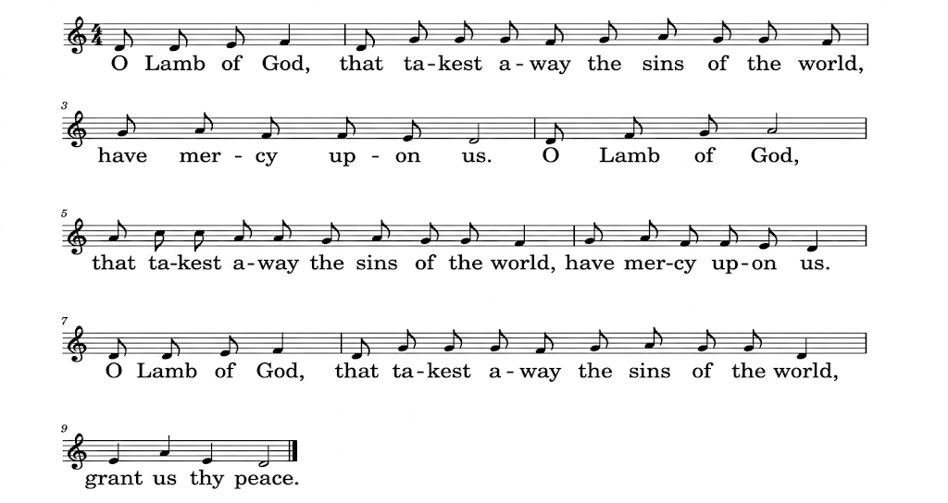

O Lamb of God, that takest away the sins of the world,
have mercy upon us.
O lamb of God that takest away the sins of the world
have mercy upon us’
O Lamb of God, you takest away the sins of the world,
grant us thy peace.
THE COMMUNION

You are welcome to receive if this is your practice. If you prefer to receive a blessing please carry this booklet to the Altar Rail. If you wish to receive Gluten Free, or wafers with wine already added please ask at the altar. Please do not dip.

COMMUNION HYMN 376 ‘ I heard the voice of Jesus say’
- I heard the voice of Jesus say,
'Come unto me and rest;
Lay down, thou weary one, lay down
Thy head upon my breast:'
I came to Jesus as I was,
Weary, and worn, and sad;
I found in him a resting place,
And he has made me glad.
- I heard the voice of Jesus say,
'Behold, I freely give
The living water, thirsty one;
Stoop down, and drink, and live:
I came to Jesus, and I drank
Of that life-giving stream;
My thirst was quenched, my soul revived,
And now I live in him.
- I heard the voice of Jesus say,
'I am this dark world’s Light;
Look unto me, thy morn shall rise,
And all thy day be bright:'
I looked to Jesus, and I found
In him my Star, my Sun;
And in that light of life I’ll walk
Till travelling days are done. Horatius Bonar. Tune KINGSFOLD
PRAYER AFTER COMMUNION
Eternal God,
whose Son Jesus Christ is the way, the truth, and the life:
grant us to walk in his way,
to rejoice in his truth,
and to share his risen life;
who is alive and reigns, now and for ever.
Amen
All Almighty God,
we thank you for feeding us
with the body and blood of your Son Jesus Christ.
Through him we offer you our souls and bodies
to be a living sacrifice.
Send us out in the power of your Spirit
to live and work to your praise and glory. Amen.
NOTICES AND SUNDAY CLUB FEEDBACK
Please stand to sing the hymn.

THE RECESSIONAL HYMN 485 ‘Thy hand O God has guided’
- Thy hand, O God, has guided
Thy flock, from age to age;
The wondrous tale is written,
Full clear, on every page;
Our fathers owned thy goodness,
And we their deeds record;
And both of this bear witness,
One Church, one Faith, one Lord.
- Thy heralds brought glad tidings
To greatest, as to least;
They bade men rise, and hasten
To share the great King's feast;
And this was all their teaching,
In every deed and word,
To all alike proclaiming
One Church, one Faith, one Lord.
- Through many a day of darkness,
Through many a scene of strife,
The faithful few fought bravely
To guard the nation's life.
Their gospel of redemption,
Sin pardoned, man restored,
Was all in this enfolded,
One Church, one Faith, one Lord.
- Thy mercy will not fail us,
Nor leave thy work undone;
With thy right hand to help us,
The victory shall be won;
And then, by men and angels,
Thy name shall be adored,
And this shall be their anthem,
One Church, one Faith, one Lord. Edward Plumtre. Tune THORNBURY

THE BLESSING

May Christ,
who out of defeat brings new hope and a new future,
fill you with his new life;
All Amen.

And the blessing of God Almighty,
the Father, the Son and the Holy Spirit,
be among you and remain with you always.
All Amen.

Go in peace to love and serve the Lord.

All In the name of Christ. Amen.

You are warmly invited to join us for refreshments after the service

Common Worship: Times and Seasons, material from which is included here,
is copyright © The Archbishops' Council 2006 and published by Church House Publishing:’

