

Parish of St Mary the Virgin
Great Shelford

First Sunday After Trinity

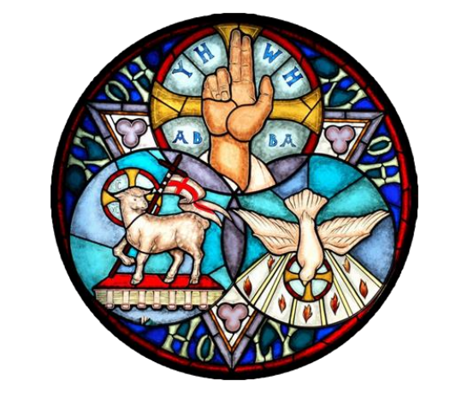

7 June 2026
10am

Welcome to St Mary the Virgin Church on this Trinity Sunday.
Please note that when asked to kneel or stand, you can do this in body or in heart.
Please stand as the Choir process to the back of Church and the first hymn is announced.
OPENING HYMN 337 ‘At the name of Jesus’
- At the name of Jesus,
Every knee shall bow,
Every tongue confess him
King of glory now;
’Tis the Father’s pleasure
We should call him Lord,
Who from the beginning
Was the mighty Word.
- Humbled for a season,
To receive a name
From the lips of sinners
Unto whom he came,
Faithfully he bore it
Spotless to the last,
Brought it back victorious
When from death he passed:
- Bore it up triumphant
With its human light,
Through all ranks of creatures,
To the central height,
To the throne of Godhead,
To the Father’s breast;
Filled it with the glory
Of that perfect rest.
- In your hearts enthrone him;
There let him subdue
All that is not holy,
All that is not true:
He is God the Saviour,
He is Christ the Lord,
Ever to be worshipped,
Trusted, and adored. Caroline Maria Noel. Tune. CAMBERWELL
THE GATHERING
The president says
In the name of the Father,
and of the Son, and of the Holy Spirit.
All Amen.
THE WELCOME

Grace, mercy and peace from God our Father
and the Lord Jesus Christ be with you
All and also with you.

PRAYER OF PREPARATION
All Almighty God,
to whom all hearts are open,
all desires known,
and from whom no secrets are hidden:
cleanse the thoughts of our hearts
by the inspiration of your Holy Spirit,
that we may perfectly love you,
and worthily magnify your holy name;
through Christ our Lord. Amen.
PRAYERS OF CONFESSION
Please sit or kneel
God the Father forgives us in Christ and heals us by the Holy Spirit.
Let us therefore put away all anger and bitterness,
all slander and malice, and confess our sins to God our redeemer.
All Father eternal, giver of light and grace,
we have sinned against you and against our neighbour;
through ignorance, through weakness,
through our own deliberate fault.
We have wounded your love, and marred your image in us.
We are sorry, and repent of all our sins.
For the sake of your Son Jesus Christ, who died for us,
forgive us all that is past; and lead us out from darkness
to walk as children of light. Amen.
May the God of love and power forgive you and free you from your sins,
heal and strengthen you by his Spirit,
and raise you to new life in Christ our Lord.
All Amen.
We stand and pray together as the children prepare to leave for their activities
All Creator God, we thank you for giving us Jesus as our Saviour:
he blessed the children who came to him
and welcomes those who come to him now.
Look with love upon these children and protect them with your care.
May they grow in wisdom, age and strength in your presence and in the sight of all.
We ask this through your beloved Son, Jesus Christ our Lord. Amen.
Please remain standing for the Gloria
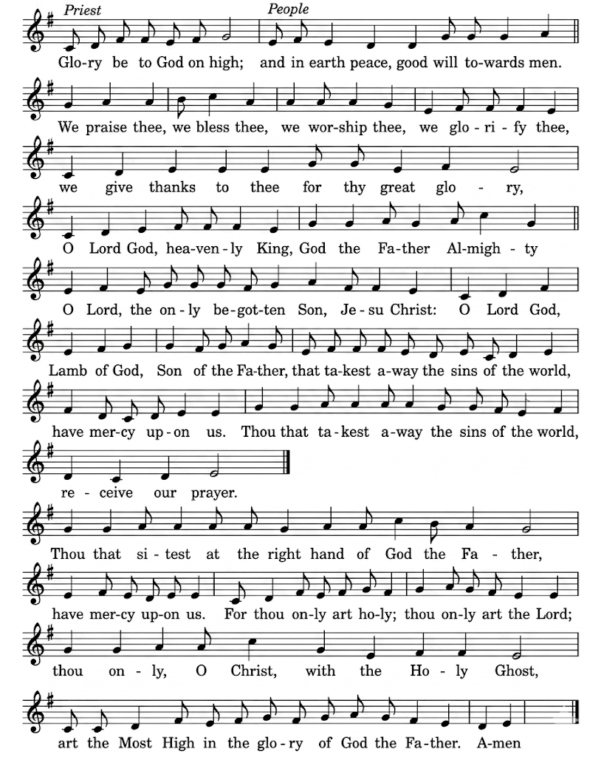
GLORIA IN EXCELSIS J Merbecke

Glory be to God on high, and in earth peace, goodwill towards men.
We praise thee, we bless thee, we worship thee, we glorify thee.
We give thanks to thee for they great glory,
O Lord God, heavenly King, God the Father almighty.
O Lord the only begotten Son, Jesu Christ;
O Lord God Lamb of God, Son of the Father,
that takest away the sins of the world, have mercy upon us.
Thou that takest away the sins of the world, receive our prayer.
Thou that sittest at the right hand of God the Father, have mercy upon us. For thou only art holy, thou only art the Lord;
Thou only, O Christ, with the Holy Ghost, art the Most High
in the glory of God the Father. Amen.
THE COLLECT
Please remain standing. The president introduces a period of silent prayer
All O God, the strength of all those who put their trust in you,
mercifully accept our prayers
and, because through the weakness of our mortal nature
we can do no good thing without you,
grant us the help of your grace,
that in the keeping of your commandments
we may please you both in will and deed;
through Jesus Christ your Son our Lord,
who is alive and reigns with you,
in the unity of the Holy Spirit,
one God, now and for ever. Amen.
Please sit for the first readings
THE LITURGY OF THE WORD
FIRST READING: Hosea 5:15–6:6
I will return again to my place until they acknowledge their guilt and seek my face. In their distress they will beg my favour.
“Come, let us return to the Lord; for it is he who has torn,
and he will heal us; he has struck down, and he will bind us up.
After two days he will revive us; on the third day he will raise us up,
that we may live before him.
Let us know, let us press on to know the Lord;
his appearing is as sure as the dawn; he will come to us like the showers, like the spring rains that water the earth.”
What shall I do with you, O Ephraim? What shall I do with you, O Judah?
Your love is like a morning cloud, like the dew that goes away early.
Therefore I have hewn them by the prophets, I have killed them by the words of my mouth, and my judgment goes forth as the light. For I desire steadfast love and not sacrifice, the knowledge of God rather than burnt offerings.
This is the word of the Lord.
All Thanks be to God

SECOND READING: Romans 4:13–25
For the promise that he would inherit the world did not come to Abraham or to his descendants through the law but through the righteousness of faith. If it is the adherents of the law who are to be the heirs, faith is null and the promise is void. For the law brings wrath; but where there is no law, neither is there transgression.
For this reason it depends on faith, in order that the promise may rest on grace and be guaranteed to all his descendants, not only to the adherents of the law but also to those who share the faith of Abraham (for he is the father of all of us, as it is written, “I have made you the father of many nations”)—in the presence of the God in whom he believed, who gives life to the dead and calls into existence the things that do not exist. Hoping against hope, he believed that he would become “the father of many nations,” according to what was said, “So numerous shall your descendants be.” He did not weaken in faith when he considered his own body, which was already as good as dead (for he was about a hundred years old), or when he considered the barrenness of Sarah’s womb. No distrust made him waver concerning the promise of God, but he grew strong in his faith as he gave glory to God, being fully convinced that God was able to do what he had promised. Therefore “it was reckoned to him as righteousness.” Now the words, “it was reckoned to him,” were written not for his sake alone, but for ours also. It will be reckoned to us who believe in him who raised Jesus our Lord from the dead, who was handed over to death for our trespasses and was raised for our justification.
This is the word of the Lord.
All Thanks be to God
GRADUAL HYMN 374 ‘How sweet the name of Jesus sounds’
- How sweet the name of Jesus sounds
In a believer's ear!
It soothes his sorrows, heals his wounds,
And drives away his fear.
- It makes the wounded spirit whole,
And calms the troubled breast;
'Tis manna to the hungry soul,
And to the weary rest.
- Dear name! the rock on which I build,
My shield and hiding-place,
My never-failing treasury filled
With boundless stores of grace.
- Jesus! my Shepherd, Brother, Friend,
My Prophet, Priest, and King,
My Lord, my Life, my Way, my End,
Accept the praise I bring.
- Weak is the effort of my heart,
and cold my warmest thought;
but when I see thee as thou art,
I'll praise thee as I ought.
- Till then I would thy love proclaim
With every fleeting breath;
And may the music of thy name
Refresh my soul in death. John Newton . Tune ST PETER

Please stand to face the Gospel
THE GOSPEL Matthew 9:9–13, 18–26

Alleluia, alleluia. Glory to the Father, and to the Son, and to the Holy Spirit, one God, who was, and who is, and who is to come, the Almighty.

All Alleluia.

Hear the Gospel of our Lord Jesus Christ according to John

All Glory to you, O Lord.
As Jesus was walking along, he saw a man called Matthew sitting at the tax booth; and he said to him, “Follow me.” And he got up and followed him.
And as he sat at dinner in the house, many tax collectors and sinners came and were sitting with him and his disciples. When the Pharisees saw this, they said to his disciples, “Why does your teacher eat with tax collectors and sinners?”
But when he heard this, he said, “Those who are well have no need of a physician, but those who are sick. Go and learn what this means, ‘I desire mercy, not sacrifice.’ For I have come to call not the righteous but sinners.”
While he was saying these things to them, suddenly a leader of the synagogue came in and knelt before him, saying, “My daughter has just died; but come and lay your hand on her, and she will live.” And Jesus got up and followed him, with his disciples.
Then suddenly a woman who had been suffering from haemorrhages for twelve years came up behind him and touched the fringe of his cloak, for she said to herself, “If I only touch his cloak, I will be made well.” Jesus turned, and seeing her he said, “Take heart, daughter; your faith has made you well.” And instantly the woman was made well.
When Jesus came to the leader’s house and saw the flute players and the crowd making a commotion, he said, “Go away; for the girl is not dead but sleeping.” And they laughed at him. But when the crowd had been put outside, he went in and took her by the hand, and the girl got up. And the report of this spread throughout that district.
This is the Gospel of the Lord.
All Praise to you, O Christ.
Please be seated
SERMON
Short silence
THE AFFIRMATION OF FAITH
Please stand as the president says,
Do you believe and trust in God the Father,
source of all being and life, the one for whom we exist?
All We believe and trust in him.
Do you believe and trust in God the Son,
who took our human nature,
died for us and rose again?
All We believe and trust in him.
Do you believe and trust in God the Holy Spirit,
who gives life to the people of God
and makes Christ known in the world?
All We believe and trust in him.
This is the faith of the Church.
All This is our faith.
We believe and trust in one God,
Father, Son and Holy Spirit.
Amen
PRAYERS OF INTERCESSION
Please sit or kneel to pray

Thrice holy! Father, Spirit, Son, Mysterious Godhead, Three in One: We pray for ourselves, for your Church, for all whom we remember before you.
At the end
Merciful Father,
All accept these prayers for the sake of your Son,
our Saviour Jesus Christ. Amen
THE LITURGY OF THE SACRAMENT
THE PEACE
Please stand

Peace to you from God our heavenly Father.

Peace from his Son Jesus Christ who is our peace.

Peace from the Holy Spirit, the life-giver.
The peace of the Lord be always with you.
All and also with you.
Let us offer one another a sign of peace.
OFFERTORY HYMN 378 ‘ Immortal love for ever full’
- Immortal love for ever full,
For ever flowing free,
For ever shared, for ever whole,
A never-ebbing sea!
- Our outward lips confess the name,
All other names above;
Love only knoweth whence it came
And comprehendeth love.
- We may not climb the heavenly steeps
To bring the Lord Christ down;
In vain we search the lowest deeps,
For him no depths can drown;
- But warm, sweet, tender, even yet
A present help is he;
And faith has still its Olivet,
And love its Galilee.

- The healing of his seamless dress
Is by our beds of pain;
We touch him in life's throng and press,
And we are whole again.
- Through him the first fond prayers are said
Our lips of childhood frame;
The last low whispers of our dead
Are burdened with his name. J Wittier. Tune BISHOPTHORPE
PREPARATION OF THE TABLE
Please remain standing
Blessed be God,
who feeds the hungry,
who raises the poor,
who fills our praise.
All Blessed be God for ever.
THE EUCHARISTIC PRAYER
The president says
The Lord is here
All His Spirit is with us
Lift up your hearts.
All We lift them to the Lord.
Let us give thanks to the Lord our God.
All It is right to give thanks and praise.
It is indeed right, our duty and our joy,
always and everywhere to give you thanks,
holy Father, almighty and eternal God.
For with your only-begotten Son and the Holy Spirit
you are one God, one Lord.
All that you reveal of your glory, the same we believe of the Son
and of the Holy Spirit, without any difference or inequality.
We, your holy Church, acclaim you,
Father of majesty unbounded,
your true and only Son, worthy of all worship,
and the Holy Spirit, advocate and guide.
Three Persons we adore, one in being and equal in majesty.
And so with angels and archangels, with cherubim and seraphim,
we sing for ever of your glory.
THE SANCTUS/BENEDICTUS J Merbecke
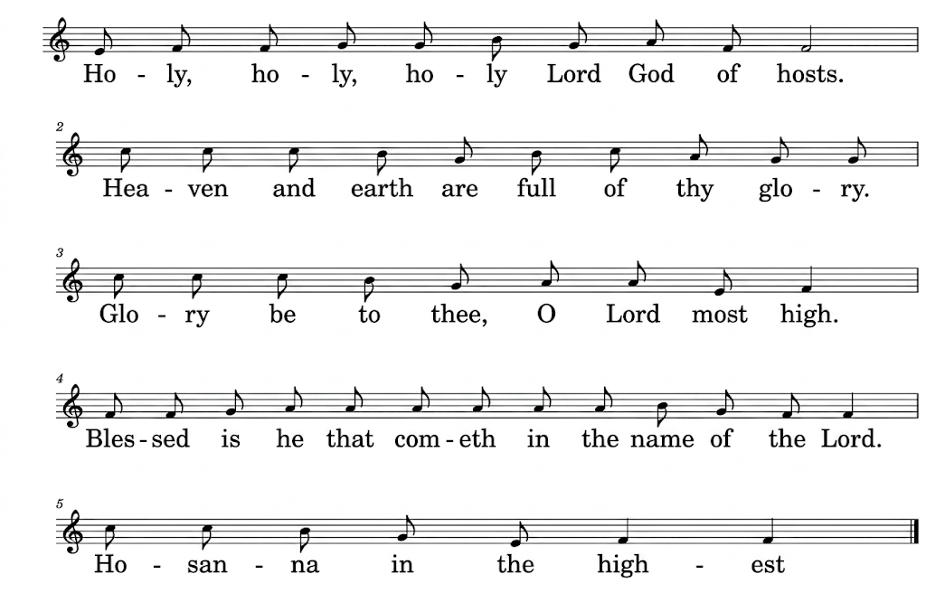
All Holy, holy, holy, Lord God of hosts.
Heaven and earth are full of thy glory.
Glory be to thee, O Lord most high.
Blessed is he that cometh
in the name of the Lord.
Hosanna in the highest.
Please remain standing until the consecration is accomplished
Lord, you are holy indeed, the source of all holiness; grant that
by the power of your Holy Spirit, and according to your holy will,
these gifts of bread and wine may be to us
the body and blood of our Lord Jesus Christ;
who, in the same night that he was betrayed,
took bread and gave you thanks;
he broke it and gave it to his disciples, saying:
Take, eat; this is my body which is given for you;
do this in remembrance of me.
In the same way, after supper he took the cup
and gave you thanks;
he gave it to them, saying:
Drink this, all of you;
this is my blood of the new covenant,
which is shed for you and for many for the forgiveness of sins.
Do this, as often as you drink it, in remembrance of me.
Great is the mystery of faith:
All Christ has died:
Christ is risen:
Christ will come again.
Please sit or kneel.
And so, Father, calling to mind his death on the cross,
his perfect sacrifice made once
for the sins of the whole world;
rejoicing in his mighty resurrection and glorious ascension,
and looking for his coming in glory,
we celebrate this memorial of our redemption.
As we offer you this our sacrifice of praise and thanksgiving,
we bring before you this bread and this cup
and we thank you for counting us worthy
to stand in your presence and serve you.
Send the Holy Spirit on your people
and gather into one in your kingdom
all who share this one bread and one cup,
so that we, in the company of Mary and all the saints,
may praise and glorify you for ever,
through Jesus Christ our Lord;
by whom, and with whom, and in whom,
in the unity of the Holy Spirit, all honour and glory be yours,
almighty Father, for ever and ever.

All Amen.

THE LORD’S PRAYER

Let us pray with confidence as our Saviour has taught us
All Our Father, who art in heaven, hallowed be thy name;
thy kingdom come; thy will be done;
on earth as it is in heaven.
Give us this day our daily bread.
And forgive us our trespasses,
as we forgive those who trespass against us.
And lead us not into temptation; but deliver us from evil. For thine is the kingdom, the power and the glory,
for ever and ever. Amen.

BREAKING OF THE BREAD
The president breaks the consecrated bread.
We break this bread to share in the body of Christ.
All Though we are many, we are one body,
because we all share in one bread.
Draw near with faith. Receive the body of our Lord Jesus Christ
which he gave for you, and his blood which he shed for you.
Eat and drink in remembrance that he died for you,
and feed on him in your hearts by faith with thanksgiving.
All Amen.

AGNUS DEI
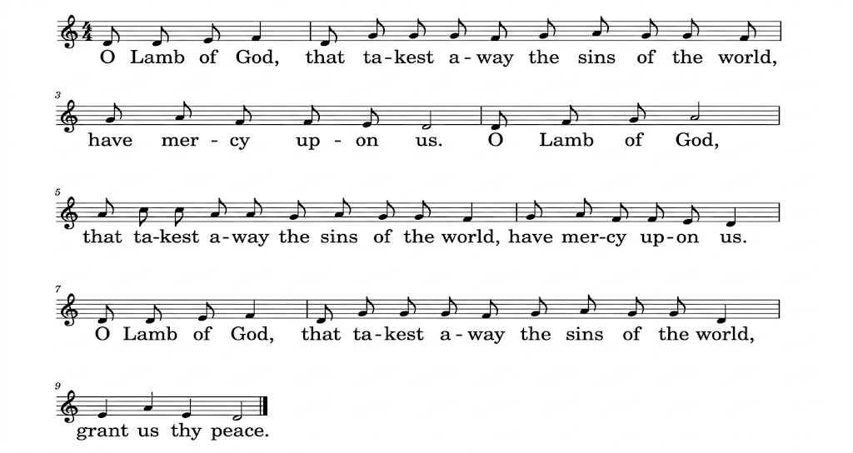
O Lamb of God, that takest away the sins of the world, have mercy upon us.
O lamb of God that takest away the sins of the world, have mercy upon us’
O Lamb of God, you takest away the sins of the world, grant us thy peace.

THE COMMUNION

You are welcome to receive if this is your practice. If you prefer to receive a blessing please carry this booklet to the Altar. If you wish to receive Gluten Free, or wafers with wine already added please ask

HYMN DURING COMMUNION 307 ‘Sweet Sacrament divine’
Please remain seated to sing the Communion hymn
- Sweet Sacrament divine,
Hid in thine earthly home,
Lo, round thy lowly shrine,
With suppliant hearts we come;
Jesu, to thee our voice we raise
In songs of love and heartfelt praise:
Sweet Sacrament divine.
- Sweet Sacrament of peace,
Dear home for every heart,
Where restless yearnings cease
And sorrows all depart;
There in thine ear all trustfully
We tell our tale of misery:
Sweet Sacrament of peace.
- Sweet Sacrament of rest,
Ark from the ocean's roar,
Within thy shelter blest
Soon may we reach the shore;
Save us, for still the tempest raves,
Save, lest we sink beneath the waves:
Sweet Sacrament of rest.
- Sweet Sacrament divine,
Earth's light and jubilee,
In thy far depths doth shine
Thy Godhead's majesty;
Sweet light, so shine on us, we pray
That earthly joys may fade away:
Sweet Sacrament divine. Francis Stanfield. Tune DIVINE MYSTERIES
PRAYER AFTER COMMUNION
Eternal Father,
we thank you for nourishing us
with these heavenly gifts:
may our communion strengthen us in faith,
build us up in hope, and make us grow in love;
for the sake of Jesus Christ our Lord. Amen.
Thanksgiving, said by everyone.
All Almighty God,
we thank you for feeding us
with the body and blood of your Son Jesus Christ.
Through him we offer you our souls and bodies
to be a living sacrifice.
Send us out in the power of your Spirit
to live and work to your praise and glory. Amen.
SUNDAY CLUB FEEDBACK, MARY MOUSE & NOTICES
CLOSING HYMN: 486 ‘We have a Gospel to proclaim’
Please stand to sing the final hymn
- We have a gospel to proclaim,
Good news for men in all the earth;
The gospel of a Saviour’s name:
We sing his glory, tell his worth.
- Tell of his birth at Bethlehem,
Not in a royal house or hall
But in a stable dark and dim:
The Word made flesh, a light for all.
- Tell of his death at Calvary,
Hated by those he came to save;
In lonely suffering on the cross
For all he loved, his life he gave.
- Tell of that glorious Easter morn:
Empty the tomb, for he was free;
He broke the power of death and hell
That we might share his victory.
- Tell of his reign at God’s right hand
By all creation glorified;
He sends his Spirit on his church
To live for him, the Lamb who died.
- Now we rejoice to name him King:
Jesus is Lord of all the earth;
This gospel-message we proclaim:
We sing his glory, tell his worth. Edward Burns Tune FULDA
THE DISMISSAL
THE BLESSING
Please remain standing

God the Holy Trinity
make you strong in faith and love,
defend you on every side,
and guide you in truth and peace;
and the blessing of God almighty, the Father, the Son
and the Holy Spirit, be among you, and remain with you always.
All Amen.

Go in peace to love and serve the Lord.
All In the name of Christ. Amen.

You are warmly invited to join us for refreshments in the Community Room after this service.

Common Worship, Services and Prayers for the Church of England, material in this service, is copyright © The Archbishops' Council 2000 and 2008.

