
PARISH OF ST MARY THE VIRGIN
GREAT SHELFORD

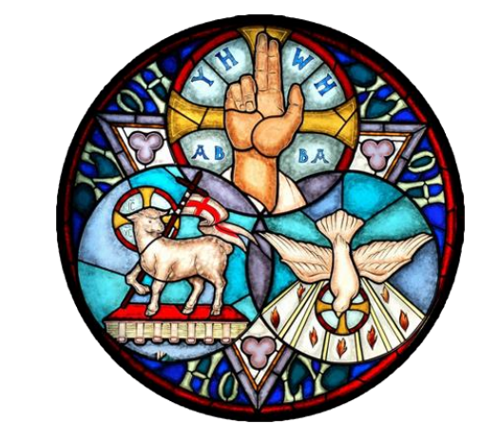

FIFTH SUNDAY AFTER TRINITY

5 JULY 2026
10am

Welcome to St Mary the Virgin Church
Please note that when asked to kneel or stand, you can do this in body or in heart.
Please stand as the Choir processes to the back of Church and the first hymn is announced.
OPENING HYMN 388 Jesus shall reign where'er the sun
- Jesus shall reign where'er the sun
Does his successive journeys run;
His kingdom stretch from shore to shore,
Till moons shall wax and wane no more.
- People and realms of every tongue
Dwell on his love with sweetest song,
And infant voices shall proclaim
Their early blessings on his name.
- Blessings abound where'er he reigns;
The prisoner leaps to lose his chains;
The weary find eternal rest,
And all the sons of want are blest.
- Let every creature rise and bring
Peculiar honours to our King;
Angels descend with songs again,
And earth repeat the long Amen. Isaac Watts. Tune TRURO
THE GATHERING
The president says
In the name of the Father,
and of the Son, and of the Holy Spirit.
All Amen.
THE WELCOME

Grace, mercy and peace from God our Father
and the Lord Jesus Christ be with you
All and also with you.

PRAYER OF PREPARATION
All Almighty God, to whom all hearts are open,
all desires known, and from whom no secrets are hidden:
cleanse the thoughts of our hearts
by the inspiration of your Holy Spirit,
that we may perfectly love you,
and worthily magnify your holy name;
through Christ our Lord. Amen.
PRAYERS OF CONFESSION
Please sit or kneel
God the Father forgives us in Christ and heals us by the Holy Spirit.
Let us therefore put away all anger and bitterness,
all slander and malice, and confess our sins to God our redeemer.
All Father eternal, giver of light and grace, we have sinned against you and against our neighbour; through ignorance, through weakness,
through our own deliberate fault.
We have wounded your love, and marred your image in us.
We are sorry, and repent of all our sins.
For the sake of your Son Jesus Christ, who died for us,
forgive us all that is past; and lead us out from darkness
to walk as children of light. Amen.
May the God of love and power forgive you and free you from your sins, heal and strengthen you by his Spirit, and raise you to new life in Christ our Lord.
All Amen.
We stand and pray together as the children prepare to leave for their activities
All Creator God, we thank you for giving us Jesus as our Saviour:
he blessed the children who came to him
and welcomes those who come to him now.
Look with love upon these children and protect them with your care.
May they grow in wisdom, age and strength
in your presence and in the sight of all.
We ask this through your beloved Son, Jesus Christ our Lord. Amen.
Please remain standing for the Gloria
Glory be to God on high, and in earth peace, goodwill towards men.
We praise thee, we bless thee, we worship thee, we glorify thee.
We give thanks to thee for thy great glory,
O Lord God, heavenly King, God the Father almighty.
O Lord the only begotten Son, Jesu Christ;
O Lord God Lamb of God, Son of the Father,
that takest away the sins of the world, have mercy upon us.
Thou that takest away the sins of the world, receive our prayer.
Thou that sittest at the right hand of God the Father, have mercy upon us.
For thou only art holy, thou only art the Lord;
Thou only, O Christ, with the Holy Ghost, art the Most High
in the glory of God the Father. Amen.
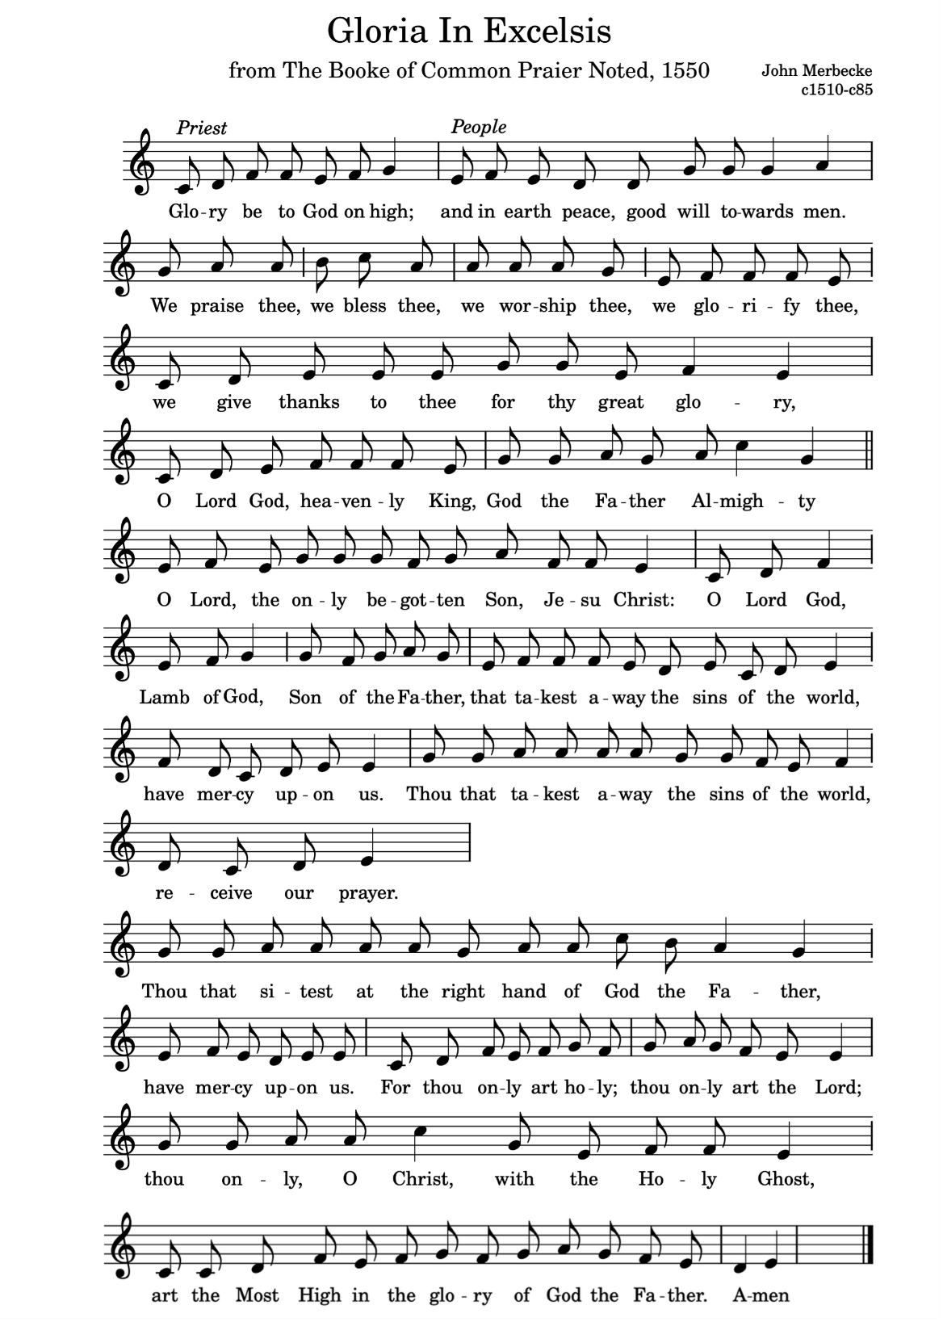
THE COLLECT
Please remain standing. The president introduces a period of silent prayer
All O God, the strength of all those who put their trust in you,
mercifully accept our prayers and,
because through the weakness of our mortal nature
we can do no good thing without you,
grant us the help of your grace, that in the keeping of your commandments we may please you both in will and deed;
through Jesus Christ your Son our Lord, who is alive and reigns with you, in the unity of the Holy Spirit, one God, now and for ever. Amen.
THE LITURGY OF THE WORD
Please sit for the first readings
FIRST READING Zechariah 9. 9-12
Rejoice greatly, O daughter Zion! Shout aloud, O daughter Jerusalem!
Lo, your king comes to you; triumphant and victorious is he, humble and riding on a donkey, on a colt, the foal of a donkey. He will cut off the chariot from Ephraim and the warhorse from Jerusalem; and the battle-bow shall be cut off, and he shall command peace to the nations; his dominion shall be from sea to sea, and from the River to the ends of the earth. As for you also, because of the blood of my covenant with you, I will set your prisoners free from the waterless pit. Return to your stronghold, O prisoners of hope; today I declare that I will restore to you double.
This is the word of the Lord.
All Thanks be to God
SECOND READING: Romans 7.15-25a
I do not understand my own actions. For I do not do what I want, but I do the very thing I hate. Now if I do what I do not want, I agree that the law is good. But in fact it is no longer I who do it but sin that dwells within me. For I know that the good does not dwell within me, that is, in my flesh. For the desire to do the good lies close at hand, but not the ability. For I do not do the good I want, but the evil I do not want is what I do. Now if I do what I do not want, it is no longer I who do it but sin that dwells within me.
So I find it to be a law that, when I want to do what is good, evil lies close at hand. For I delight in the law of God in my inmost self, but I see in my members another law at war with the law of my mind, making me captive to the law of sin that dwells in my members. Wretched person that I am! Who will rescue me from this body of death? Thanks be to God through Jesus Christ our Lord!
This is the word of the Lord.
All Thanks be to God
GRADUAL HYMN 376 ‘I heard the voice of Jesus say,
- I heard the voice of Jesus say,
'Come unto me and rest;
Lay down, thou weary one, lay down
Thy head upon my breast:'
I came to Jesus as I was,
Weary, and worn, and sad;
I found in him a resting place,
And he has made me glad.
- I heard the voice of Jesus say,
'Behold, I freely give
The living water, thirsty one;
Stoop down, and drink, and live:
I came to Jesus, and I drank
Of that life-giving stream;
My thirst was quenched, my soul revived,
And now I live in him.
- I heard the voice of Jesus say,
'I am this dark world’s Light;
Look unto me, thy morn shall rise,
And all thy day be bright:'
I looked to Jesus, and I found
In him my Star, my Sun;
And in that light of life I’ll walk
Till travelling days are done. Horatius Bonar Tune. KINGSFOLD

Please stand to face the Gospel
THE GOSPEL Matthew 11.16-19 and 25-30

Alleluia, alleluia. Glory to the Father, and to the Son, and to the Holy Spirit, one God, who was, and who is, and who is to come, the Almighty.

All Alleluia.

Hear the Gospel of our Lord Jesus Christ according to John

All Glory to you, O Lord.

“But to what will I compare this generation? It is like children sitting in the marketplaces and calling to one another, We played the flute for you, and you did not dance; we wailed, and you did not mourn. For John came neither eating nor drinking, and they say, ‘He has a demon’; the Son of Man came eating and drinking, and they say, ‘Look, a glutton and a drunkard, a friend of tax collectors and sinners!’ Yet wisdom is vindicated by her deeds.”

At that time Jesus said, “I thank you, Father, Lord of heaven and earth, because you have hidden these things from the wise and the intelligent and have revealed them to infants; yes, Father, for such was your gracious will. All things have been handed over to me by my Father, and no one knows the Son except the Father, and no one knows the Father except the Son and anyone to whom the Son chooses to reveal him.

“Come to me, all you who are weary and are carrying heavy burdens, and I will give you rest. Take my yoke upon you, and learn from me, for I am gentle and humble in heart, and you will find rest for your souls. For my yoke is easy, and my burden is light.”
This is the Gospel of the Lord.
All Praise to you, O Christ.
Please be seated
SERMON
Short silence
THE NICENE CREED
Please stand as the president says,
We believe in one God, the Father, the Almighty,
maker of heaven and earth, of all that is,
seen and unseen.
We believe in one Lord, Jesus Christ,
the only Son of God, eternally begotten of the Father,
God from God, Light from Light, true God from true God,
begotten, not made, of one Being with the Father;
through him all things were made.
For us and for our salvation he came down from heaven,
was incarnate from the Holy Spirit and the Virgin Mary
and was made man.
For our sake he was crucified under Pontius Pilate;
he suffered death and was buried.
On the third day he rose again in accordance with the Scriptures;
he ascended into heaven and is seated at the right hand of the Father.
He will come again in glory to judge the living and the dead,
and his kingdom will have no end.
We believe in the Holy Spirit, the Lord, the giver of life,
who proceeds from the Father and the Son,
who with the Father and the Son is worshipped and glorified,
who has spoken through the prophets.
We believe in one holy catholic and apostolic Church.
We acknowledge one baptism for the forgiveness of sins.
We look for the resurrection of the dead,
and the life of the world to come.
Amen.
PRAYERS OF INTERCESSION
Please sit or kneel to pray
In the power of the Spirit and in union with Christ
let us pray to the Father.
At the end
Merciful Father,
All accept these prayers for the sake of your Son,
our Saviour Jesus Christ. Amen
THE LITURGY OF THE SACRAMENT
THE PEACE
Please stand
To crown all things there must be love, to bind all together and complete the whole. Let the peace of Christ rule in our hearts.
The peace of the Lord be always with you.
All and also with you.
Let us offer one another a sign of peace.
OFFERTORY HYMN 294 ‘Just as I am, without one plea,’
1 Just as I am, without one plea
But that thy blood was shed for me,
And that thou bidd’st me come to thee,
O Lamb of God, I come.
2 Just as I am, though tossed about
With many a conflict, many a doubt,
Fightings within, and fears without,
O Lamb of God, I come.
3 Just as I am, poor, wretched, blind;
Sight, riches, healing of the mind,
Yea all I need, in thee to find,
O Lamb of God, I come.
4 Just as I am, thou wilt receive,
Wilt welcome, pardon, cleanse, relieve;
Because thy promise I believe,
O Lamb of God, I come.
5 Just as I am (thy love unknown
Has broken every barrier down),
Now to be thine, yea thine alone,
O Lamb of God, I come.
6 Just as I am, of that free love
The breadth, length, depth and height to prove,
Here for a season then above,
O Lamb of God, I come.
Charlotte Elliott. Tune SAFFRON WALDEN - 6vv
PREPARATION OF THE TABLE
Please remain standing
Blessed be God, who feeds the hungry,
who raises the poor, who fills our praise.
All Blessed be God for ever.
THE EUCHARISTIC PRAYER
The president says
The Lord is here
All His Spirit is with us
Lift up your hearts.
All We lift them to the Lord.
Let us give thanks to the Lord our God.
All It is right to give thanks and praise.
It is indeed right, our duty and our joy,
always and everywhere to give you thanks,
holy Father, almighty and eternal God.
For with your only-begotten Son and the Holy Spirit
you are one God, one Lord.
All that you reveal of your glory, the same we believe of the Son
and of the Holy Spirit, without any difference or inequality.
We, your holy Church, acclaim you, Father of majesty unbounded,
your true and only Son, worthy of all worship,
and the Holy Spirit, advocate and guide.
Three Persons we adore, one in being and equal in majesty.
And so with angels and archangels, with cherubim and seraphim,
we sing for ever of your glory.

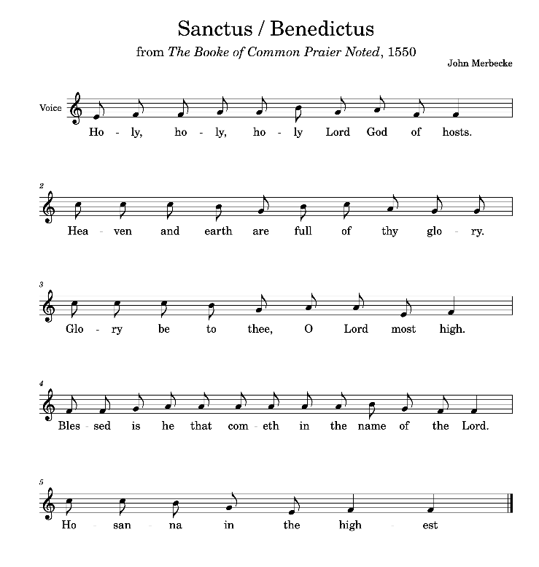
THE SANCTUS
All Holy, holy, holy, Lord God of hosts.
Heaven and earth are full of thy glory.
Glory be to thee, O Lord most high.
Blessed is he that cometh in the name of the Lord.
Hosanna in the highest.
Please remain standing until the consecration is accomplished
Lord, you are holy indeed, the source of all holiness; grant that
by the power of your Holy Spirit, and according to your holy will,
these gifts of bread and wine may be to us
the body and blood of our Lord Jesus Christ;
who, in the same night that he was betrayed,
took bread and gave you thanks;
he broke it and gave it to his disciples, saying:
Take, eat; this is my body which is given for you;
do this in remembrance of me.

In the same way, after supper he took the cup and gave you thanks;
he gave it to them, saying: Drink this, all of you;
this is my blood of the new covenant,
which is shed for you and for many for the forgiveness of sins.
Do this, as often as you drink it, in remembrance of me.
Great is the mystery of faith:
All Christ has died:
Christ is risen:
Christ will come again.
Please sit or kneel.
And so, Father, calling to mind his death on the cross,
his perfect sacrifice made once
for the sins of the whole world;
rejoicing in his mighty resurrection and glorious ascension,
and looking for his coming in glory,
we celebrate this memorial of our redemption.
As we offer you this our sacrifice of praise and thanksgiving,
we bring before you this bread and this cup
and we thank you for counting us worthy
to stand in your presence and serve you.
Send the Holy Spirit on your people
and gather into one in your kingdom
all who share this one bread and one cup,
so that we, in the company of Mary and all the saints,
may praise and glorify you for ever, through Jesus Christ our Lord;
by whom, and with whom, and in whom,
in the unity of the Holy Spirit, all honour and glory be yours,
almighty Father, for ever and ever.

All Amen.

THE LORD’S PRAYER

Let us pray with confidence as our Saviour has taught us
All Our Father, who art in heaven, hallowed be thy name;
thy kingdom come; thy will be done;
on earth as it is in heaven.
Give us this day our daily bread.
And forgive us our trespasses,
as we forgive those who trespass against us.
And lead us not into temptation; but deliver us from evil. For thine is the kingdom, the power and the glory,
for ever and ever. Amen.

BREAKING OF THE BREAD
The president breaks the consecrated bread.
We break this bread to share in the body of Christ.
All Though we are many, we are one body,
because we all share in one bread.
Draw near with faith. Receive the body of our Lord Jesus Christ
which he gave for you, and his blood which he shed for you.
Eat and drink in remembrance that he died for you,
and feed on him in your hearts by faith with thanksgiving.
All Amen.
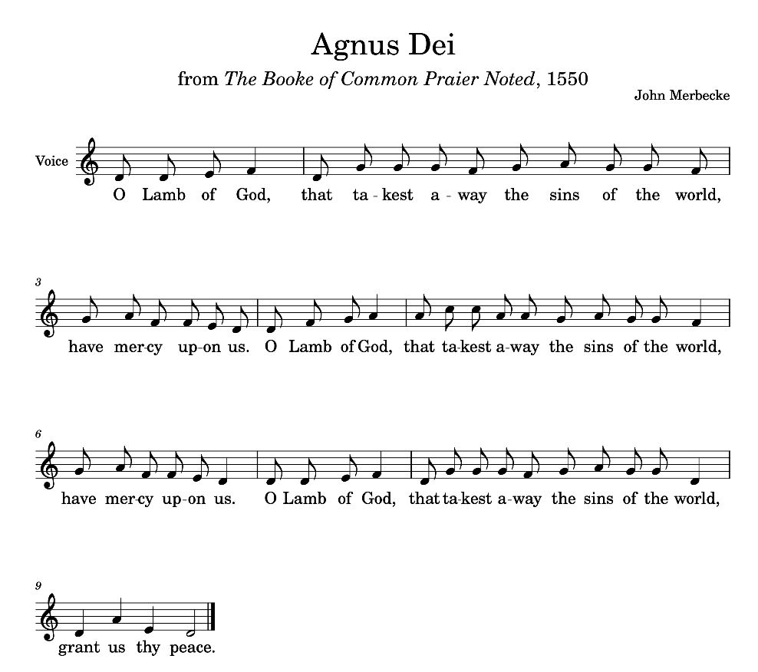

AGNUS DEI
O Lamb of God, that takest away the sins of the world, have mercy upon us.
O lamb of God that takest away the sins of the world, have mercy upon us’
O Lamb of God, you takest away the sins of the world, grant us thy peace.
THE COMMUNION
You are welcome to receive if this is your practice. If you prefer to receive a blessing please carry this booklet to the Altar. If you wish to receive Gluten Free, or wafers with wine already added please ask.
HYMN DURING COMMUNION 307 ‘Sweet Sacrament divine’
Please remain seated to sing the Communion hymn
- Sweet Sacrament divine,
Hid in thine earthly home,
Lo, round thy lowly shrine,
With suppliant hearts we come;
Jesu, to thee our voice we raise
In songs of love and heartfelt praise:
Sweet Sacrament divine.
- Sweet Sacrament of peace,
Dear home for every heart,
Where restless yearnings cease
And sorrows all depart;
There in thine ear all trustfully
We tell our tale of misery:
Sweet Sacrament of peace.
- Sweet Sacrament of rest,
Ark from the ocean's roar,
Within thy shelter blest
Soon may we reach the shore;
Save us, for still the tempest raves,
Save, lest we sink beneath the waves:
Sweet Sacrament of rest.
- Sweet Sacrament divine,
Earth's light and jubilee,
In thy far depths doth shine
Thy Godhead's majesty;
Sweet light, so shine on us, we pray
That earthly joys may fade away:
Sweet Sacrament divine. Francis Stanfield. Tune DIVINE MYSTERIES

PRAYER AFTER COMMUNION
Eternal Father,
we thank you for nourishing us
with these heavenly gifts:
may our communion strengthen us in faith,
build us up in hope, and make us grow in love;
for the sake of Jesus Christ our Lord. Amen.
Thanksgiving, said by everyone.
All Almighty God,
we thank you for feeding us
with the body and blood of your Son Jesus Christ.
Through him we offer you our souls and bodies
to be a living sacrifice.
Send us out in the power of your Spirit
to live and work to your praise and glory. Amen.
SUNDAY CLUB FEEDBACK, MARY MOUSE & NOTICES
NB Birthday of Ellen and also of Eliot coming up
CLOSING HYMN: 263 ‘All creatures of our God and King’
Please stand to sing the final hymn
- All creatures of our God and King,
Lift up your voice and with us sing
Alleluia, Alleluia!
Thou burning sun with golden beam,
Thou silver moon with softer gleam:
Refrain O praise him, O praise him
Alleluia, Alleluia, Alleluia!
- Thou rushing wind that art so strong,
Ye clouds that sail in heaven along,
O praise him! Alleluia!
Thou rising morn, in praise rejoice,
Ye lights of evening, find a voice: [Refrain]
- Thou flowing water, pure and clear,
Make music for thy Lord to hear,
Alleluia, Alleluia!
Thou fire so masterful and bright,
That givest man both warmth and light: [Refrain]
- Dear mother earth, who day by day
Unfoldest blessings on our way,
O praise him, Alleluia, The flowers and fru
its that in thee grow,
Let them his glory also show: [Refrain]
- Let all things their Creator bless,
And worship him in humbleness,
O praise him Alleluia!
Praise, praise the Father, praise the Son,
And praise the Spirit, three in One: [Refrain]
St Francis. Tune. LASST UNS ERFREUEN
THE DISMISSAL
THE BLESSING
Please remain standing
God the Holy Trinity
make you strong in faith and love,
defend you on every side,
and guide you in truth and peace;
and the blessing of God almighty, the Father, the Son
and the Holy Spirit, be among you, and remain with you always.
All Amen.

Go in peace to love and serve the Lord.
All In the name of Christ. Amen.

You are warmly invited to join us for refreshments in the Community Room after this service.

Common Worship, Services and Prayers for the Church of England, material in this service, is copyright © The Archbishops' Council 2000 and 2008. CCLI 316528

