

Parish of St Mary the Virgin
Great Shelford

FOURTEENTH SUNDAY AFTER TRINITY

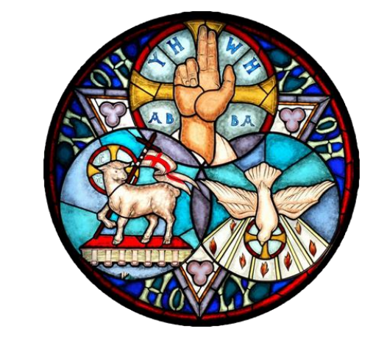

PARISH COMMUNION

10am 6 SEPTEMBER 2026

J Merbecke Setting of the Mass

Welcome to St Mary the Virgin Church.

Please note that when asked to kneel or stand, you can do this in body or in heart.
Please stand as the Choir process and the first hymn is announced.
OPENING HYMN
- Awake, awake: fling off the night!
For God has sent his glorious light;
and we who live in Christ's new day
must works of darkness put away.
- Let in the light; all sin expose
to Christ, whose life no darkness knows.
Before the cross expectant kneel;
That Christ may judge, and judging heal.
- Awake, and rise up from the dead,
and Christ his light on you will shed.
Its power will wrong desires destroy,
and your whole nature fill with joy.
- Then sing for joy, and use each day;
give thanks for everything alway.
Lift up your hearts; with one accord
praise God through Jesus Christ our Lord.
Words: J.R. Peacey, Tune: DEUS TUORUM MILITUM
THE GATHERING
The president says
In the name of the Father,
and of the Son, and of the Holy Spirit.
All Amen.
THE WELCOME

Grace, mercy and peace from God our Father
and the Lord Jesus Christ be with you
All and also with you.

PRAYER OF PREPARATION
All Almighty God,
to whom all hearts are open,
all desires known,
and from whom no secrets are hidden:
cleanse the thoughts of our hearts
by the inspiration of your Holy Spirit,
that we may perfectly love you,
and worthily magnify your holy name;
through Christ our Lord. Amen.
PRAYERS OF PENITENCE
SUMMARY OF THE LAW
Our Lord Jesus Christ said: The first commandment is this:
‘Hear, O Israel, the Lord our God is the only Lord.
You shall love the Lord your God with all your heart,
with all your soul, with all your mind, and with all your strength.’
The second is this: ‘Love your neighbour as yourself’
There is no other commandment greater than these.
On these two commandments hang all the law and the prophets.
All Amen. Lord, have mercy.
PRAYERS OF CONFESSION
Please sit or kneel
God the Father forgives us in Christ and heals us by the Holy Spirit.
Let us therefore put away all anger and bitterness,
all slander and malice, and confess our sins to God our redeemer.
All Father eternal, giver of light and grace,
we have sinned against you and against our neighbour;
through ignorance, through weakness,
through our own deliberate fault.
We have wounded your love, and marred your image in us.
We are sorry, and repent of all our sins.
For the sake of your Son Jesus Christ, who died for us,
forgive us all that is past; and lead us out from darkness
to walk as children of light. Amen.
May the God of love and power forgive you
and free you from your sins,
heal and strengthen you by his Spirit,
and raise you to new life in Christ our Lord.
All Amen.
We stand and pray together as the children prepare to leave for their activities
All Creator God, we thank you for giving us Jesus as our Saviour:
he blessed the children who came to him
and welcomes those who come to him now.
Look with love upon these children
and protect them with your care.
May they grow in wisdom, age
and strength in your presence and in the sight of all.
We ask this through your beloved Son, Jesus Christ our Lord. Amen.
Please remain standing for the Gloria
Glory be to God on high, and in earth peace, goodwill towards men.
We praise thee, we bless thee, we worship thee, we glorify thee.
We give thanks to thee for thy great glory,
O Lord God, heavenly King, God the Father almighty.
O Lord the only begotten Son, Jesu Christ;
O Lord God Lamb of God, Son of the Father,
that takest away the sins of the world, have mercy upon us.
Thou that takest away the sins of the world, receive our prayer.
Thou that sittest at the right hand of God the Father, have mercy upon us. For thou only art holy, thou only art the Lord;
Thou only, O Christ, with the Holy Ghost, art the Most High
in the glory of God the Father. Amen.

GLORIA IN EXCELSIS J Merbecke
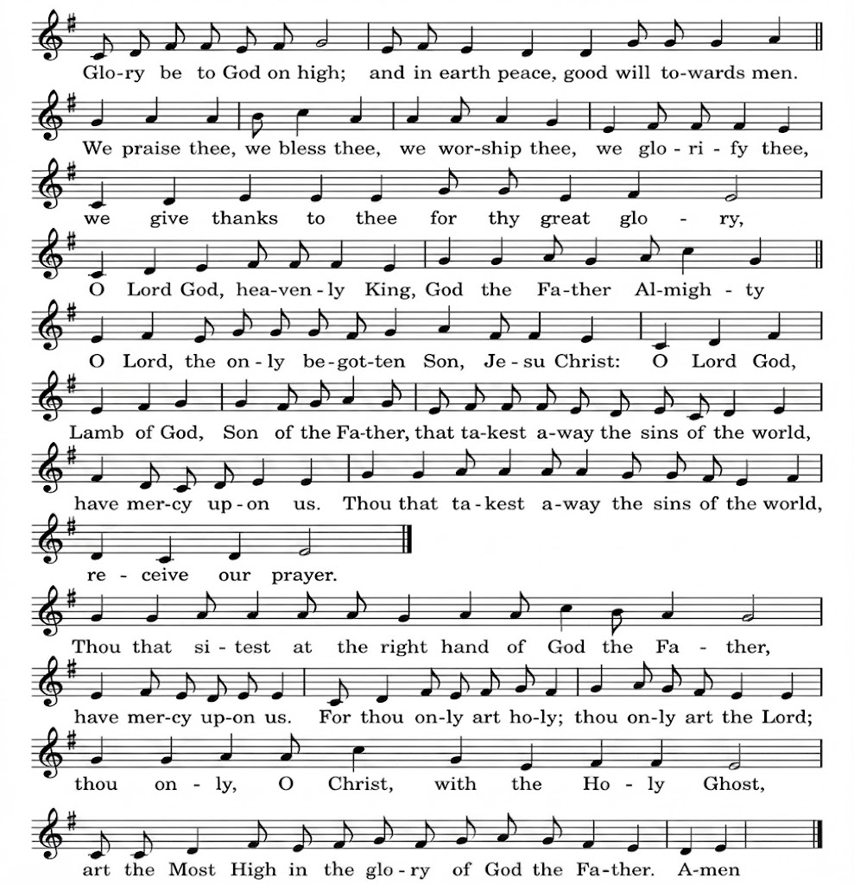
THE COLLECT
Please remain standing. The president introduces a period of silent prayer
All Almighty God,
whose only Son has opened for us
a new and living way into your presence:
give us pure hearts and steadfast wills
to worship you in spirit and in truth;
through Jesus Christ your Son our Lord,
who is alive and reigns with you, in the unity of the Holy Spirit,
one God, now and for ever. Amen

THE LITURGY OF THE WORD
Please sit for the first readings
FIRST READING: Ezekiel 33.7-11 b
So you, mortal, I have made a sentinel for the house of Israel; whenever you hear a word from my mouth, you shall give them warning from me. If I say to the wicked, ‘O wicked ones, you shall surely die’, and you do not speak to warn the wicked to turn from their ways, the wicked shall die in their iniquity, but their blood I will require at your hand. But if you warn the wicked to turn from their ways, and they do not turn from their ways, the wicked shall die in their iniquity, but you will have saved your life.
Now you, mortal, say to the house of Israel, Thus you have said: ‘Our transgressions and our sins weigh upon us, and we waste away because of them; how then can we live?’ Say to them, As I live, says the Lord GOD, I have no pleasure in the death of the wicked, but that the wicked turn from their ways and live.
This is the word of the Lord.
All Thanks be to God

SECOND READING: Romans 13. 8-14
Owe no one anything, except to love one another; for the one who loves another has fulfilled the law. The commandments, ‘You shall not commit adultery; You shall not murder; You shall not steal; You shall not covet’; and any other commandment, are summed up in this word, ‘Love your neighbour as yourself.’ Love does no wrong to a neighbour; therefore, love is the fulfilling of the law.
Besides this, you know what time it is, how it is now the moment for you to wake from sleep. For salvation is nearer to us now than when we became believers; the night is far gone, the day is near. Let us then lay aside the works of darkness and put on the armour of light; let us live honourably as in the day, not in revelling and drunkenness, not in debauchery and licentiousness, not in quarrelling and jealousy. Instead, put on the Lord Jesus Christ, and make no provision for the flesh, to gratify its desires.
This is the word of the Lord.
All Thanks be to God

GRADUAL HYMN 500 ‘Thy kingdom come! on bended knee’
- Thy kingdom come! on bended knee
The passing ages pray;
And faithful souls have yearned to see
On earth that kingdom's day.
- But the slow watches of the night
Not less to God belong;
And for the everlasting right
The silent stars are strong.
- And lo, already on the hills
The flags of dawn appear;
Gird up your loins, ye prophet souls,
Proclaim the day is near.
- The day in whose clear-shining light
All wrong shall stand revealed,
When justice shall be throned in might,
And every hurt be healed.
- When knowledge, hand in hand with peace,
Shall walk the earth abroad:
The day of perfect righteousness,
The promised day of God. Frederick Hosmer Tune IRISH

Please stand to face the Gospel
THE GOSPEL Matt 18.15-20

Alleluia, alleluia.

Glory to the Father, and to the Son, and to the Holy Spirit,

one God, who was, and who is, and who is to come.

All Alleluia.

Hear the Gospel of our Lord Jesus Christ according to Matthew

All Glory to you, O Lord.
‘If another member of the church sins against you, go and point out the fault when the two of you are alone. If the member listens to you, you have regained that one. But if you are not listened to, take one or two others along with you, so that every word may be confirmed by the evidence of two or three witnesses. If the member refuses to listen to them, tell it to the church; and if the offender refuses to listen even to the church, let such a one be to you as a Gentile and a tax-collector. Truly I tell you, whatever you bind on earth will be bound in heaven, and whatever you loose on earth will be loosed in heaven. Again, truly I tell you, if two of you agree on earth about anything you ask, it will be done for you by my Father in heaven. For where two or three are gathered in my name, I am there among them.’
This is the Gospel of the Lord.
All Praise to you, O Christ.
Please be seated
SERMON
Short silence
THE NICENE CREED
Please stand as the president says
Let us affirm our faith in God, Father, Son and Holy Spirit.
We believe in one God, the Father, the Almighty,
maker of heaven and earth, of all that is, seen and unseen.
We believe in one Lord, Jesus Christ,
the only Son of God, eternally begotten of the Father,
God from God, Light from Light, true God from true God,
begotten, not made, of one Being with the Father;
through him all things were made.
For us and for our salvation he came down from heaven,
was incarnate from the Holy Spirit and the Virgin Mary
and was made man.
For our sake he was crucified under Pontius Pilate;
he suffered death and was buried.
On the third day he rose again in accordance with the Scriptures;
he ascended into heaven and is seated at the right hand of the Father.
He will come again in glory to judge the living and the dead,
and his kingdom will have no end.

We believe in the Holy Spirit, the Lord, the giver of life,
who proceeds from the Father and the Son,
who with the Father and the Son is worshipped and glorified,
who has spoken through the prophets.
We believe in one holy catholic and apostolic Church.
We acknowledge one baptism for the forgiveness of sins.
We look for the resurrection of the dead,
and the life of the world to come.
Amen.
PRAYERS OF INTERCESSION
In the power of the Spirit and in union with Christ let us pray to the Father.
At the end
Merciful Father,
All accept these prayers for the sake of your Son,
our Saviour Jesus Christ. Amen
THE LITURGY OF THE SACRAMENT
THE PEACE
Please stand
Jesus says: Peace I leave with you; my peace I give to you.
Not as the world gives do I give you.
Do not let your hearts be troubled, neither let them be afraid.
The peace of the Lord be always with you.
All and also with you.
Let us offer one another a sign of peace.
OFFERTORY HYMN For the healing of the nations
- For the healing of the nations,
Lord, we pray with one accord;
for a just and equal sharing
of the things that earth affords.
To a life of love in action
help us rise and pledge our word.

- Lead us further into freedom;
from despair your world release,
that, redeemed from war and hatred,
all may come and go in peace
Show us how through care and goodness
fear will die and hope increase.
- All that kills abundant living,
let it from the earth be banned;
pride of status, race, or schooling,
dogmas that obscure your plan.
In our common quest for justice
may we hallow life's brief span.
- You, Creator-God, have written
your great name on humankind;
for our growing in your likeness
bring the life of Christ to mind;
that by our response and service
earth its destiny may find.
Fred Kaan Tune Westminster Abbey NEH 205
PREPARATION OF THE TABLE
Please remain standing
Blessed be God,
who feeds the hungry,
who raises the poor,
who fills our praise.
All Blessed be God for ever.
THE EUCHARISTIC PRAYER
The president says
The Lord is here
All His Spirit is with us
Lift up your hearts.
All We lift them to the Lord.
Let us give thanks to the Lord our God.
All It is right to give thanks and praise.
It is truly right and just, our duty and our salvation,
always and everywhere to give you thanks,
holy Father, almighty and eternal God.
From sunrise to sunset this day is holy,
for Christ has risen from the tomb
and scattered the darkness of death
with light that will not fade.
This day the risen Lord walks with your gathered people,
unfolds for us your word,
and makes himself known in the breaking of the bread.
And though the night will overtake this day
you summon us to live in endless light,
the never-ceasing sabbath of the Lord.
And so, with choirs of angels and with all the heavenly host,
we proclaim your glory and join their unending song of praise:
THE SANCTUS/BENEDICTUS J Merbecke
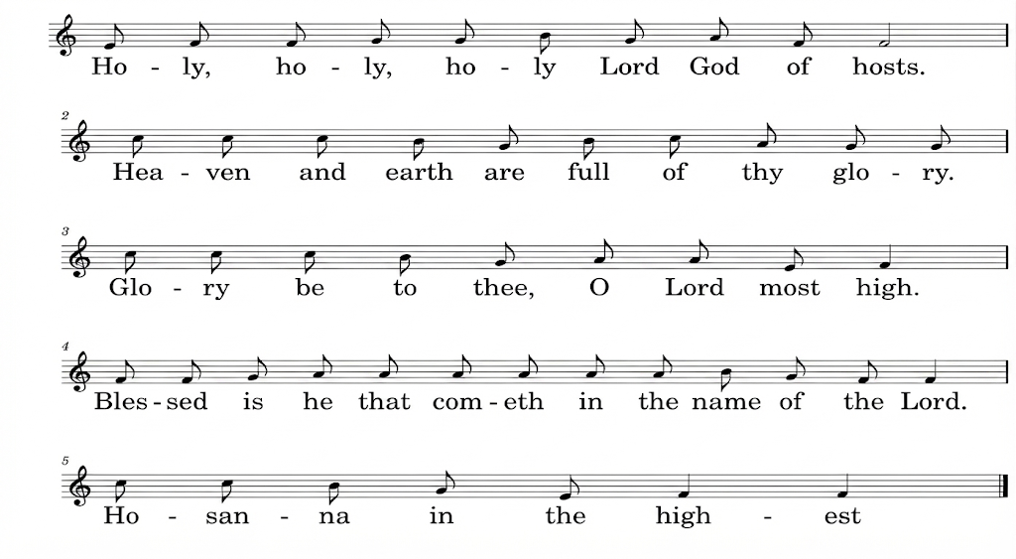
All Holy, holy, holy, Lord God of hosts.
Heaven and earth are full of thy glory.
Glory be to thee, O Lord most high.
Blessed is he that cometh
in the name of the Lord. Hosanna in the highest.
Please kneel or sit,
Accept our praises, heavenly Father,
through your Son our Saviour Jesus Christ,
and as we follow his example and obey his command,
grant that by the power of your Holy Spirit
these gifts of bread and wine
may be to us his body and his blood;
who, in the same night that he was betrayed,
took bread and gave you thanks;
he broke it and gave it to his disciples, saying: Take, eat;
this is my body which is given for you; do this in remembrance of me.
In the same way, after supper
he took the cup and gave you thanks;
he gave it to them, saying: Drink this, all of you;
this is my blood of the new covenant,
which is shed for you and for many for the forgiveness of sins.
Do this, as often as you drink it, in remembrance of me.
Therefore, heavenly Father,
we remember his offering of himself
made once for all upon the cross;
we proclaim his mighty resurrection and glorious ascension;
we look for the coming of your kingdom,
and with this bread and this cup
we make the memorial of Christ your Son our Lord.
Christ is the bread of life:
All When we eat this bread and drink this cup,
we proclaim your death, Lord Jesus,
until you come in glory.
Accept through him, our great high priest,
this our sacrifice of thanks and praise,
and as we eat and drink these holy gifts
in the presence of your divine majesty,
renew us by your Spirit, inspire us with your love
and unite us in the body of your Son, Jesus Christ our Lord.

Through him, and with him, and in him,
in the unity of the Holy Spirit,
with all who stand before you in earth and heaven,
we worship you, Father almighty, in songs of everlasting praise:
All Blessing and honour and glory and power
be yours for ever and ever.
Amen.

THE LORD’S PRAYER

Let us pray with confidence as our Saviour has taught us
All Our Father, who art in heaven, hallowed be thy name;
thy kingdom come; thy will be done; on earth as it is in heaven.
Give us this day our daily bread.
And forgive us our trespasses,
as we forgive those who trespass against us.
And lead us not into temptation; but deliver us from evil. For thine is the kingdom, the power and the glory,
for ever and ever. Amen.

BREAKING OF THE BREAD
The president breaks the consecrated bread.
We break this bread to share in the body of Christ.
All Though we are many, we are one body,
because we all share in one bread.
Draw near with faith. Receive the body of our Lord Jesus Christ
which he gave for you, and his blood which he shed for you.
Eat and drink in remembrance that he died for you,
and feed on him in your hearts by faith with thanksgiving.
All Amen.

AGNUS DEI
O Lamb of God, that takest away the sins of the world,
have mercy upon us.
O lamb of God that takest away the sins of the world,
have mercy upon us’
O Lamb of God, that takest away the sins of the world,
grant us thy peace.

AGNUS DEI J Merbecke
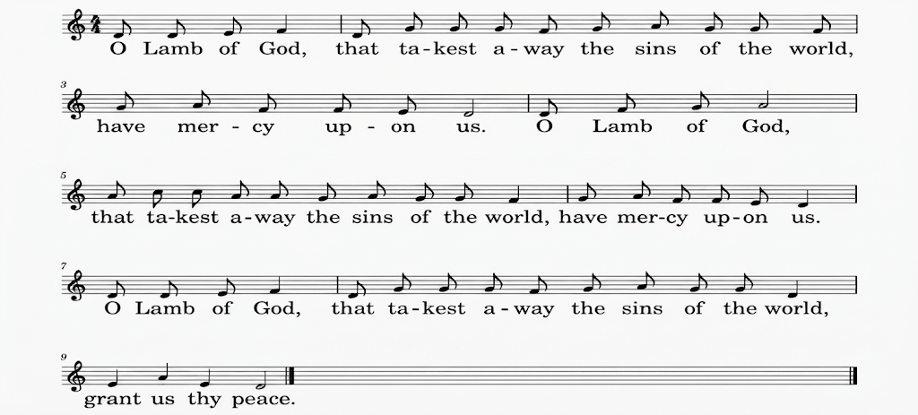
THE COMMUNION

You are welcome to receive if this is your practice. If you prefer to receive a blessing please carry this booklet to the Altar. If you wish to receive Gluten Free, or wafers with wine already added please ask
HYMN DURING COMMUNION 357 Father, hear the prayer we offer
- Father, hear the prayer we offer:
Not for ease that prayer shall be,
But for strength that we may ever
Live our lives courageously.
- Not for ever in green pastures
Do we ask our way to be;
But the steep and rugged pathway
May we tread rejoicingly.
- Not for ever by still waters
Would we idly rest and stay;
But would smite the living fountains
From the rocks along our way.
- Be our strength in hours of weakness,
In our wanderings be our guide;
Through endeavour, failure, danger,
Father, be thou at our side. Maria Willis 1824-1908 Tune Sussex
PRAYER AFTER COMMUNION
Lord God, the source of truth and love,
keep us faithful to the apostles’ teaching and fellowship,
united in prayer and the breaking of bread,
and one in joy and simplicity of heart,
in Jesus Christ our Lord.
All Amen.
Thanksgiving, said by everyone.
All Almighty God,
we thank you for feeding us
with the body and blood of your Son Jesus Christ.
Through him we offer you our souls and bodies
to be a living sacrifice.
Send us out in the power of your Spirit
to live and work to your praise and glory. Amen.
SUNDAY CLUB FEEDBACK, MARY MOUSE & NOTICES
AN APPRECIATION OF THE LIGHT WE SEE IN EACH OTHER – CERTIFICATES OF APPRECIATION.
CLOSING HYMN: Father, Lord of all creation
- Father, Lord of all creation,
Ground of being, life and love;
Height and depth beyond description
Only life in you can prove:
You are mortal life’s dependence:
Thought, speech, sight are ours by grace;
Yours is every hour’s existence,
Sovereign Lord of time and space.

- Jesus Christ, the Man for others,
We, your people, make our prayer:
Help us love, as sisters, brothers,
All whose burdens we can share.
Where your name binds us together
You, Lord Christ, will surely be;
Where no selfishness can sever
There your love the world may see.
- Holy Spirit, rushing, burning,
Wind and flame of Pentecost,
Fire our hearts afresh with yearning
To regain what we have lost.
May your love unite our action,
Never more to speak alone:
God, in us abolish faction,
God, through us your love make known.
Bishop David Cross. Tune ABBOT'S LEIGH
THE DISMISSAL
THE BLESSING
Please remain standing
The peace of God, which passes all understanding,
keep your hearts and minds in the knowledge and love of God,
and of his Son Jesus Christ our Lord:
and the blessing of God almighty, the Father, the Son,
and the Holy Spirit, be amongst you and remain with you always.
All Amen.
Go in peace to love and serve the Lord.
All In the name of Christ. Amen.
You are warmly invited to join us for refreshments in the Community Room after this service.

Common Worship, Services and Prayers for the Church of England, material in this service, is copyright © The Archbishops' Council 2000 and 2008. CCLI 1031266

