

Parish of St Mary the Virgin
Great Shelford

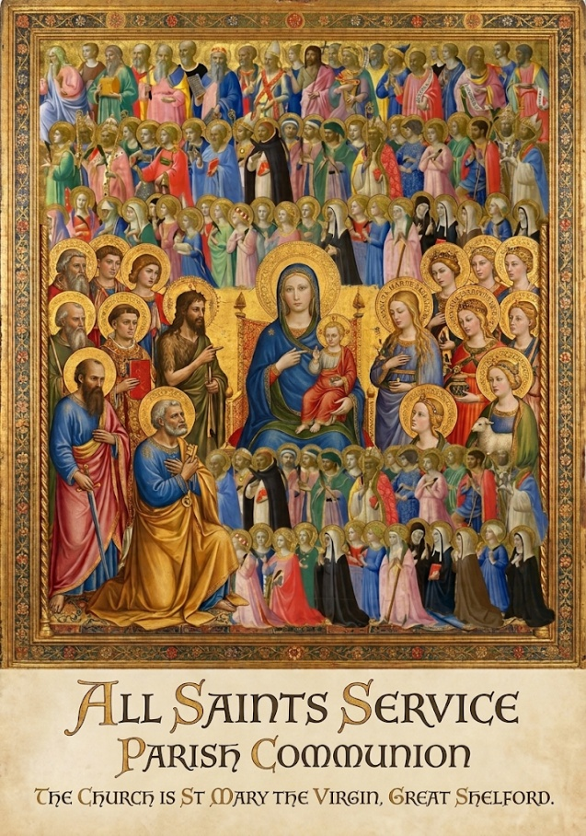

Feast of All Saints

1 November 2026
10am

Mass Setting MERBECKE
Welcome to St Mary’s Church
Please note that when instructed to stand or kneel, this can be accomplished in body or heart.
Please stand as the Choir process and the first hymn is announced.

THE OPENING HYMN 197 For all the Saints
- For all the Saints who from their labours rest,
Who thee by faith before the world confest.
Thy name, O Jesu, be for ever blest.
Alleluya! Alleluya!
- Thou wast their Rock, their Fortress, and their Might;
Thou, Lord, their Captain in the well fought fight;
Thou in the darkness drear their one true Light.
Alleluya! Alleluya!
- O may thy soldiers, faithful, true, and bold,
Fight as the Saints who nobly fought of old,
And win, with them, the victor's crown of gold.
Alleluya! Alleluya!
- O blest communion! fellowship divine!
We feebly struggle, they in glory shine;
Yet all are one in thee, for all are thine.
Alleluya! Alleluya!
- And when the strife is fierce, the warfare long,
Steals on the ear the distant triumph-song,
And hearts are brave again, and arms are strong.
Alleluya! Alleluya! W. Walsham How Tune SINE NOMINE
THE GATHERING
The president says,
In the name of the Father,
and of the Son,
and of the Holy Spirit.
All Amen.

THE WELCOME
Grace, mercy and peace from God our Father
and the Lord Jesus Christ be with you
All and also with you.

PRAYERS OF CONFESSION

Since we are surrounded by a great cloud of witnesses, let us also lay aside every weight and the sin that clings so closely, looking to Jesus in penitence and faith. Hebrews 12:1

Silence

Your unfailing kindness, O Lord, is in the heavens,

and your faithfulness reaches to the clouds: Lord, have mercy.

All Lord, have mercy.

Your righteousness is like the strong mountains,

and your justice as the great deep: Christ, have mercy.

All Christ, have mercy.

For with you is the well of life

and in your light shall we see light: Lord, have mercy.

All Lord, have mercy
Almighty God, who forgives all who truly repent, have mercy upon you, pardon and deliver you from all your sins, confirm and strengthen you in all goodness, and keep you in life eternal: through Jesus Christ our Lord.
All Amen.

We stand and pray as the children prepare to leave for their activities.

All Creator God, we thank you for giving us Jesus as our Saviour:

he blessed the children who came to him,

and welcomes those who come to him now.

Look with love upon these children

and protect them with your care.

May they grow in wisdom, age and strength

in your presence and in the sight of all.

We ask this through your beloved Son,

Jesus Christ our Lord. Amen.

Please remain standing for the Gloria

THE GLORIA MERBECKE
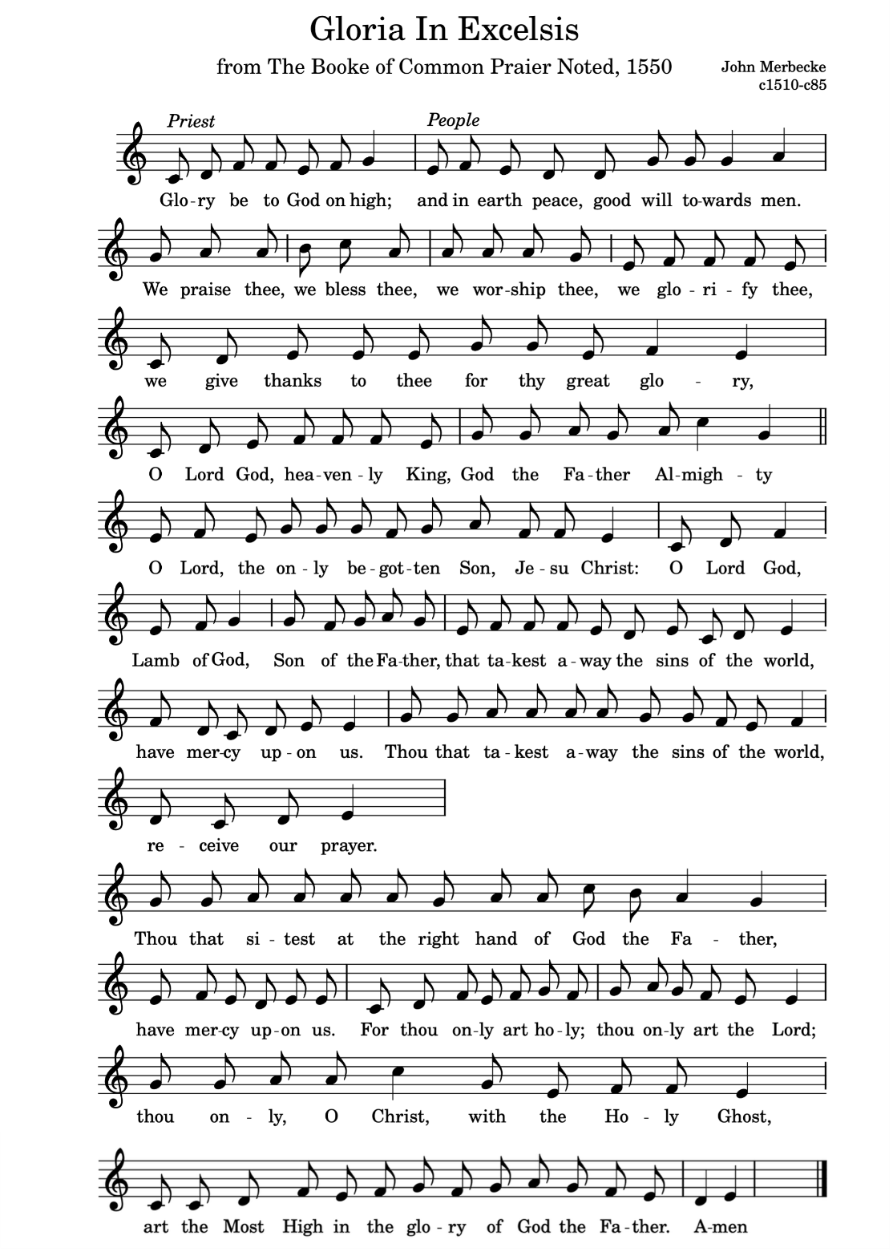
Glory be to God on high, and in earth peace, goodwill towards men.
We praise thee, we bless thee, we worship thee, we glorify thee.
We give thanks to thee for they great glory,
O Lord God, heavenly King, God the Father almighty.
O Lord the only begotten Son, Jesu Christ;
O Lord God Lamb of God, Son of the Father,
that takest away the sins of the world, have mercy upon us.
Thou that takest away the sins of the world, receive our prayer.
Thou that sittest at the right hand of God the Father, have mercy upon us. For thou only art holy, thou only art the Lord;
Thou only, O Christ, with the Holy Ghost, art the Most High
in the glory of God the Father. Amen.
THE COLLECT
All Almighty God, you have knit together your elect
in one communion and fellowship
in the mystical body of your Son Christ our Lord:
grant us grace so to follow your blessed saints
in all virtuous and godly living
that we may come to those inexpressible joys
that you have prepared for those who truly love you. Amen

FIRST READING Revelation 7. 9- 17

Please sit for the first two readings

After this I looked, and there was a great multitude that no one could count, from every nation, from all tribes and peoples and languages, standing before the throne and before the Lamb, robed in white, with palm branches in their hands. They cried out in a loud voice, saying,

‘Salvation belongs to our God who is seated on the throne, and to the Lamb!’

And all the angels stood around the throne and around the elders and the four living creatures, and they fell on their faces before the throne and worshipped God, singing, ‘Amen! Blessing and glory and wisdom and thanksgiving and honour

and power and might be to our God for ever and ever! Amen.’

Then one of the elders addressed me, saying, ‘Who are these, robed in white, and where have they come from?’

I said to him ‘Sir, you are the one that knows.’

Then he said to me, ‘These are they who have come out of the great ordeal; they have washed their robes and made them white in the blood of the Lamb.

For this reason they are before the throne of God, and worship him day and night within his temple, and the one who is seated on the throne will shelter them.

They will hunger no more, and thirst no more; the sun will not strike them,

nor any scorching heat; for the Lamb at the centre of the throne will be their shepherd, and he will guide them to springs of the water of life,

and God will wipe away every tear from their eyes.’
This is the word of the Lord.
All Thanks be to God.
SECOND READING: 1 John 3 1-3
See what love the Father has given us, that we should be called children of God; and that is what we are. The reason the world does not know us is that it did not know him. Beloved, we are God's children now; what we will be has not yet been revealed. What we do know is this: when he is revealed, we will be like him, for we will see him as he is. And all who have this hope in him purify themselves, just as he is pure.
This is the word of the Lord.
All Thanks be to God.

Please stand to sing

THE GRADUAL HYMN 373 ‘How shall I sing that majesty’
- How shall I sing that majesty
Which angels do admire?
Let dust in dust and silence lie;
Sing, sing, ye heavenly choir.
Thousands of thousands stand around
Thy throne, O God most high;
Ten thousand times ten thousand sound
Thy praise; but who am I?
- Thy brightness unto them appears,
Whilst I thy footsteps trace;
A sound of God comes to my ears,
But they behold thy face.
They sing because thou art their Sun;
Lord, send a beam on me;
For where heaven is but once begun
There alleluyas be.
- Enlighten with faith’s light my heart,
Inflame it with love’s fire;
Then shall I sing and bear a part
With that celestial choir.
I shall, I fear, be dark and cold,
With all my fire and light;
Yet when thou dost accept their gold,
Lord, treasure up my mite.

- How great a being, Lord, is thine,
Which doth all beings keep!
Thy knowledge is the only line
To sound so vast a deep.
Thou art a sea without a shore,
A sun without a sphere;
Thy time is now and evermore,
Thy place is everywhere John Mason. Tune COE FEN

Please remain standing and face the Gospel.

THE GOSPEL Matthew 5.1-12

Alleluia, alleluia.

You are a chosen race, a royal priesthood, a holy nation,

God’s own people, called out of darkness into his marvellous light.

All Alleluia,

Hear the Gospel of our Lord Jesus Christ according toMatthew

All Glory to you, O Lord.

When Jesus saw the crowds, he went up the mountain; and after he sat down, his disciples came to him. Then he began to speak, and taught them, saying: “Blessed are the poor in spirit, for theirs is the kingdom of heaven. “Blessed are those who mourn, for they will be comforted. “Blessed are the meek, for they will inherit the earth. “Blessed are those who hunger and thirst for righteousness, for they will be filled. “Blessed are the merciful, for they will receive mercy. “Blessed are the pure in heart, for they will see God. “Blessed are the peacemakers, for they will be called children of God. “Blessed are those who are persecuted for righteousness’ sake, for theirs is the kingdom of heaven. “Blessed are you when people revile you and persecute you and utter all kinds of evil against you falsely on my account. Rejoice and be glad, for your reward is great in heaven.”

This is the Gospel of the Lord. All Praise to you, O Christ.

Sermon

PRAYERS OF INTERCESSION
Please sit or kneel to pray
In the power of the Spirit and in union with Christ let us pray to the Father.
At the end
Merciful Father,
All accept these prayers for the sake of your Son,
our Saviour Jesus Christ. Amen
THE LITURGY OF THE SACRAMENT
THE PEACE
Please stand
We are fellow-citizens with the saints and of the household of God, through Christ our Lord, who came and preached peace to those who were far off and those who were near.
The peace of the Lord be always with you.
All and also with you.
Let us offer one another a sign of peace.
Please stand. During the hymn, the gifts of the people are gathered and presented.
THE OFFERTORY and CREEDAL HYMN
- We believe in God the Father,
God Almighty, by whose plan
Earth and Heaven sprang into being,
All created things began.
We believe in Christ the Saviour,
Son of God in human frame,
Virgin born, the Child of Mary,
Upon whom the Spirit came.
- Christ, who on the cross forsaken,
Like a lamb to slaughter led,
Suffered under Pontius Pilate,
He descended to the dead.
We believe in Jesus risen,
Heaven’s King to rule and reign,
To the Father’s side ascended
Till as Judge He comes again.
- We believe in God the Spirit:
In one Church, below, above;
Saints of God in one communion,
One in holiness and love.
So by faith, our sins forgiven,
Christ our Saviour, Lord and friend,
We shall rise with Him in glory
To the life that knows no end.
Timothy Dudley Smith, Tune Blaenwern
Please remain standing
PREPARATION OF THE TABLE
To you we come, Father of lights,
with angels and saints,
where heaven and earth unite.
May Jesus meet us in the breaking of the bread.
All Amen.
The president says
THE EUCHARISTIC PRAYER
The Lord is here.
All His Spirit is with us.
Lift up your hearts.
All We lift them to the Lord.
Let us give thanks to the Lord our God.
All It is right to give thanks and praise.
Lord of all life,
you created the universe,
where all living things reflect your glory.
You give us this great and beautiful earth,
to discover and to cherish.
And now we give you thanks
because in him you have received us
as your sons and daughters,
joined us in one fellowship with the saints,
and made us citizens of your kingdom.
Therefore we lift our voices to proclaim the glory of your name and sing our joyful hymn of praise:
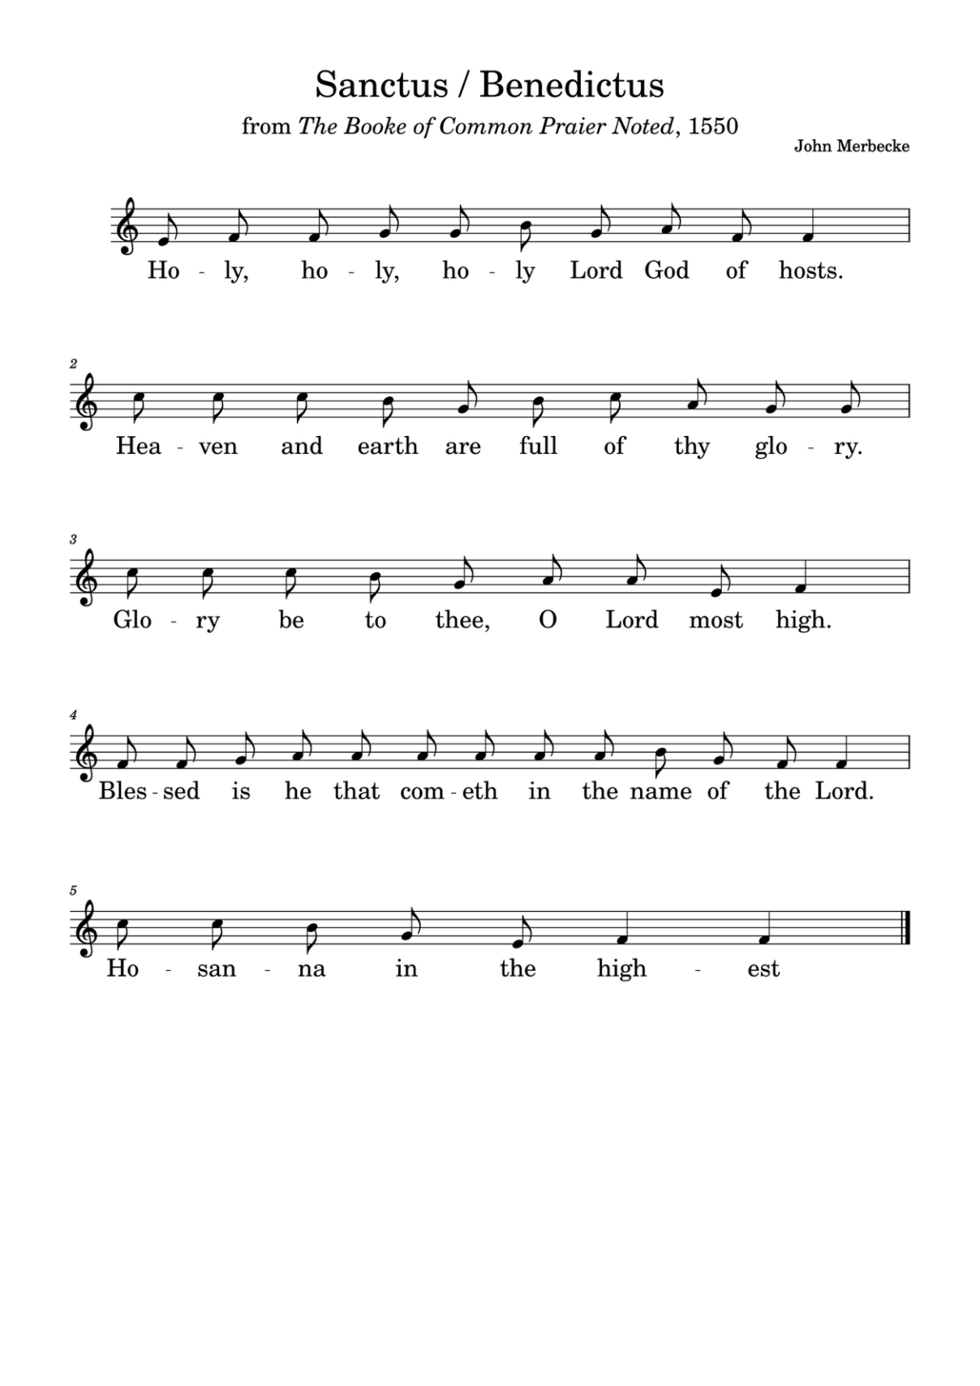
THE SANCTUS/BENEDICTUS
Holy, holy, holy, Lord God of hosts.
Heaven and earth are full of thy glory.
Glory be to thee, O Lord most high.
Blessed is he that cometh in the name of the Lord.
Hosanna in the highest.
Accept our praises, heavenly Father,
through your Son our Saviour Jesus Christ,
and as we follow his example and obey his command,
grant that by the power of your Holy Spirit
these gifts of bread and wine may be to us his body and his blood;
who, in the same night that he was betrayed,
took bread and gave you thanks;
he broke it and gave it to his disciples, saying:
Take, eat; this is my body which is given for you;
do this in remembrance of me.
In the same way, after supper he took the cup and gave you thanks he gave it to them, saying:
Drink this, all of you; this is my blood of the new covenant,
which is shed for you and for many
for the forgiveness of sins.
Do this, as often as you drink it, in remembrance of me.
Therefore, heavenly Father, we remember his offering of himself made once for all upon the cross;
we proclaim his mighty resurrection and glorious ascension;
we look for the coming of your kingdom;
and with this bread and this cup
we make the memorial of Christ your Son our Lord.
Great is the mystery of faith:
All Christ has died: Christ is risen:
Christ will come again.
Accept through him, our great high priest,
this our sacrifice of thanks and praise,
and as we eat and drink these holy gifts
in the presence of your divine majesty,
renew us by your Spirit, inspire us with your love
and unite us in the body of your Son, Jesus Christ our Lord.
Through him, and with him, and in him,
in the unity of the Holy Spirit, with St Mary
and all who stand before you in earth and heaven,
we worship you, Father almighty,
in songs of everlasting praise:
All Blessing and honour and glory and power
be yours for ever and ever. Amen.

THE LORD’S PRAYER

Let us pray with confidence as our Saviour has taught us
All Our Father, who art in heaven, hallowed be thy name;
thy kingdom come; thy will be done;
on earth as it is in heaven.
Give us this day our daily bread. And forgive us our trespasses,
as we forgive those who trespass against us.
And lead us not into temptation;
but deliver us from evil.
For thine is the kingdom, the power and the glory,
for ever and ever. Amen.

BREAKING OF THE BREAD
The president breaks the consecrated bread.
We break this bread to share in the body of Christ.
All Though we are many, we are one body,
because we all share in one bread.
GIVING OF COMMUNION
The president says
Draw near with faith.
Receive the body of our Lord Jesus Christ
which he gave for you and his blood which he shed for you.
Eat and drink in remembrance that he died for you,
and feed on him in your hearts by faith with thanksgiving
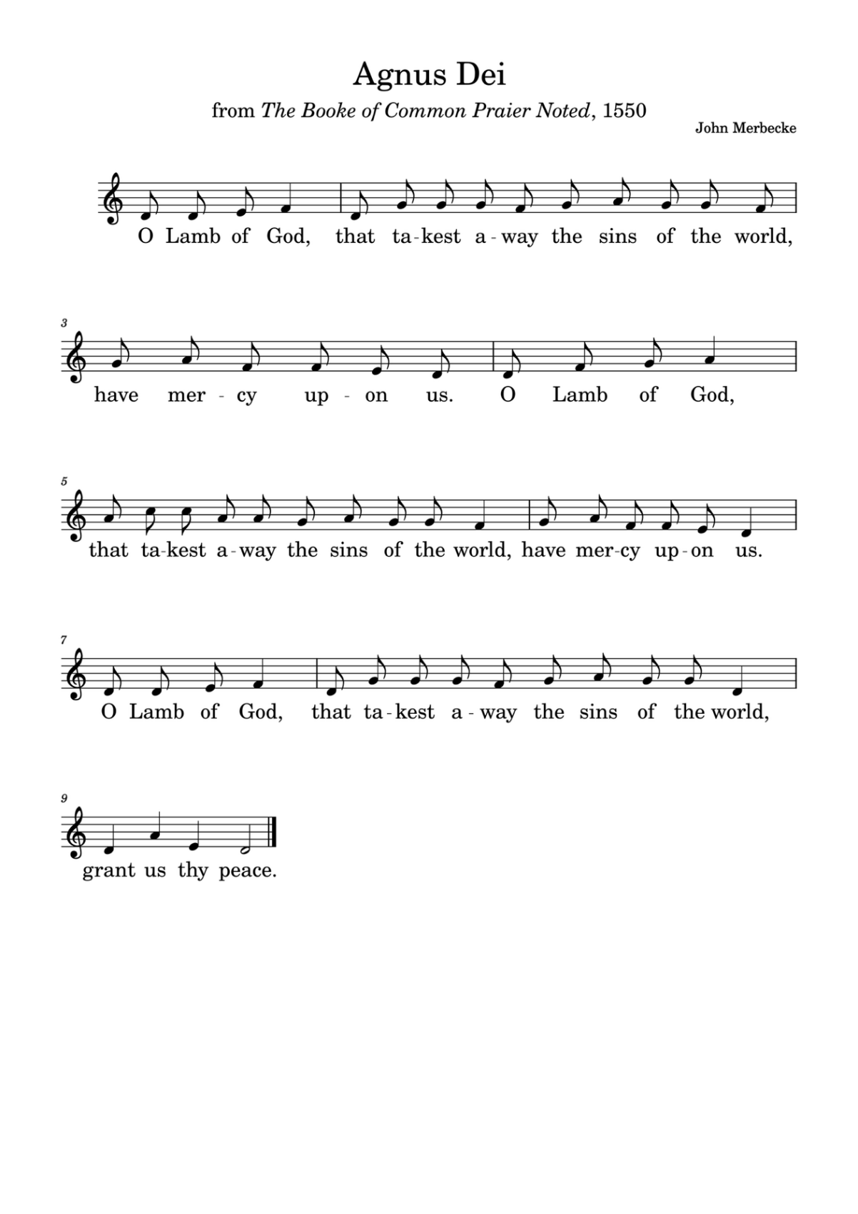
THE AGNUS DEI
O Lamb of God, that takest away the sins of the world, have mercy upon us.
O lamb of God that takest away the sins of the world have mercy upon us’
O Lamb of God, that takest away the sins of the world, grant us thy peace.

If you normally receive communion in your Church you are welcome to do so here. If you would like a wafer with the wine already present, please ask, but do not dip. Similarly, if you would like gluten free wafer, please ask. If you would like to receive a blessing please carry this Booklet.
HYMN DURING THE COMMUNION 381: Jerusalem the golden
- Jerusalem the golden,
With milk and honey blest,
Beneath thy contemplation
Sink heart and voice opprest.
I know not, O I know not,
What social joys are there,
What radiancy of glory,
What light beyond compare.
- They stand, those halls of Sion,
Conjubilant with song,
And bright with many an angel,
And all the martyr throng;
The Prince is ever in them,
The daylight is serene,
The pastures of the blessèd
Are decked in glorious sheen.
- There is the throne of David,
And there, from care released,
The song of them that triumph,
The shout of them that feast;
And they who, with their Leader,
Have conquered in the fight,
For ever and for ever
Are clad in robes of white.
- O sweet and blessèd country,
Shall I ever see thy face?
O sweet and blessèd country,
Shall I ever win thy grace?
Exult, O dust and ashes!
The Lord shall be thy part:
His only, his for ever,
Thou shalt be, and thou art!
Bernard of Cluny 12th century Tr J.M. Neale 1818 – 66 Tune: EWING

PRAYER AFTER COMMUNION
God, the source of all holiness and giver of all good things:
may we who have shared at this table
as strangers and pilgrims here on earth
be welcomed with all your saints into your Kingdom.
All Amen
All Almighty God, we thank you for feeding us
with the body and blood of your Son Jesus Christ.
Through him we offer you our souls and bodies
to be a living sacrifice.
Send us out in the power of your Spirit
to live and work to your praise and glory. Amen.
MARY MOUSE & SUNDAY CLUB AND PILGRIM GROUP & NOTICES
NB. Remembrance Service at 9.30am next week at the Free Church. No 10am service at St Mary the Virgin
Please stand to sing our closing Hymn of praise which vividly portrays the Communion of Saints and the cosmic worship of God.
CLOSING
- Ye watchers and ye holy ones,
Bright Seraphs, Cherubim and Thrones,
Raise the glad strain, Alleluya!
Cry out Dominions, Princedoms, Powers,
Virtues, Archangels, Angels' choirs,
Refrain: Alleluya, Alleluya,
Alleluya, Alleluya, Alleluya!
- O higher than the Cherubim,
More glorious than the Seraphim,
Lead their praises, Alleluya!
Thou Bearer of the eternal Word,
Most gracious, magnify the Lord, [Refrain]
- Respond, ye souls in endless rest,
Ye Patriarchs and Prophets blest,
Alleluya, Alleluya!
Ye holy Twelve, ye Martyrs strong,
All Saints triumphant, raise the song [Refrain]
- O friends, in gladness let us sing,
Supernal anthems echoing,
Alleluya, Alleluya!
To God the Father, God the Son,
And God the Spirit, Three in One, [Refrain] Athelstan Riley. Tune: LASST UNS ERFREUEN ( 4vv)
DISMISSAL
THE BLESSING
Christ Jesus,
the splendour of the Father and the image of his being,
draw you to himself
that you may live in his light and share his glory;
and the blessing of God almighty…,
All Amen.
Go in peace to love and serve the Lord.
All In the name of Christ. Amen.

You are warmly invited to join us for refreshments in the Community Room after this service

Common Worship, Services and Prayers for the Church of England, material in this service, is copyright © The Archbishops' Council 2000 and 2008 . CCLI 1031266

