
The Parish Church of
St Mary the Virgin, Great Shelford Charity No: 245456

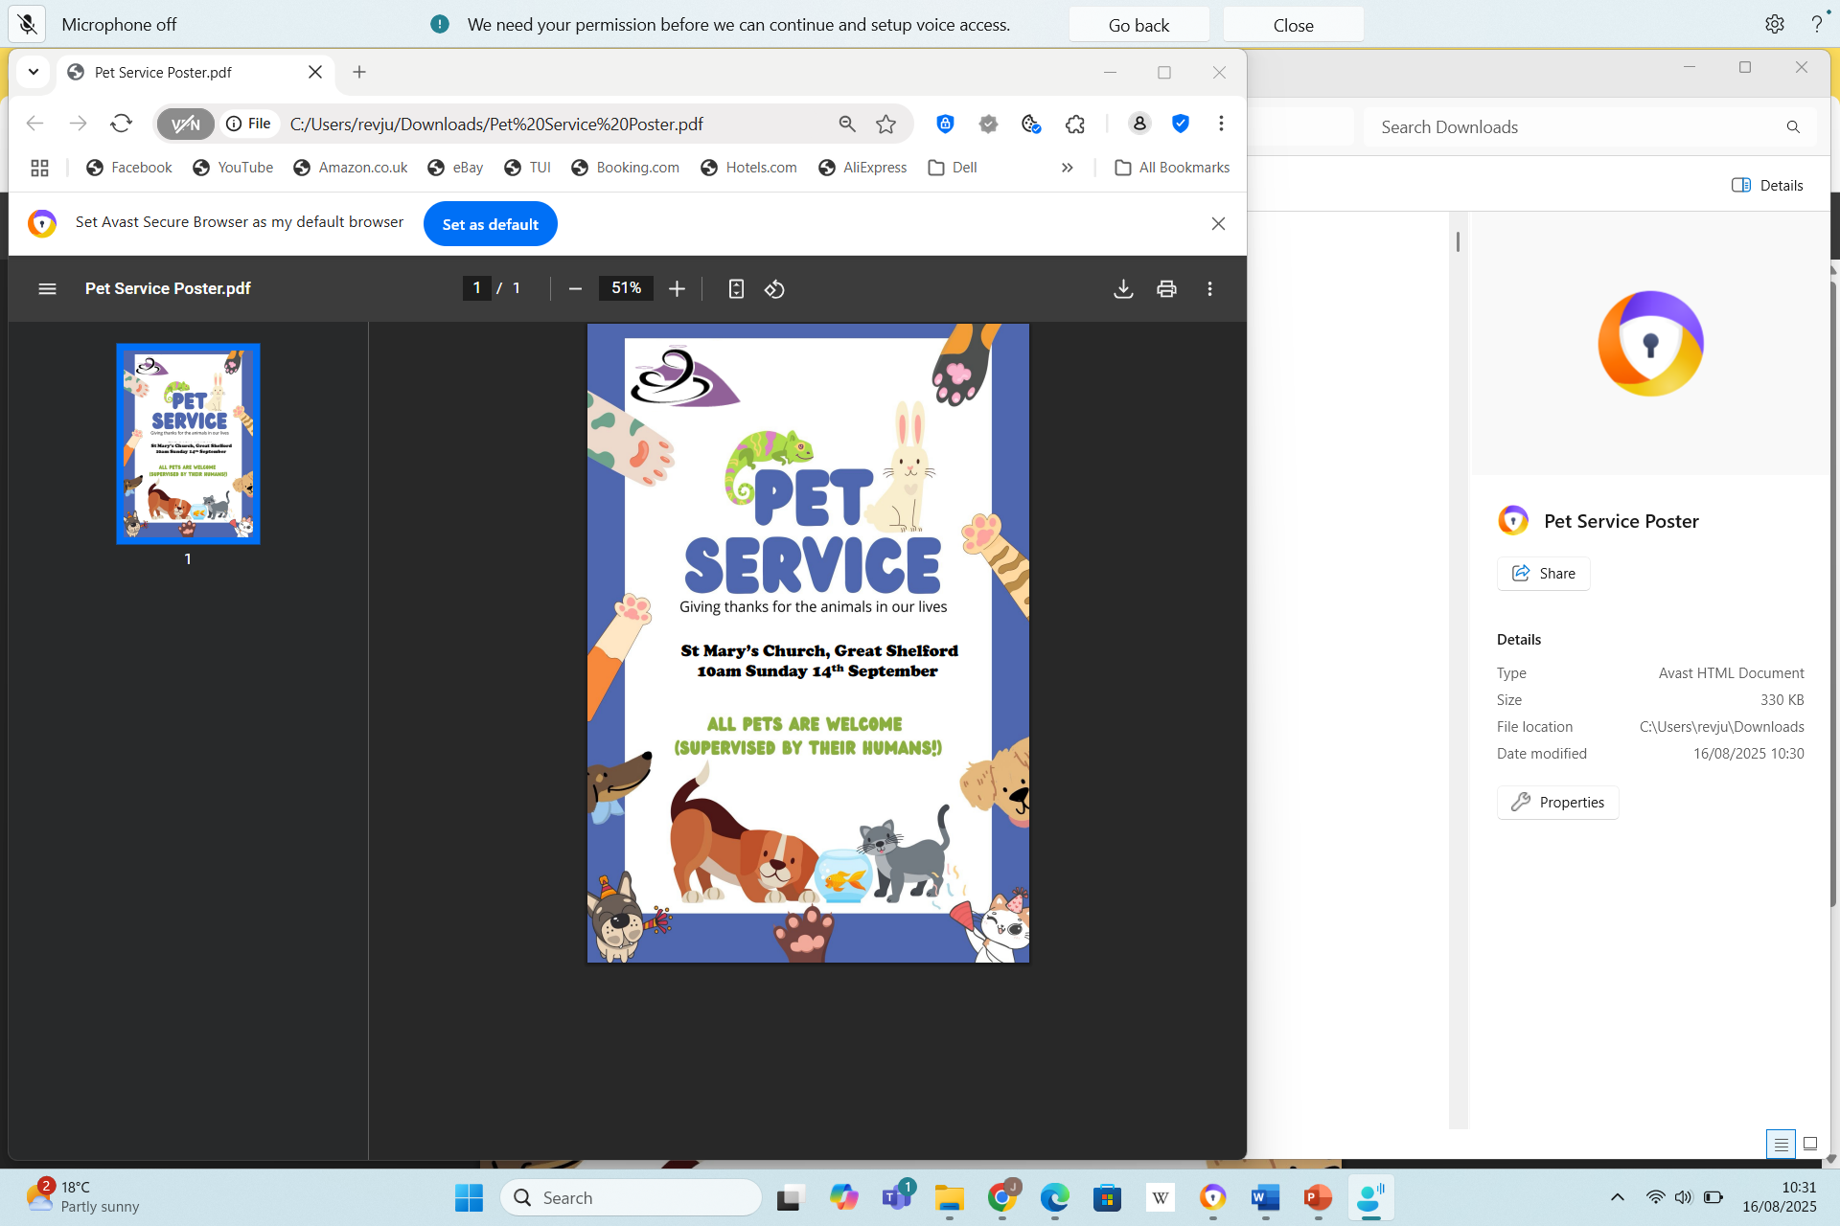

Sunday 14th September 2025
10am

Parish Service followed by short Communion service

We are delighted to welcome you and your pets today. For their comfort, there are water bowls outside the doors and some treats at the back of church. Please make sure that they are comfortable and not distressed.
There is to be a short Communion following on from the Pet Service. This will take place in the Chancel area. We invited those with pets to leave for treats and refreshments during the last hymn.

Please stand to sing as the choir processes

OPENING HYMN –
- All creatures of our God and King,
Lift up your voice and with us sing
Alleluya, alleluya!
Thou burning sun with golden beam,
Thou silver moon with softer gleam:
Refrain: O praise him, O praise him
Alleluya, Alleluya, Alleluya!
- Thou flowing water, pure and clear,
Make music for thy Lord to hear,
Alleluya, Alleluya!
Thou fire so masterful and bright,
That givest man both warmth and light: [Refrain]
- Dear mother earth, who day by day
Unfoldest blessings on our way,
O praise him, Alleluya!
The flowers and fruits that in thee grow,
Let them his glory also show: [Refrain]
- Let all things their Creator bless,
And worship him in humbleness,
O praise him! Alleluya!
Praise, praise the Father, praise the Son,
And praise the Spirit, three in One: [Refrain]
St Francis of Assisi. Tune. LASST UNS ERFREUEN (R Vaughan Williams)

THE WELCOME AND GATHERING

The president says
We meet in the name of God:
All Father, Son and Holy Spirit.
We have come together, amid the beauty of God’s creation,
to rejoice with him at the wonderful creatures around us.
God of a thousand ears, the music of your creatures resounds throughout creation and in heaven a symphony is made.
All Christ, in all things restore our senses and give us again that experience of joy in all created things.
WE WELCOME AND THANK GOD FOR OUR PETS
God, the Father, Son and Holy Spirit,
who is wonderful in all his works,
be with you.
All and also with you.
CONFESSION AND ABSOLUTION
The President says
God called us in the beginning to be stewards of creation, caring for and nurturing the world.
As we come to ask for God’s blessing on our pets we first ask for forgiveness for the times we have not made the best use of His blessings and gifts.
Please sit or kneel to pray
When we have forgotten you, Lord Have Mercy
All Lord Have Mercy
When we take for granted the gifts you give, Christ have mercy
All Christ Have Mercy
When our love is selfish Lord Have Mercy
All Lord Have Mercy
May the God of Earth and Heaven cleanse you of all sin
and draw you to His wonderful light.
All Amen.
Please stand for the Collect
THE COLLECT
Creator God, you made the goodness of this land,
the riches of the sea, and the rhythm of the seasons;
as we thank you for the harvest,
may we cherish and respect this planet and its peoples,
through Jesus Christ our Lord. Amen
All O God, you have made us and all living things
to form your family on earth.
You are even more wonderful than what you have made. We thank you for giving us these pets who bring us joy.
As you take care of us, may we take care of the creatures who trust us to look after them.
By doing this, we share in your own love for all creation.
We ask this in the name of Jesus our Lord.
Amen.
Please be seated
THE FIRST READING - Job 12:7-10
‘But ask the animals, and they will teach you;
the birds of the air, and they will tell you;
ask the plants of the earth, and they will teach you;
and the fish of the sea will declare to you.
Who among all these does not know
that the hand of the Lord has done this?
In his hand is the life of every living thing
and the breath of every human being.
This is the word of the Lord
All Thanks be to God.
remain standing for the Gospel reading.
THE GOSPEL
Hear the Gospel of the Lord Jesus Christ according to Matthew.
All Glory to you O Lord
Are not two sparrows sold for a penny? Yet not one of them will fall to the ground unperceived by your Father. And even the hairs of your head are all counted. So do not be afraid; you are of more value than many sparrows. Matthew 10. 29-31
This is the Gospel of the Lord
All Praise to you O Christ
Hymn Morning has broken
- Morning has broken
like the first morning,
blackbird has spoken
like the first bird.
Praise for the singing!
Praise for the morning!
Praise for them, springing
fresh from the Word!
- Sweet the rain’s new fall
sunlit from heaven,
like the first dewfall
on the first grass.
Praise for the sweetness
of the wet garden,
sprung in completeness
where God’s feet pass.
- Mine is the sunlight!
Mine is the morning
born of the one light
Eden saw play!
Praise with elation,
praise every morning,
God’s recreation
of the new day!
Eleanor Farjeon. Tune. BUNNESAN
REFLECTION – Please sit

PRAYERS OF THANKSGIVING AND INTERCESSION
Rejoicing in a world of wonders,
we join with all living things to praise our Creator,
and to ask for his protection of our planet
which is forever moving and shifting;
and where life tries to find a way.
With the moon that dips low in the sky
and the sun coaxing the shooting seed:
All let your holy name be praised.
For the wind which tosses the trees
and plucks the leaves from their branches,
and the rain which is filling the parched streams and gulleys:
All let your holy name be praised.
Rejoicing in a world of wonders,
we join with them to praise our Creator.
For all that is gigantic, small, slithering, rippling,
furry, glistening, spiky, feathered, soft, strong or wild:
All let your holy name be praised. Amen
Prayer after Saint Francis for Animals
God our Heavenly Father, you created the world
to serve humanity's needs and to lead them to you.
By our own fault we have lost the beautiful relationship
which we once had with all your creation.
Help us to restore our relationship with you
and with all your creation.
All Amen
Moment of Remembrance
We give thanks for the memories of those loved pets we have lost.
We remember with thanksgiving their loving friendship and acceptance of our ways, and how they enriched our lives.
We pray for all who this day mourn their loss.
Bring peace and consolation to each of them. Amen

THE LORD’S PRAYER
As our Saviour taught us, so we pray
All Our Father, who art in heaven,
hallowed be thy name;
Thy kingdom come; thy will be done;
On earth as it is in heaven.
Give us this day our daily bread.
And forgive us our sins
as we forgive each other
And lead us not into temptation;
but deliver us from evil.
For thine is the kingdom,
the power and the glory,
for ever for ever .Amen.
AFFIRMATION OF FAITH
Please stand as the President says
Let us declare our faith in God.
All We believe in God the Father,
from whom every family

in heaven and on earth is named.

We believe in God the Son,

who lives in our hearts through faith,

and fills us with his love.

We believe in God the Holy Spirit,

who strengthens us

with power from on high.

We believe in one God;

Father, Son and Holy Spirit. Amen.
THE PEACE
Please stand as the President says
God gave our first parents the animals
when creation lived in peace.
We are called to be peacemakers –
with each other and the whole of creation.
In Christ’s name we share his peace.
The peace of the Lord be with you always.
All and also with you.
Let us offer one another a sign of peace.
All may exchange a sign of peace.
BLESSING OF THE PETS
Please remain in your places as the clergy walk around the congregation blessing the animals:

Blessed are you, Lord God, maker of all living creatures.
You called forth fish in the sea, birds in the air
and animals on the land.
As Saint Francis called all of them his brothers and sisters, we also pray for you blessing on these pets.
By the power of your love,
enable them to live according to your purpose.
May we always praise you for all your beauty in creation.
All Blessed are you, in all your creatures,
O Lord our God. Amen.
To each pet a member of the clergy team will say,
N, may God bless you and your human family. Amen
As the clergy go around the church to bless the animals, Harriet will sing,
Hymn
All pets weird and wonderful,
Tiny, short or tall.
Fluffy, wriggly or sleek
We thank you for them all!
- Dogs going for long walkies,
Or barking for their tea!
Cats who know they own the house,
Aloof, yet cuddly!
All pets weird and wonderful...
- The horses in the meadow
The goats inside their pen.
That darling little rabbit has
Dug up the lawn again...
All pets weird and wonderful...
- Sleek snakes and bearded dragons,
Giant snails and tiny ants!
Stick insects and green Gekkos
Dear Lord, we raise our thanks!
- Budgies and bright parrots,
Chinchillas and guinea pigs too!
We love our pets so very much
And Lord, they come from you!
All pets weird and wonderful...
- So help us to care for them
In the kindest ways,
To repay laughs, and cuddles
That brighten up our days!
All pets weird and wonderful...
Harriot Applegate-Trick Tune. ALL THINGS BRIGHT AND BEAUTIFUL (Monk)
PRAYER OF COMMITMENT TO CARE FOR GOD’S CREATION
Lord God our creator,
we praise you for the love and friendship of these animals.
We promise that we will do our best to care for them,
and to treat them and all your creatures
with the respect that is their due.
Help us to keep this promise and to work with you
to maintain the beauty and wonder of your creation,
we ask this in the name of Jesus Christ our Lord. Amen.

THE BLESSING
May the God of all creation,
who clothes the lilies and feeds the birds of the sky,
Who leads the lamb to pasture and the deer to water
give to us, and all creation, newness of life.
And the blessing of God almighty,
the Father, the Son, and the Holy Spirit,
be among you and remain with you always.
All Amen
The Closing Hymn
- Make me a channel of your peace,
Where there is hatred let me bring your love
Where there is injury, your pardon, Lord,
And where there’s doubt, true faith in you.
Refrain Master grant that I may never seek
So much to be consoled as to console;
To be understood as to understand,
To be loved as to love with all my soul.
- Make me a channel of your peace
Where there’s despair in life, let me bring hope,
Where there is darkness only light,
And where there’s sadness ever joy. Refrain
- Make me a channel of your peace
It is in pardoning that we are pardoned;
In giving to all men that we receive,
And in dying that we’re born to eternal life.
Those with pets may leave at this point. There are refreshments and treats for people and pets in the Community room.
Those who would like to receive Communion, please move to the chancel.
The Eucharist
The Lord is here
All His Spirit is with us.
Lift up your hearts
All We lift them to the Lord
Let us give thanks to the Lord our God
All It is right to give thanks and praise.
It is right to praise you, Father, Lord of all creation;
In your love you made us for yourself.
When we turned away You did not reject us,
But came to meet us in your Son.
You embraced us as your children
And welcomed us to sit and eat with you.
In Christ you shared our life
That we might live in him and he in us.
He opened his arms of love upon the cross
And made for all the perfect sacrifice for sin.
On the night he was betrayed,
At supper with his friends
He took bread, and gave you thanks;
He broke it and gave it to them, saying:
Take, eat; this is my body which is given for you;
Do this is remembrance of me.
At the end of supper, taking the cup of wine,
He gave you thanks and gave it to them, saying:
Drink this, all of you.
This is my blood, the new promise of God’s unfailing love.
Do this to remember me.
As we proclaim his death and celebrate his rising in glory,
Send your Holy Spirit that this bread and this wine
May be to us the body and blood of your dear Son.
As we eat and drink these holy gifts make us one in Christ,
our risen Lord. With your whole church and all creation we lift our
voices to join the eternal song of heaven:
All Holy, holy, holy Lord, God of power and might,
heaven and earth are full of your glory.
Hosanna in the highest.
Blessed is he who comes in the name of the Lord.
Hosanna in the highest.
THE BREAKING OF THE BREAD
The president breaks the bread
We break this bread to share in the body of Christ.
All Though we are many, we are one body,
because we all share in one bread.
GIVING OF COMMUNION
Jesus is the lamb of God who takes away the sin of the world.
All Lord we are not worthy to receive you
but only say the word, and we shall be healed.
Please ask if you need Gluten Free or wafers with wine already added.
PRAYER AFTER COMMUNION
All Almighty God,
we thank you for feeding us
with the body and blood of your Son Jesus Christ.
Through him we offer you our souls and bodies
to be a living sacrifice.
Strengthen us in the power of your Spirit
to live and work to your praise and glory. Amen.
THE BLESSING
The peace of God, which passes all understanding,
keep your hearts and minds in the knowledge and love of God,
and of his Son Jesus Christ our Lord;
and the blessing of God almighty, the Father, the Son and the Holy Spirit, be among you, and remain with you always.
All Amen.
Go in the peace of Christ.
All Thanks be to God.
You are warmly invited to join us for refreshments
Common Worship: Times and Seasons, material from which is reproduced above, is copyright © The Archbishop's Council 2006.

