

Parish of St Mary the Virgin
Great Shelford

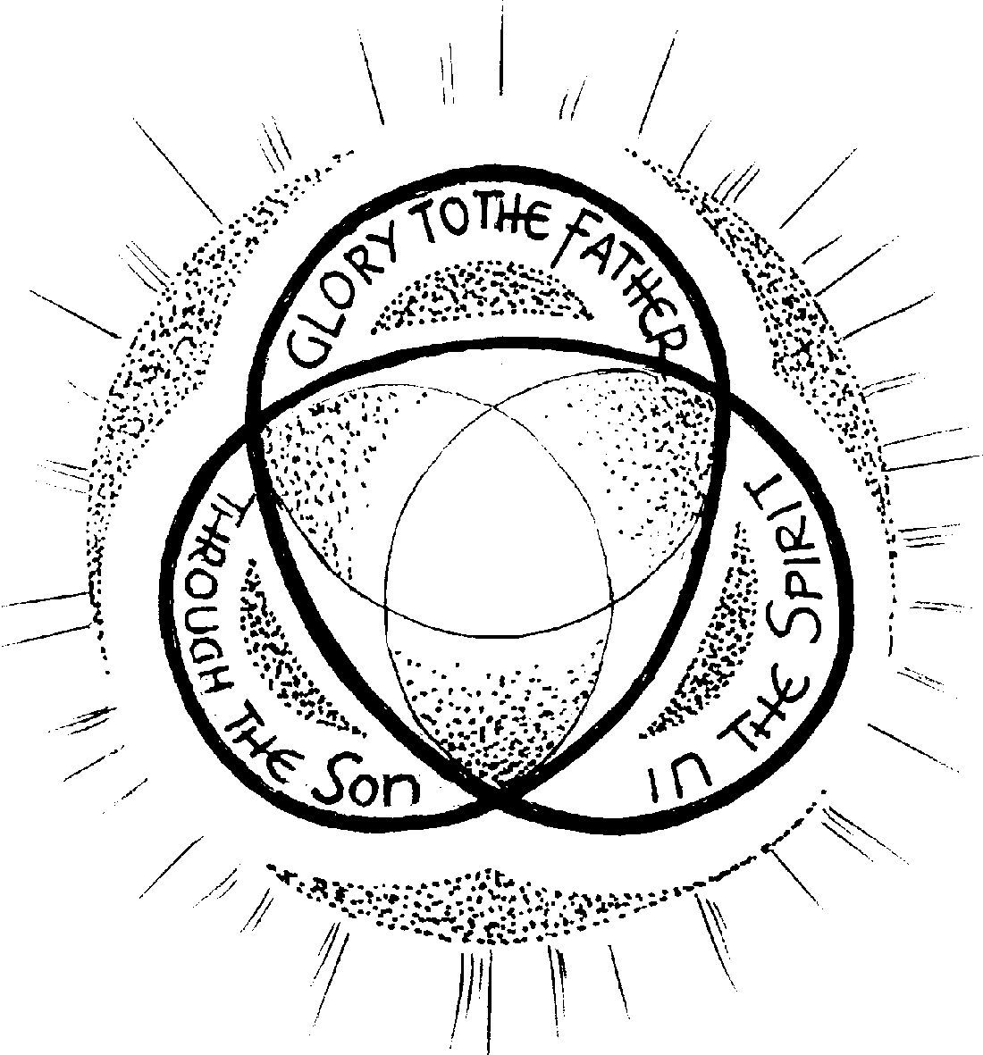

Seventh Sunday After Trinity
3 August 2025
10am

Welcome to St Mary’s, and to the service today.

If you would like a clergy visit, please let us know.
Please note that when asked to kneel or stand, you can do this in body or in heart.
Please stand as the Choir process to the back and the first hymn is announced.
Opening hymn 364: God is Love: let heav'n adore him
- God is Love: let heav'n adore him;
God is Love: let earth rejoice;
Let creation sing before him,
And exalt him with one voice,
He who laid the earth's foundation,
He who spread the heav'ns above,
He who breathes through all creation,
He is Love, eternal Love.
- God is Love: and he enfoldeth
All the world in one embrace;
With unfailing grasp he holdeth
Every child of every race.
And when human hearts are breaking
Under sorrow's iron rod,
Then they find that selfsame aching
Deep within the heart of God.
- God is Love: and though with blindness
Sin afflicts the souls of men,
God's eternal loving-kindness
Holds and guides them even then.
Sin and death and hell shall never
O'er us final triumph gain;
God is Love, so Love for ever
O'er the universe must reign. Timothy Rees 1874-1939, tune Blaenwern
THE GATHERING

The president says,
In the name of the Father, and of the Son,
and of the Holy Spirit.
All Amen.

The Greeting
Grace, mercy and peace from God our Father
and the Lord Jesus Christ be with you
All and also with you.

Prayer of Preparation
All: Almighty God, to whom all hearts are open, all desires known, and from whom no secrets are hidden:
cleanse the thoughts of our hearts
by the inspiration of your Holy Spirit,
that we may perfectly love you,
and worthily magnify your holy name;
through Christ our Lord. Amen.
Silence is kept. Please sit or kneel
Prayers of Confession
God the Father forgives us in Christ
and heals us by the Holy Spirit.
Let us therefore put away all anger
and bitterness, all slander and malice,
and confess our sins to God our redeemer. (c.f. Ephesians 4:30,32)
All Father eternal, giver of light and grace,
we have sinned against you and against our neighbour;
through ignorance, through weakness,
through our own deliberate fault.
We have wounded your love,
and marred your image in us.
We are sorry and ashamed, and repent of all our sins.
For the sake of your Son Jesus Christ, who died for us,
forgive us all that is past; and lead us out from darkness
to walk as children of light. Amen.
Absolution
May the God of love and power forgive you and free you from your sins, heal and strengthen you by his Spirit,
and raise you to new life in Christ our Lord.
All Amen.
We stand and pray together as the children prepare to leave for their activities in the Community Room:
All Creator God, we thank you for giving us Jesus as our Saviour: he blessed the children who came to him,
and welcomes those who come to him now.
Look with love upon these children
and protect them with your care.
May they grow in wisdom, age and strength in your presence and in the sight of all.
We ask this through your beloved Son, Jesus Christ our Lord. Amen.
GLORIA
Please remain standing.
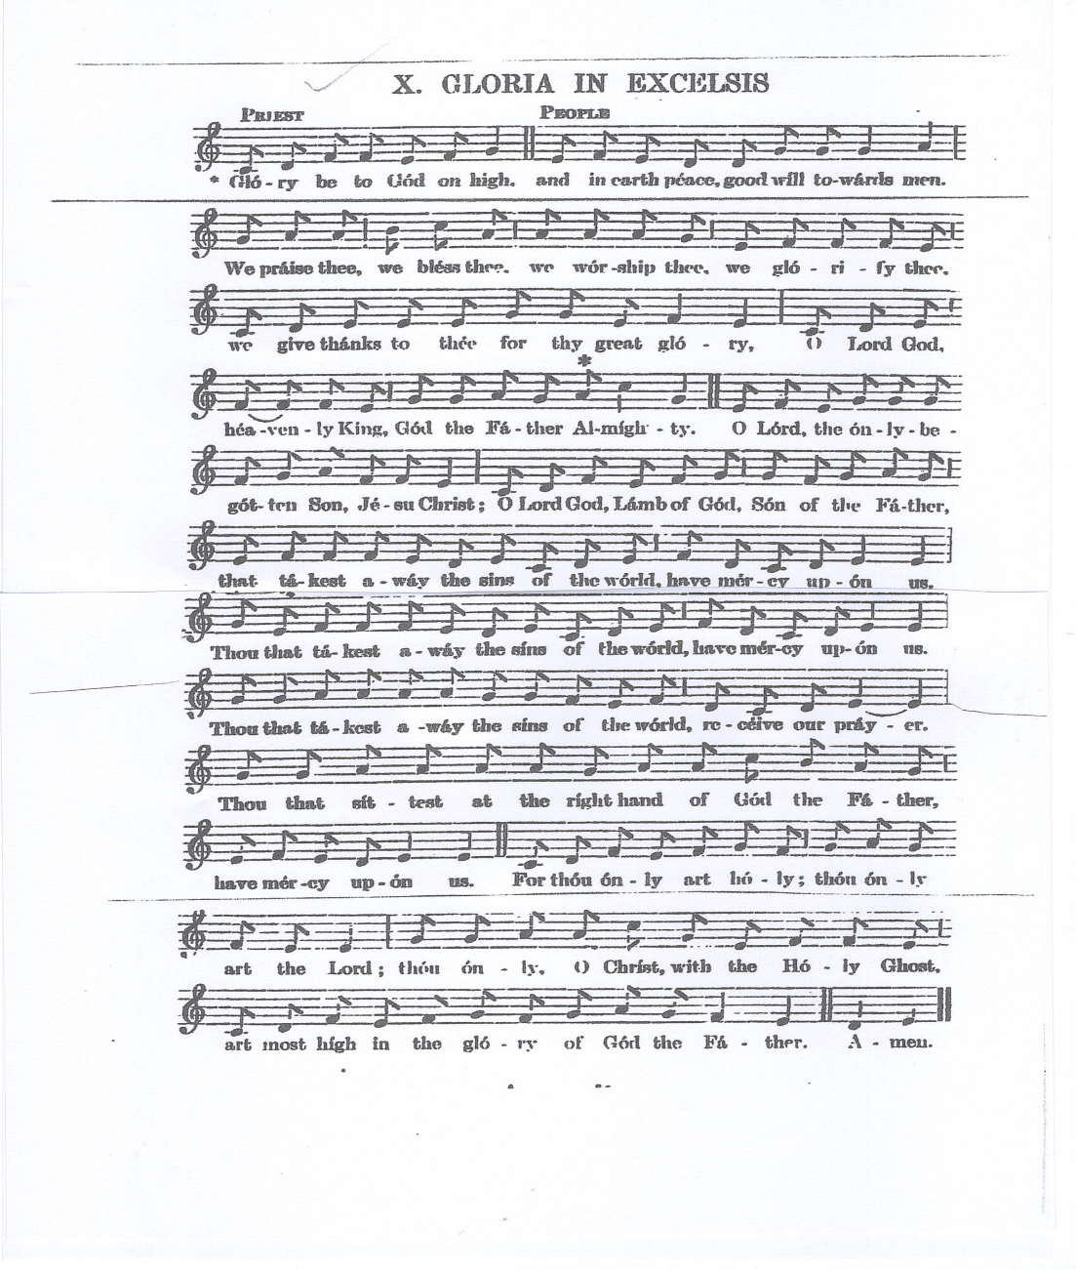
The Collect
All Lord of all power and might,
the author and giver of all good things:
graft in our hearts the love of your name,
increase in us true religion, nourish us with all goodness,
and of your great mercy keep us in the same;
through Jesus Christ your Son our Lord,
who is alive and reigns with you, in the unity of the Holy Spirit,
one God, now and for ever. Amen
Please sit for the readings
THE LITURGY OF THE WORD
First Reading: Hosea 11.1–11
When Israel was a child, I loved him, and out of Egypt I called my son. The more I called them, the more they went from me; they kept sacrificing to the Baals, and offering incense to idols. Yet it was I who taught Ephraim to walk, I took them up in my arms; but they did not know that I healed them. I led them with cords of human kindness, with bands of love. I was to them like those who lift infants to their cheeks. I bent down to them and fed them. They shall return to the land of Egypt, and Assyria shall be their king, because they have refused to return to me. The sword rages in their cities, it consumes their oracle-priests, and devours because of their schemes. My people are bent on turning away from me. To the Most High they call, but he does not raise them up at all. How can I give you up, Ephraim? How can I hand you over, O Israel? How can I make you like Admah? How can I treat you like Zeboiim? My heart recoils within me; my compassion grows warm and tender. I will not execute my fierce anger; I will not again destroy Ephraim; for I am God and no mortal, the Holy One in your midst, and I will not come in wrath. They shall go after the Lord, who roars like a lion; when he roars, his children shall come trembling from the west.They shall come trembling like birds from Egypt, and like doves from the land of Assyria; and I will return them to their homes, says the Lord.
This is the word of the Lord.
All: Thanks be to God.
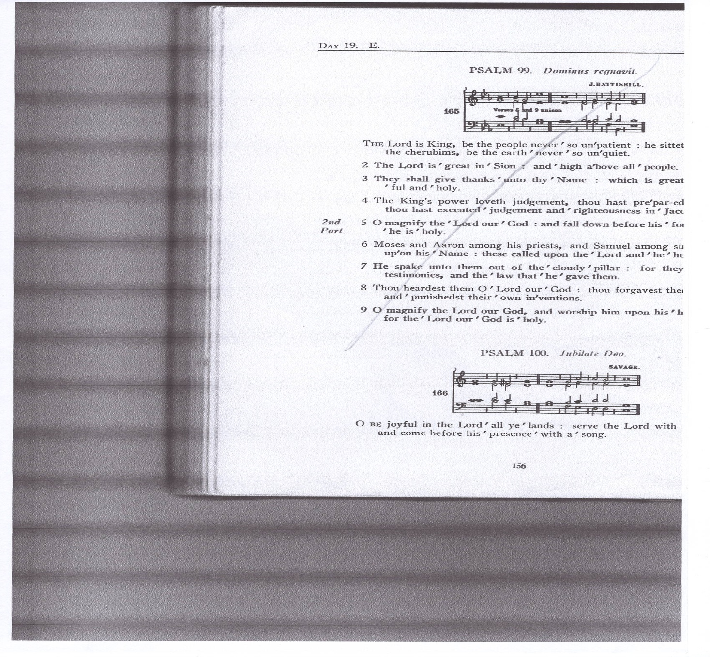
Psalm 100

1 O be joyful in the Lord ‘ all ye ‘ lands : serve the Lord with gladness, and come before his ‘ presence ‘ with a ‘ song.
2 Be ye sure that the Lord ‘ he is ‘ God : it is he that hath made us and not we ourselves, we are his ‘ people . and the ‘ sheep of his ‘ pasture.
3 O go your way into his gates with thanksgiving, and into his ‘ courts with ‘ praise : be thankful unto him and ‘ speak good ‘ of his ‘ name.
4 For the Lord is gracious, his mercy is ‘ ever ‘ lasting : and his truth endureth from gene‘ration to ‘ gene’ration.
Glory be to the Father, and ‘ to the ‘ Son : and ‘ to the ‘ Holy ‘ Ghost;
As it was in the beginning, is now and ‘ ever ‘ shall be : world without ‘ end ‘ A’men.
Second Reading: Colossians 3.1–11
So if you have been raised with Christ, seek the things that are above, where Christ is, seated at the right hand of God. Set your minds on things that are above, not on things that are on earth, for you have died, and your life is hidden with Christ in God. When Christ who is your life is revealed, then you also will be revealed with him in glory.
Put to death, therefore, whatever in you is earthly: fornication, impurity, passion, evil desire, and greed (which is idolatry). On account of these the wrath of God is coming on those who are disobedient. These are the ways you also once followed, when you were living that life. But now you must get rid of all such things—anger, wrath, malice, slander, and abusive language from your mouth. Do not lie to one another, seeing that you have stripped off the old self with its practices and have clothed yourselves with the new self, which is being renewed in knowledge according to the image of its creator. In that renewal there is no longer Greek and Jew, circumcised and uncircumcised, barbarian, Scythian, slave and free; but Christ is all and in all!
This is the word of the Lord
All Thanks be to God.
Gradual hymn 456 Teach me my God and King
- TEACH me, my God and King,
In all things thee to see;
And what I do in anything
To do it as for thee!
- A man that looks on glass,
On it may stay his eye;
Or if he pleaseth, through it pass,
And then the heaven espy.
- All may of thee partake;
Nothing can be so mean,
Which, with this tincture, 'for thy sake',
Will not grow bright and clean.
- A servant with this clause
Makes drudgery divine;
Who sweeps a room, as for thy laws,
Makes that and the action fine.
- This is the famous stone
That turneth all to gold;
For that which God doth touch and own
Cannot for less be told. George Herbert. Tune SANDYS

The Gospel

Alleluia, alleluia.

We do not live by bread alone,

But by every word that comes from the mouth of God. Matthew 4.4

All: Alleluia.

Hear the Gospel of our Lord Jesus Christ according to Luke

All: Glory to you, O Lord.
Someone in the crowd said to him, ‘Teacher, tell my brother to divide the family inheritance with me.’ But he said to him, ‘Friend, who set me to be a judge or arbitrator over you?’ And he said to them, ‘Take care! Be on your guard against all kinds of greed; for one’s life does not consist in the abundance of possessions.’ Then he told them a parable: ‘The land of a rich man produced abundantly. And he thought to himself, “What should I do, for I have no place to store my crops?” Then he said, “I will do this: I will pull down my barns and build larger ones, and there I will store all my grain and my goods. And I will say to my soul, Soul, you have ample goods laid up for many years; relax, eat, drink, be merry.” But God said to him, “You fool! This very night your life is being demanded of you. And the things you have prepared, whose will they be?” So it is with those who store up treasures for themselves but are not rich towards God.’ Luke 12.13–21
This is the Gospel of the Lord.
All Praise to you, O Christ.
Sermon
THE CREED
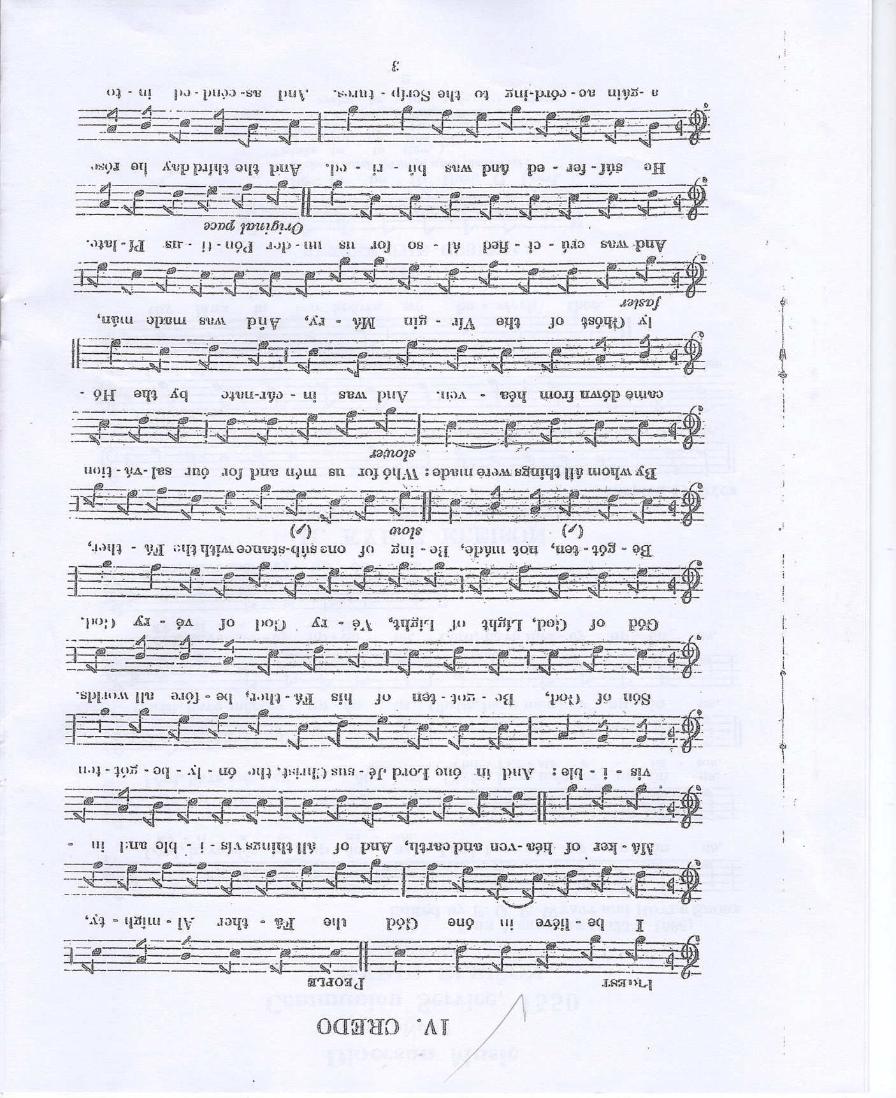
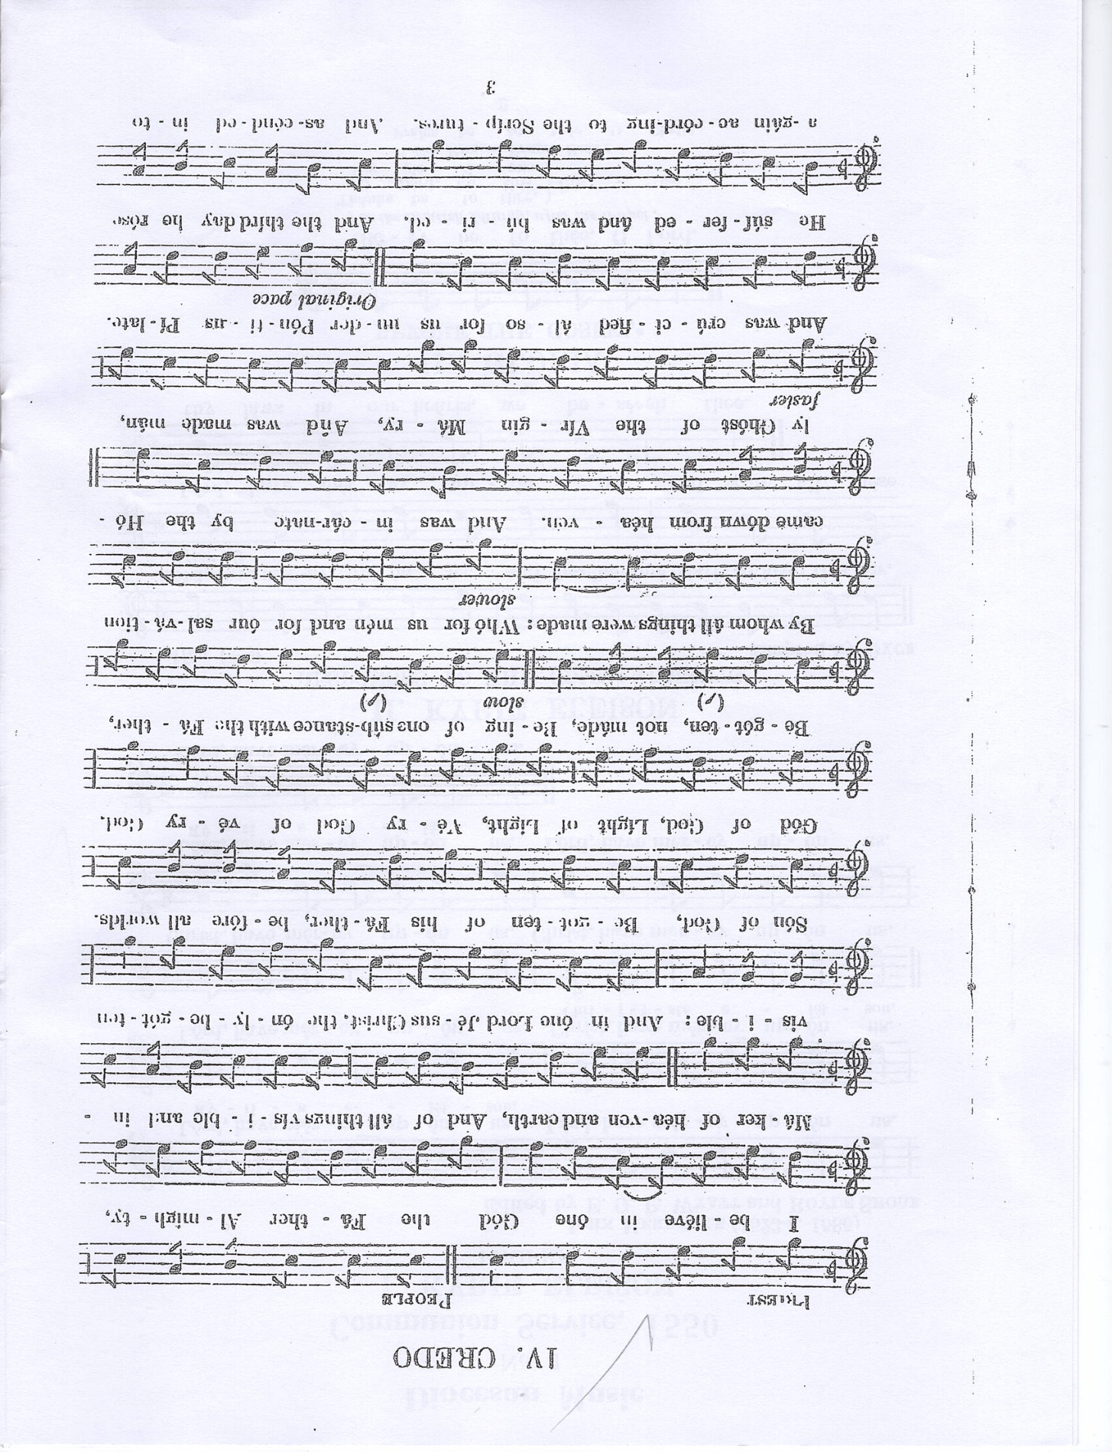
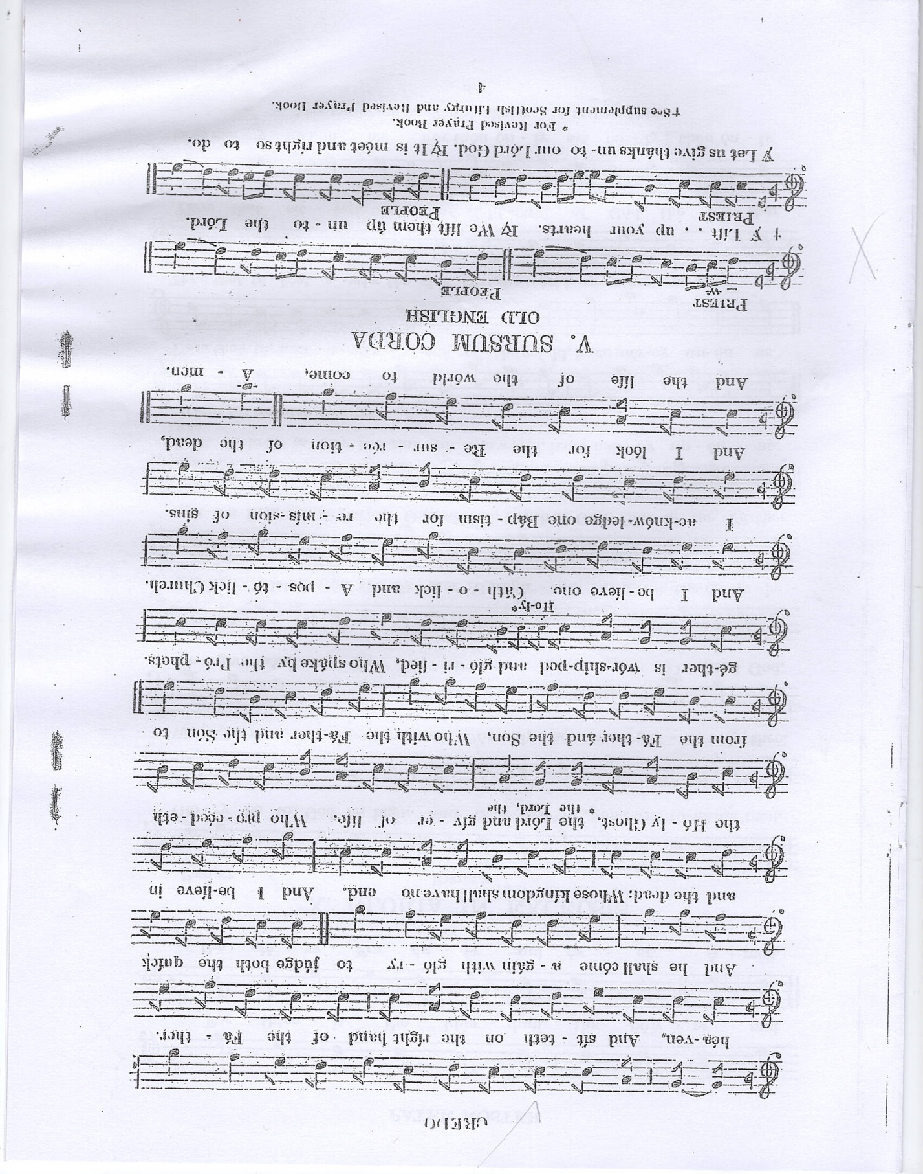

Prayers Of Intercession
Please sit or kneel to pray
In the power of the Spirit and in union with Christ
let us pray to the Father.
At the end
Merciful Father,
All accept these prayers for the sake of your Son,
our Saviour Jesus Christ. Amen

THE LITURGY OF THE SACRAMENT
The Peace
Please stand
Blessed are the peacemakers;
they shall be called children of God.
We meet in the name of Christ and share his peace.
The peace of the Lord be always with you.
All and also with you.
Let us offer one another a sign of peace.
Offertory hymn 333: All my hope on God is founded.
- All my hope on God is founded;
He doth still my trust renew.
Me through change and chance he guideth,
Only good and only true.
God unknown, He alone
Calls my heart to be his own.
- God's great goodness aye endureth,
Deep his wisdom, passing thought:
Splendour, light and life attend him,
Beauty springeth out of naught.
Evermore, From his store
New-born worlds rise and adore.

- Daily doth th'Almighty giver
Bounteous gifts on us bestow;
His desire our soul delighteth,
Pleasure leads us where we go.
Love doth stand, At his hand;
Joy doth wait on his command.
- Still from man to God eternal
Sacrifice of praise be done,
High above all praises praising
For the gift of Christ his Son.
Christ doth call, One and all:
Ye who follow shall not fall. J. Neander. Tune MICHAEL
Preparation of the Table
Please remain standing
Blessed are you, Lord God of all creation:
through your goodness we have this bread to set before you,
which earth has given and human hands have made.
It will become for us the bread of life.
All Blessed be God for ever.
Blessed are you, Lord God of all creation:through your goodness we have this wine to set before you,
fruit of the vine and work of human hands.
It will become for us the cup of salvation.
All Blessed be God for ever.
The Eucharistic Prayer
The president says
The Lord is here
All His Spirit is with us
Lift up your hearts.
All We lift them to the Lord.
Let us give thanks to the Lord our God.
All It is right to give thanks and praise.

It is indeed right, it is our duty and our joy, always and everywhere to give you thanks, holy Father, almighty and everlasting God, through Jesus Christ, your only Son our Lord.
For he is your living Word;
through him you have created all things from the beginning,
and formed us in your own image.
Through him you have freed us from the slavery of sin,
giving him to be born of a woman and to die upon the cross;
you raised him from the dead
and exalted him to your right hand on high.
Through him you have sent upon us your holy and life-giving Spirit, and made us a people for your own possession.
Therefore, with angels and archangels,
and with all the company of heaven,
we proclaim your great and glorious name,
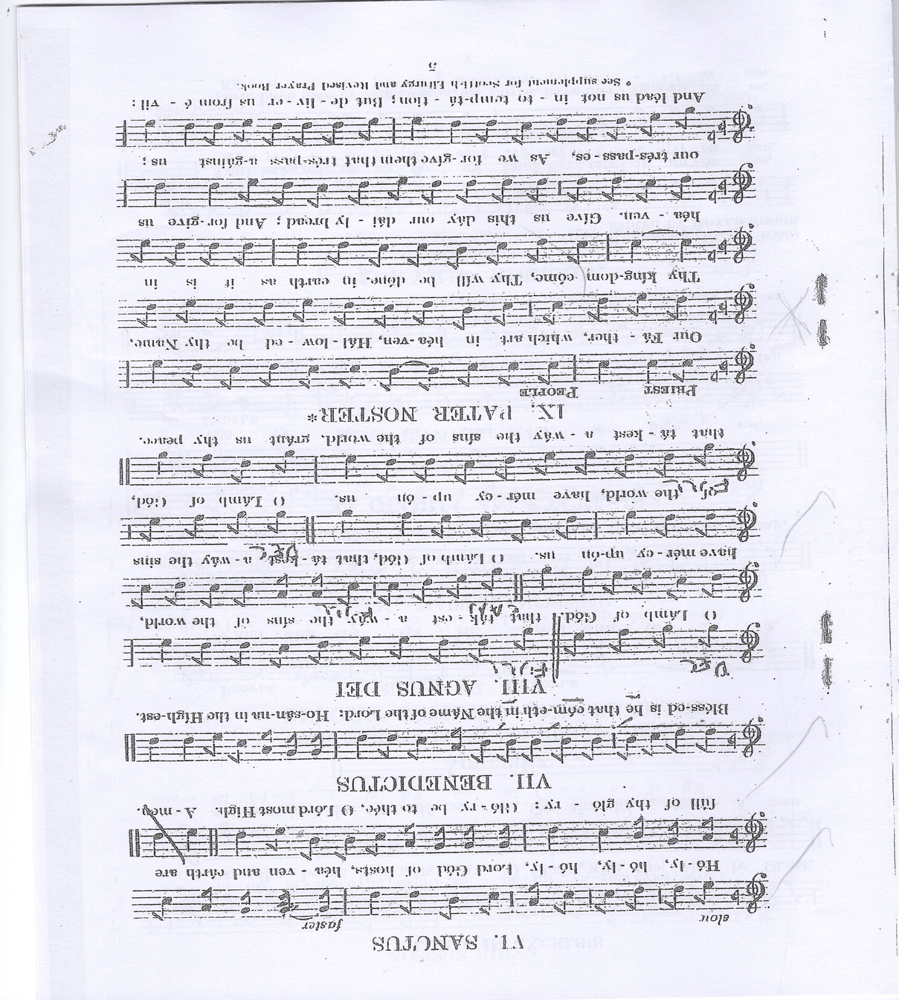
for ever praising you and sin
Merbecke
Please sit or kneel
Accept our praises, heavenly Father,
through your Son our Saviour Jesus Christ,
and as we follow his example and obey his command,
grant that by the power of your Holy Spirit
these gifts of bread and wine
may be to us his body and his blood;

who, in the same night that he was betrayed,
took bread and gave you thanks; he broke it and gave it to his disciples, saying: Take, eat; this is my body which is given for you;
do this in remembrance of me.
In the same way, after supper he took the cup and gave you thanks
he gave it to them, saying: Drink this, all of you;
this is my blood of the new covenant,
which is shed for you and for many for the forgiveness of sins.
Do this, as often as you drink it, in remembrance of me.
Therefore, heavenly Father, we remember his offering of himself made once for all upon the cross;
we proclaim his mighty resurrection and glorious ascension;
we look for the coming of your kingdom;
and with this bread and this cup
we make the memorial of Christ your Son our Lord.
Great is the mystery of faith:
All Christ has died: Christ is risen:
Christ will come again.
Accept through him, our great high priest,
this our sacrifice of thanks and praise,
and as we eat and drink these holy gifts
in the presence of your divine majesty,
renew us by your Spirit, inspire us with your love
and unite us in the body of your Son, Jesus Christ our Lord.
Through him, and with him, and in him,
in the unity of the Holy Spirit, with St Mary
and all who stand before you in earth and heaven,
we worship you, Father almighty, in songs of everlasting praise:
All Blessing and honour and glory and power
be yours for ever and ever. Amen.

THE LORD’S PRAYER

Let us pray with confidence as our Saviour has taught us
All Our Father, who art in heaven, hallowed be thy name;
thy kingdom come; thy will be done;
on earth as it is in heaven.
Give us this day our daily bread.
And forgive us our trespasses,
as we forgive those who trespass against us.
And lead us not into temptation; but deliver us from evil. For thine is the kingdom, the power and the glory,
for ever and ever. Amen.

Breaking of the Bread
The president breaks the consecrated bread.
We break this bread
to share in the body of Christ.
All Though we are many, we are one body,
because we all share in one bread.
Giving of Communion
The president says
Draw near with faith.
Receive the body of our Lord Jesus Christ
which he gave for you,
and his blood which he shed for you.
Eat and drink
in remembrance that he died for you,
and feed on him in your hearts
by faith with thanksgiving.
Agnus Dei
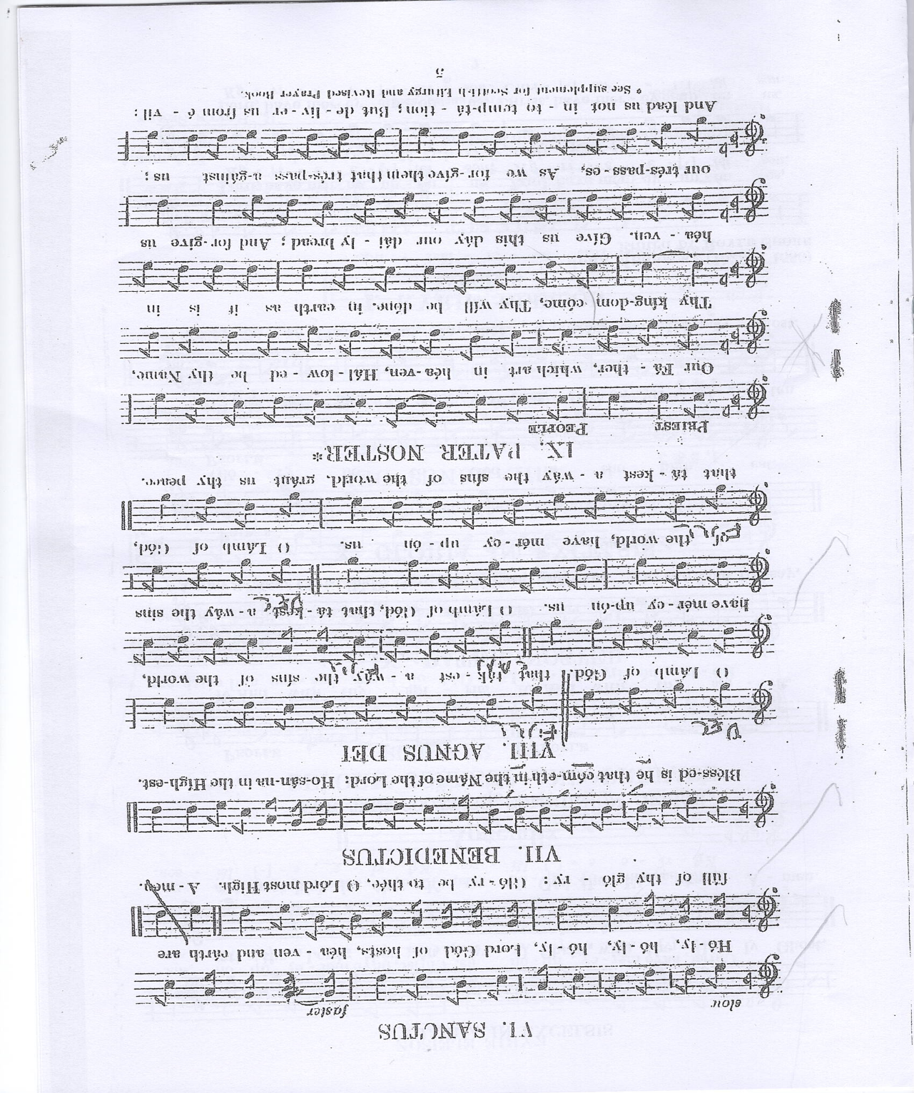

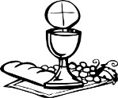
If you normally receive communion in your usual Church you are welcome to do so here. If you would like a wafer with the wine already present, please ask, but do not dip. Similarly, if you would like gluten free wafer, please ask. If you would like to receive a blessing please carry this Booklet.

Hymn During the Communion: Take my life and let it be
- Take my life, and let it be consecrated Lord, to thee,
Take my moments and my days,
let them flow in ceaseless praise.
- Take my hands, and let them move at the impulse of thy love
Take my feet, and let them be
swift and beautiful for thee.
- Take my voice, and let me sing always only for my King;
Take my lips, and let them be
filled with messages from thee.
- Take my silver and my gold, not a mite would I withhold;
Take my intellect, and use
ev’ry power as thou shalt choose.

- Take my will, and make it thine it shall be no longer mine;
Take my heart it is thine own
it shall be thy royal throne.
- Take my love; my Lord, I pour at thy feet its treasure -store;
Take myself, and I will be ever,
only, all for thee. F R Havergal. Tune NOTTINGHAM
Prayer After Communion
Lord God, whose Son is the true vine and the source of life,
ever giving himself that the world may live:
may we so receive within ourselves the power of his death and passion that, in his saving cup, we may share his glory and be made perfect in his love; for he is alive and reigns, now and for ever. Amen
Thanksgiving, said by everyone.

All Almighty God,
we thank you for feeding us
with the body and blood of your Son Jesus Christ.
Through him we offer you our souls and bodies
to be a living sacrifice.
Send us out in the power of your Spirit
to live and work to your praise and glory. Amen.
SUNDAY CLUB FEEDBACK Mary Mouse & NOTICES
Hymn: 480: In Christ there is no East or West
- In Christ there is no East or West,
In him no South or North,
But one great fellowship of love
Throughout the whole wide earth.
- Join hands, then, brothers of the faith,
Whate'er your race may be;
Who serves my Father as a son
Is surely kin to me.
- In Christ now meet both East and West,
In him meet South and North,
All Christlike souls are one in him,
Throughout the whole wide earth.
John Oxenham 1852 – 1941, tune St Stephen
THE DISMISSAL
The Lord God almighty, Father, Son, and Holy Spirit,
the holy and undivided Trinity, guard you, save you,
and bring you to that heavenly city,
where he lives and reigns for ever and ever. Amen.
and the blessing of God almighty,
the Father, the Son and the Holy Spirit,
be among you, and remain with you always.
All Amen.
Go in peace to love and serve the Lord.
All In the name of Christ. Amen. Common Worship, material in this service, is copyright © The Archbishops' Council 2000 and 2008.

